Weaf HR
Human Resource & Payroll Management System
System Documentation
A complete guide to the platform, from the public website to payroll

Document | Weaf HR System Documentation
Covers | 100 screens across 16 modules
Application | Weaf HR (Weaf Payroll System)
Environment | https://weafpayroll.weafcompany.com
Version | 3.3
Date | 12 August 2026
Prepared by | Weaf Company Uganda Ltd.
Status | Draft for review

© 2026 Weaf Company Uganda Ltd. All rights reserved.

Table of Contents
Part I — Introduction 1
1. About This Document 2
1.1 Who this is for 2
1.2 How this document was produced 2
1.3 How to read the figures 2
2. What Weaf HR Is 3
2.1 The modules 3
2.2 Users, employees, and the difference 3
Part II — Getting Started 4
3. The Public Website 5
3.1 The page at a glance 5
3.2 Header and navigation 7
3.3 Hero 8
3.4 Features 9
3.5 Product tour 10
3.6 Why choose us 11
3.7 About 12
3.8 Team 13
3.9 Testimonials 14
3.10 Pricing plans 15
3.11 Frequently asked questions 16
3.12 Newsletter 17
3.13 Contact 18
3.14 Footer 19
3.15 Where the navigation leads 20
3.16 The pricing page 21
3.17 The developer documentation 22
3.18 How the public site is maintained 23
4. Creating Your Company Account 24
4.1 Signing up 24
5. Signing In 25
6. Finding Your Way Around 26
6.1 The workspace 26
6.2 The dashboard 27
6.3 How every list page works 28
Part III — Setting Up Your Organisation 29
7. Users, Roles and Access 30
7.1 Users 31
7.2 Roles 33
8. Company Structure 35
8.1 Branches 36
8.2 Departments 38
8.3 Designations 40
8.4 Document Types 42
9. Employees 44
9.1 Employees 45
Part IV — Running HR Day to Day 47
10. Leave Management 48
10.1 Leave Types 49
10.2 Leave Policies 51
10.3 Leave Applications 53
10.4 Leave Balances 55
11. Attendance and Time 57
11.1 Shifts 58
11.2 Attendance Policies 60
11.3 Attendance Records 62
11.4 Attendance Regularizations 64
11.5 Biometric Attendance 66
11.6 Time Entries 67
12. Payroll 69
12.1 Salary Components 70
12.2 Employee Salaries 72
12.3 Payroll Runs 73
12.4 Payslips 75
12.5 Salary Advances 76
13. Recruitment and Onboarding 77
13.1 Job Categories 78
13.2 Job Types 80
13.3 Job Locations 82
13.4 Custom Questions 84
13.5 Job Postings 86
13.6 careers 88
13.7 Candidate Sources 89
13.8 Candidates 91
13.9 Interview Types 92
13.10 Interview Rounds 94
13.11 Interviews 96
13.12 Interview Feedback 97
13.13 Candidate Assessments 99
13.14 Offer Templates 101
13.15 Offers 103
13.16 Onboarding Checklists 105
13.17 Checklist Items 107
13.18 Candidate Onboarding 109
14. Performance 110
14.1 Indicator Categories 111
14.2 Indicators 113
14.3 Goal Types 115
14.4 Employee Goals 117
14.5 Review Cycles 119
14.6 Employee Reviews 121
15. Training 122
15.1 Training Types 123
15.2 Training Programs 125
15.3 Training Sessions 127
15.4 Employee Trainings 129
16. Asset Management 130
16.1 Asset Types 131
16.2 Assets 133
16.3 Dashboard 135
16.4 Depreciation 136
17. Contracts 137
17.1 Contract Types 138
17.2 Employee Contracts 140
17.3 Contract Templates 142
18. Documents 144
18.1 Document Categories 145
18.2 HR Documents 147
18.3 Acknowledgments 148
18.4 Document Templates 149
19. Meetings and Calendar 151
19.1 Meeting Types 152
19.2 Meeting Rooms 154
19.3 Meetings 156
19.4 Meeting Attendees 157
19.5 Meeting Minutes 159
19.6 Action Items 161
19.7 Calendar 163
19.8 Media Library 164
20. The Employee Record Over Time 165
20.1 Award Types 166
20.2 Awards 168
20.3 Promotions 170
20.4 Transfers 172
20.5 Trips 174
20.6 Warnings 176
20.7 Complaints 178
20.8 Resignations 180
20.9 Terminations 182
20.10 Holidays 184
20.11 Announcements 186
Part V — Administration 188
21. Administration 189
21.1 Settings 190
21.2 Plans 192
21.3 Plan Requests 193
21.4 Plan Orders 194
21.5 Referral Program 195
21.6 Landing Page 196
22. Developer Tools 197
22.1 API Tokens 198
22.2 Webhooks 199
22.3 API Reference 200
Appendix 201
A. Complete Page Index 202

List of Figures
Figure 1: The complete welcome page in two columns, reading left to right, with its thirteen sections numbered 5
Figure 2: The header and navigation section 7
Figure 3: The hero section 8
Figure 4: The features section 9
Figure 5: The product tour section 10
Figure 6: The why choose us section 11
Figure 7: The about section 12
Figure 8: The team section 13
Figure 9: The testimonials section 14
Figure 10: The pricing plans section 15
Figure 11: The frequently asked questions section 16
Figure 12: The newsletter section 17
Figure 13: The contact section 18
Figure 14: The footer section 19
Figure 15: The pricing page 21
Figure 16: The developer documentation 22
Figure 17: The registration page 24
Figure 18: The sign-in page 25
Figure 19: The workspace, common to every page 26
Figure 20: The dashboard 27
Figure 21: The anatomy of a list page, shown on Employees 28
Figure 22: The Users page 31
Figure 23: The Add User form 32
Figure 24: The Roles page 33
Figure 25: The Add New Role form 34
Figure 26: The Branches page 36
Figure 27: The Add Branch form 37
Figure 28: The Departments page 38
Figure 29: The Add Department form 39
Figure 30: The Designations page 40
Figure 31: The Add Designation form 41
Figure 32: The Document Types page 42
Figure 33: The Add Document Type form 43
Figure 34: The Employees page 45
Figure 35: The Add Employee form 46
Figure 36: The Leave Types page 49
Figure 37: The Add Leave Type form 50
Figure 38: The Leave Policies page 51
Figure 39: The Add Leave Policy form 52
Figure 40: The Leave Applications page 53
Figure 41: The Add Leave Application form 54
Figure 42: The Leave Balances page 55
Figure 43: The Add Leave Balance form 56
Figure 44: The Shifts page 58
Figure 45: The Add Shift form 59
Figure 46: The Attendance Policies page 60
Figure 47: The Add Attendance Policy form 61
Figure 48: The Attendance Records page 62
Figure 49: The Add Record form 63
Figure 50: The Attendance Regularizations page 64
Figure 51: The Add Request form 65
Figure 52: The Biometric Attendance page 66
Figure 53: The Time Entries page 67
Figure 54: The Add Time Entry form 68
Figure 55: The Salary Components page 70
Figure 56: The Add Component form 71
Figure 57: The Employee Salaries page 72
Figure 58: The Payroll Runs page 73
Figure 59: The Add Payroll Run form 74
Figure 60: The Payslips page 75
Figure 61: The Salary Advances page 76
Figure 62: The Job Categories page 78
Figure 63: The Add Job Category form 79
Figure 64: The Job Types page 80
Figure 65: The Add Job Type form 81
Figure 66: The Job Locations page 82
Figure 67: The Add Job Location form 83
Figure 68: The Custom Questions page 84
Figure 69: The Add Custom Question form 85
Figure 70: The Job Postings page 86
Figure 71: The Add Job Posting form 87
Figure 72: The careers page 88
Figure 73: The Candidate Sources page 89
Figure 74: The Add Candidate Source form 90
Figure 75: The Candidates page 91
Figure 76: The Interview Types page 92
Figure 77: The Add Interview Type form 93
Figure 78: The Interview Rounds page 94
Figure 79: The Add Interview Round form 95
Figure 80: The Interviews page 96
Figure 81: The Interview Feedback page 97
Figure 82: The Add Feedback form 98
Figure 83: The Candidate Assessments page 99
Figure 84: The Add Assessment form 100
Figure 85: The Offer Templates page 101
Figure 86: The Add Template form 102
Figure 87: The Offers page 103
Figure 88: The Create Offer form 104
Figure 89: The Onboarding Checklists page 105
Figure 90: The Add Checklist form 106
Figure 91: The Checklist Items page 107
Figure 92: The Add Item form 108
Figure 93: The Candidate Onboarding page 109
Figure 94: The Indicator Categories page 111
Figure 95: The Add Category form 112
Figure 96: The Indicators page 113
Figure 97: The Add Indicator form 114
Figure 98: The Goal Types page 115
Figure 99: The Add Goal Type form 116
Figure 100: The Employee Goals page 117
Figure 101: The Add Goal form 118
Figure 102: The Review Cycles page 119
Figure 103: The Add Review Cycle form 120
Figure 104: The Employee Reviews page 121
Figure 105: The Training Types page 123
Figure 106: The Add Training Type form 124
Figure 107: The Training Programs page 125
Figure 108: The Add Training Program form 126
Figure 109: The Training Sessions page 127
Figure 110: The Add Session form 128
Figure 111: The Employee Trainings page 129
Figure 112: The Asset Types page 131
Figure 113: The Add Asset Type form 132
Figure 114: The Assets page 133
Figure 115: The Add Asset form 134
Figure 116: The Dashboard page 135
Figure 117: The Depreciation page 136
Figure 118: The Contract Types page 138
Figure 119: The Add Contract Type form 139
Figure 120: The Employee Contracts page 140
Figure 121: The Add Contract form 141
Figure 122: The Contract Templates page 142
Figure 123: The Add Template form 143
Figure 124: The Document Categories page 145
Figure 125: The Add Category form 146
Figure 126: The HR Documents page 147
Figure 127: The Acknowledgments page 148
Figure 128: The Document Templates page 149
Figure 129: The Add Template form 150
Figure 130: The Meeting Types page 152
Figure 131: The Add Meeting Type form 153
Figure 132: The Meeting Rooms page 154
Figure 133: The Add Meeting Room form 155
Figure 134: The Meetings page 156
Figure 135: The Meeting Attendees page 157
Figure 136: The Add Attendee form 158
Figure 137: The Meeting Minutes page 159
Figure 138: The Add Minute form 160
Figure 139: The Action Items page 161
Figure 140: The Add Action Item form 162
Figure 141: The Calendar page 163
Figure 142: The Media Library page 164
Figure 143: The Award Types page 166
Figure 144: The Add Award Type form 167
Figure 145: The Awards page 168
Figure 146: The Add Award form 169
Figure 147: The Promotions page 170
Figure 148: The Add Promotion form 171
Figure 149: The Transfers page 172
Figure 150: The Add Transfer form 173
Figure 151: The Trips page 174
Figure 152: The Add Trip form 175
Figure 153: The Warnings page 176
Figure 154: The Add Warning form 177
Figure 155: The Complaints page 178
Figure 156: The Add Complaint form 179
Figure 157: The Resignations page 180
Figure 158: The Add Resignation form 181
Figure 159: The Terminations page 182
Figure 160: The Add Termination form 183
Figure 161: The Holidays page 184
Figure 162: The Add Holiday form 185
Figure 163: The Announcements page 186
Figure 164: The Add Announcement form 187
Figure 165: The Settings page 190
Figure 166: The Add IP Address form 191
Figure 167: The Plans page 192
Figure 168: The Plan Requests page 193
Figure 169: The Plan Orders page 194
Figure 170: The Referral Program page 195
Figure 171: The Landing Page page 196
Figure 172: The API Tokens page 198
Figure 173: The Webhooks page 199
Figure 174: The API Reference page 200

List of Tables
Table 1: The modules of Weaf HR and where each is documented 3
Table 2: The thirteen sections of the welcome page, in order 6
Table 3: Navigation destinations in the header, as published 20
Table 4: Fields on the registration form 24
Table 5: Complete index of application pages 202

These three lists are Word fields. If they look out of date, select all (Ctrl+A) and press F9, then choose “Update entire table”.

Part I — Introduction

1. About This Document

1.1 Who this is for
This manual assumes no prior knowledge of Weaf HR. It starts at the public website, walks through creating a company and signing in, and then covers every page of the application in the order someone setting the system up would meet them. A reader who follows it from the beginning will be able to run the system; a reader who already knows it can use the contents pages to jump to one screen.

1.2 How this document was produced
Every screenshot was captured from the running system at https://weafpayroll.weafcompany.com, and the details quoted in the text — page titles, table columns, button labels and form fields — were read from those same pages rather than from the source code. Where a page is configurable and an administrator has changed it, the live page is treated as correct.
The screens shown belong to a demonstration company, so the names, salaries and other details in them are fictitious. The structure around that data is real.

1.3 How to read the figures
Screenshots are marked up. A crimson outline identifies the element being discussed and a numbered crimson badge sits on its corner; the numbered list under the figure explains the marked elements in the same order. Crimson appears nowhere in the product’s own palette, so an annotation can never be mistaken for part of the interface.
Captures were taken on a desktop screen. The system is responsive: on a narrow screen the sidebar collapses behind a menu button and multi-column layouts stack. The content is the same; only its arrangement changes.
Note: Instructions in this manual never include a final confirmation of anything destructive. Where a screen can delete or approve, the manual says so but stops short of walking you through it.

2. What Weaf HR Is
Weaf HR is a human resource and payroll platform for a company and its staff. It holds the record of who works for you, what they are paid, when they are at work, when they are on leave, how they are performing, and everything that happens between joining and leaving.
It is multi-company by design: each company's data is separate, and a company signs up for its own account rather than being created by an administrator. The public website in chapter 3 is the front door to that sign-up.

2.1 The modules
The sidebar groups the system into modules. This manual devotes a chapter to each, in the order they are usually set up:
Table 1: The modules of Weaf HR and where each is documented
Module | What it covers | Chapter
Staff | Logins and permissions | 7
HR Management | Branches, departments, designations, employees | 8, 9
Leave Management | Leave types, policies, applications, balances | 10
Attendance / Time Tracking | Shifts, records, corrections, project hours | 11
Payroll Management | Components, salaries, runs, payslips, advances | 12
Recruitment | Postings, candidates, interviews, offers, onboarding | 13
Performance | Indicators, goals, review cycles, reviews | 14
Training | Programmes, sessions, employee assignments | 15
Asset Management | Asset register, assignment, depreciation | 16
Contract Management | Contract types, templates, agreements | 17
Document Management | Documents, templates, acknowledgements | 18
Meetings and Calendar | Meetings, minutes, action items | 19
Employee lifecycle | Awards, promotions, transfers, discipline, exits | 20
Administration | Settings, plans, referrals, the public site | 21
Developer | API tokens, webhooks, the API reference | 22

2.2 Users, employees, and the difference
One distinction causes more confusion than any other, so it is worth settling before anything else.
- A user — is a login: an email address, a password and a role that says what they may do.
- An employee — is an HR record: a person the company employs, with a department, a salary and a leave balance.
They are related but not the same. A worker who never touches a computer is an employee with no user. An external accountant may be a user who is not an employee. Creating one does not create the other, and chapter 7 covers users while chapter 9 covers employees.

Part II — Getting Started

3. The Public Website
The welcome page is served at the root of the application and is the only screen a visitor sees before deciding whether to register. It has three jobs, in order: explain what the product does, give enough evidence to believe it, and route the visitor onward — into registration, into an existing account, or into a conversation.

3.1 The page at a glance
The page is built from thirteen stacked sections and runs to roughly 11,354 pixels at desktop width. The figure below shows the whole page reduced to fit, with each section numbered down the left margin.
Figure 1: The complete welcome page in two columns, reading left to right, with its thirteen sections numbered
Table 2: The thirteen sections of the welcome page, in order
# | Section | What it does
1 | Header / navigation | Fixed bar with the brand, navigation and account actions.
2 | Hero | Headline, calls to action and a product preview.
3 | Features | Six cards naming the main capabilities.
4 | Product tour | Captioned screenshots of the application.
5 | Why choose us | Four differentiators and a trust panel.
6 | About | Company background, mission, values and vision.
7 | Team | The people behind the product.
8 | Testimonials | Customer quotes and an aggregate rating.
9 | Pricing plans | Subscription tiers with a billing toggle.
10 | FAQ | Seven expandable questions.
11 | Newsletter | Email capture for announcements.
12 | Contact | Enquiry form and contact details.
13 | Footer | Grouped links, social links and copyright.

3.2 Header and navigation
The header is fixed to the top of the window and stays visible as the visitor scrolls, so the two account actions are always one click away. It carries the brand on the left, the navigation in the centre and the account actions on the right.
Figure 2: The header and navigation section
1 Brand wordmark — the company name or logo, linking back to the top. Set from the landing page settings.
2 Primary navigation — in-page anchors and standalone pages. The anchors scroll; the rest navigate.
3 Login — sends an existing user to the sign-in screen.
4 Get Started — the registration route, shown only when the platform runs in multi-company mode.

3.3 Hero
The hero fills the first screen: a headline stating the proposition, a supporting line naming the areas covered, two actions — register or sign in — three statistics used as proof, and a screenshot of the real dashboard.
Figure 3: The hero section
1 Announcement pill — an optional one-line notice for the most recent release. Left empty, it disappears.
2 Headline — the main proposition, and the page’s only level-one heading.
3 Supporting line — one sentence naming the areas the platform covers.
4 Primary action — the conversion route into registration.
5 Secondary action — the route for people who already have an account.
6 Proof statistics — three configurable figures used as social proof.
7 Product preview — a screenshot of the real dashboard, so the first impression is the product rather than an illustration.

3.4 Features
Six cards summarising what the platform does, each with an icon, a name and a single sentence. The intent is scannability; the detail belongs to the tour that follows.
Figure 4: The features section
1 section heading · 2 section subtitle · 3 feature card

3.5 Product tour
Where the features section asserts, this one shows: six captioned screenshots of the working application, each labelled with the module it comes from.
Figure 5: The product tour section
1 section heading · 2 one captioned screen

3.6 Why choose us
Four differentiators beside a panel of adoption and satisfaction figures. This answers the comparison question rather than the capability question.
Figure 6: The why choose us section
1 section heading · 2 one differentiator · 3 adoption and satisfaction panel

3.7 About
The company rather than the software: how long it has operated, who it serves, and four statements covering mission, values, commitment and vision.
Figure 7: The about section
1 section heading · 2 highlight panel · 3 one of four value cards

3.8 Team
Named people with roles and photographs, followed by a recruitment prompt linking to open positions.
Figure 8: The team section
1 section heading · 2 a team member · 3 recruitment prompt

3.9 Testimonials
Customer quotes with star ratings and attributed authors, closing with an aggregate rating panel. These are records in the system, so they can be added or withdrawn without a release.
Figure 9: The testimonials section
1 section heading · 2 one testimonial · 3 aggregate rating

3.10 Pricing plans
Three plans side by side, with the recommended plan raised and badged. Each card states its price, the usage limits that define the tier, the features it unlocks and its own call to action. A toggle switches every price between monthly and yearly.
Figure 10: The pricing plans section
1 section heading · 2 billing period toggle · 3 the recommended plan · 4 usage limits

3.11 Frequently asked questions
Seven questions in an expandable list, collapsed by default, covering how the platform works, payroll and leave automation, data security, recruitment, appraisals, reporting and plan changes.
Figure 11: The frequently asked questions section
1 section heading · 2 one collapsed question

3.12 Newsletter
An email field and a subscribe button, with three lines describing what a subscriber receives. Submission is handled without leaving the page.
Figure 12: The newsletter section
1 email field · 2 subscribe

3.13 Contact
An enquiry form beside the company’s published contact details, so a visitor can choose between writing on the page and using their own email or telephone.
Figure 13: The contact section
1 section heading · 2 enquiry form · 3 published contact details

3.14 Footer
Five columns of links, a second subscribe box for visitors who reached the bottom without acting, social links and the copyright line. The Developers entry leads to the public API documentation.
Figure 14: The footer section
1 one of five link columns · 2 developers (api docs) · 3 second subscribe box · 4 copyright and social links

3.15 Where the navigation leads
Table 3: Navigation destinations in the header, as published
Label | Destination | Type
Home | / | Page
Pricing | /pricing | Page
Developers | /api/docs | Public API documentation
About Us | /page/about-us | Content page
Privacy Policy | /page/privacy-policy | Content page
Terms of Service | /page/terms-of-service | Content page
Contact Us | /page/contact-us | Content page
FAQ | /page/faq | Content page
Refund Policy | /page/refund-policy | Content page
Login | /login | Authentication
Get Started | /register | Authentication

The six content pages are not fixed in code. They are custom pages created in the administration area, and each appears in this menu automatically once published — see chapter 21.

3.16 The pricing page
The same plans as the welcome page, on a page of their own so the comparison can be linked to directly.
Figure 15: The pricing page

3.17 The developer documentation
Public API documentation with every endpoint listed and a console for trying them. It requires no account, so a developer can evaluate the platform before anyone signs up.
Figure 16: The developer documentation

3.18 How the public site is maintained
None of the welcome page is fixed in code. Its text, images, ordering and visibility are stored as settings and applied when the page renders, so the marketing site can change without a deployment. It is administered at /landing-page/settings, which is restricted to super administrators.
- Content — text, images, statistics, team members and headings.
- Order — the sequence of the thirteen sections.
- Visibility — whether a section appears at all; a hidden section is not rendered rather than merely concealed.
Plans, testimonials, FAQ entries and custom pages are records rather than settings, maintained in their own parts of the application. The welcome page renders whatever is currently published, which is why the figures in this chapter are true as at the date on the title page.

4. Creating Your Company Account
Weaf HR is multi-company. You do not ask an administrator for an account; you create one, and it becomes your company's own workspace with its own data, staff and subscription.

4.1 Signing up
Registration is reached from Get Started in the header of the welcome page, or directly at /register.
Figure 17: The registration page
1. Open the welcome page and choose Get Started.
2. Complete the form: Full name, Email address, Password, Confirm password, I agree to the Terms and Conditions.
3. Submit the form. The company workspace is created and you are signed in as its first user.
Table 4: Fields on the registration form
Field | Type | Required
Full name | text | Yes
Email address | email | Yes
Password | password | Yes
Confirm password | password | Yes
I agree to the Terms and Conditions | checkbox | No

Note: The first user created this way owns the company account. Give other people their own logins rather than sharing this one — chapter 7 explains how, and why shared logins make every later record ambiguous.

5. Signing In
Sign-in is reached from Login in the header, or directly at /login.
Figure 18: The sign-in page
1 Email
2 Password
3 Forgotten password
4 Sign in
5 Create an account
1. Enter the email address the account was created with.
2. Enter the password.
3. Choose Login. You arrive at the dashboard.
If the password has been forgotten, the Forgot password link sends a reset message to the registered address; no one else can reset it for you.

6. Finding Your Way Around
Every screen in the application is built from the same frame, and almost every screen inside that frame is the same kind of list. Learning both once makes the remaining ninety pages familiar on first sight, which is why this chapter comes before any of them.

6.1 The workspace
Figure 19: The workspace, common to every page
1 Module sidebar — every module in the system. Groups expand to reveal their pages, and the current page is highlighted.
2 Collapse the sidebar — narrows the sidebar to icons when you want more room.
3 Breadcrumb trail — where you are, and a way back up.
4 Language, alerts and account — the interface language, notifications, and the menu holding your profile and sign-out.
5 Working area — the page itself. Everything else stays put as you move between pages.

6.2 The dashboard
The landing screen after signing in. It answers “what needs my attention today?” with counts across the whole system — headcount, branches, attendance, outstanding leave, open jobs and candidates — and charts showing how the workforce is distributed and how hiring has moved over six months.
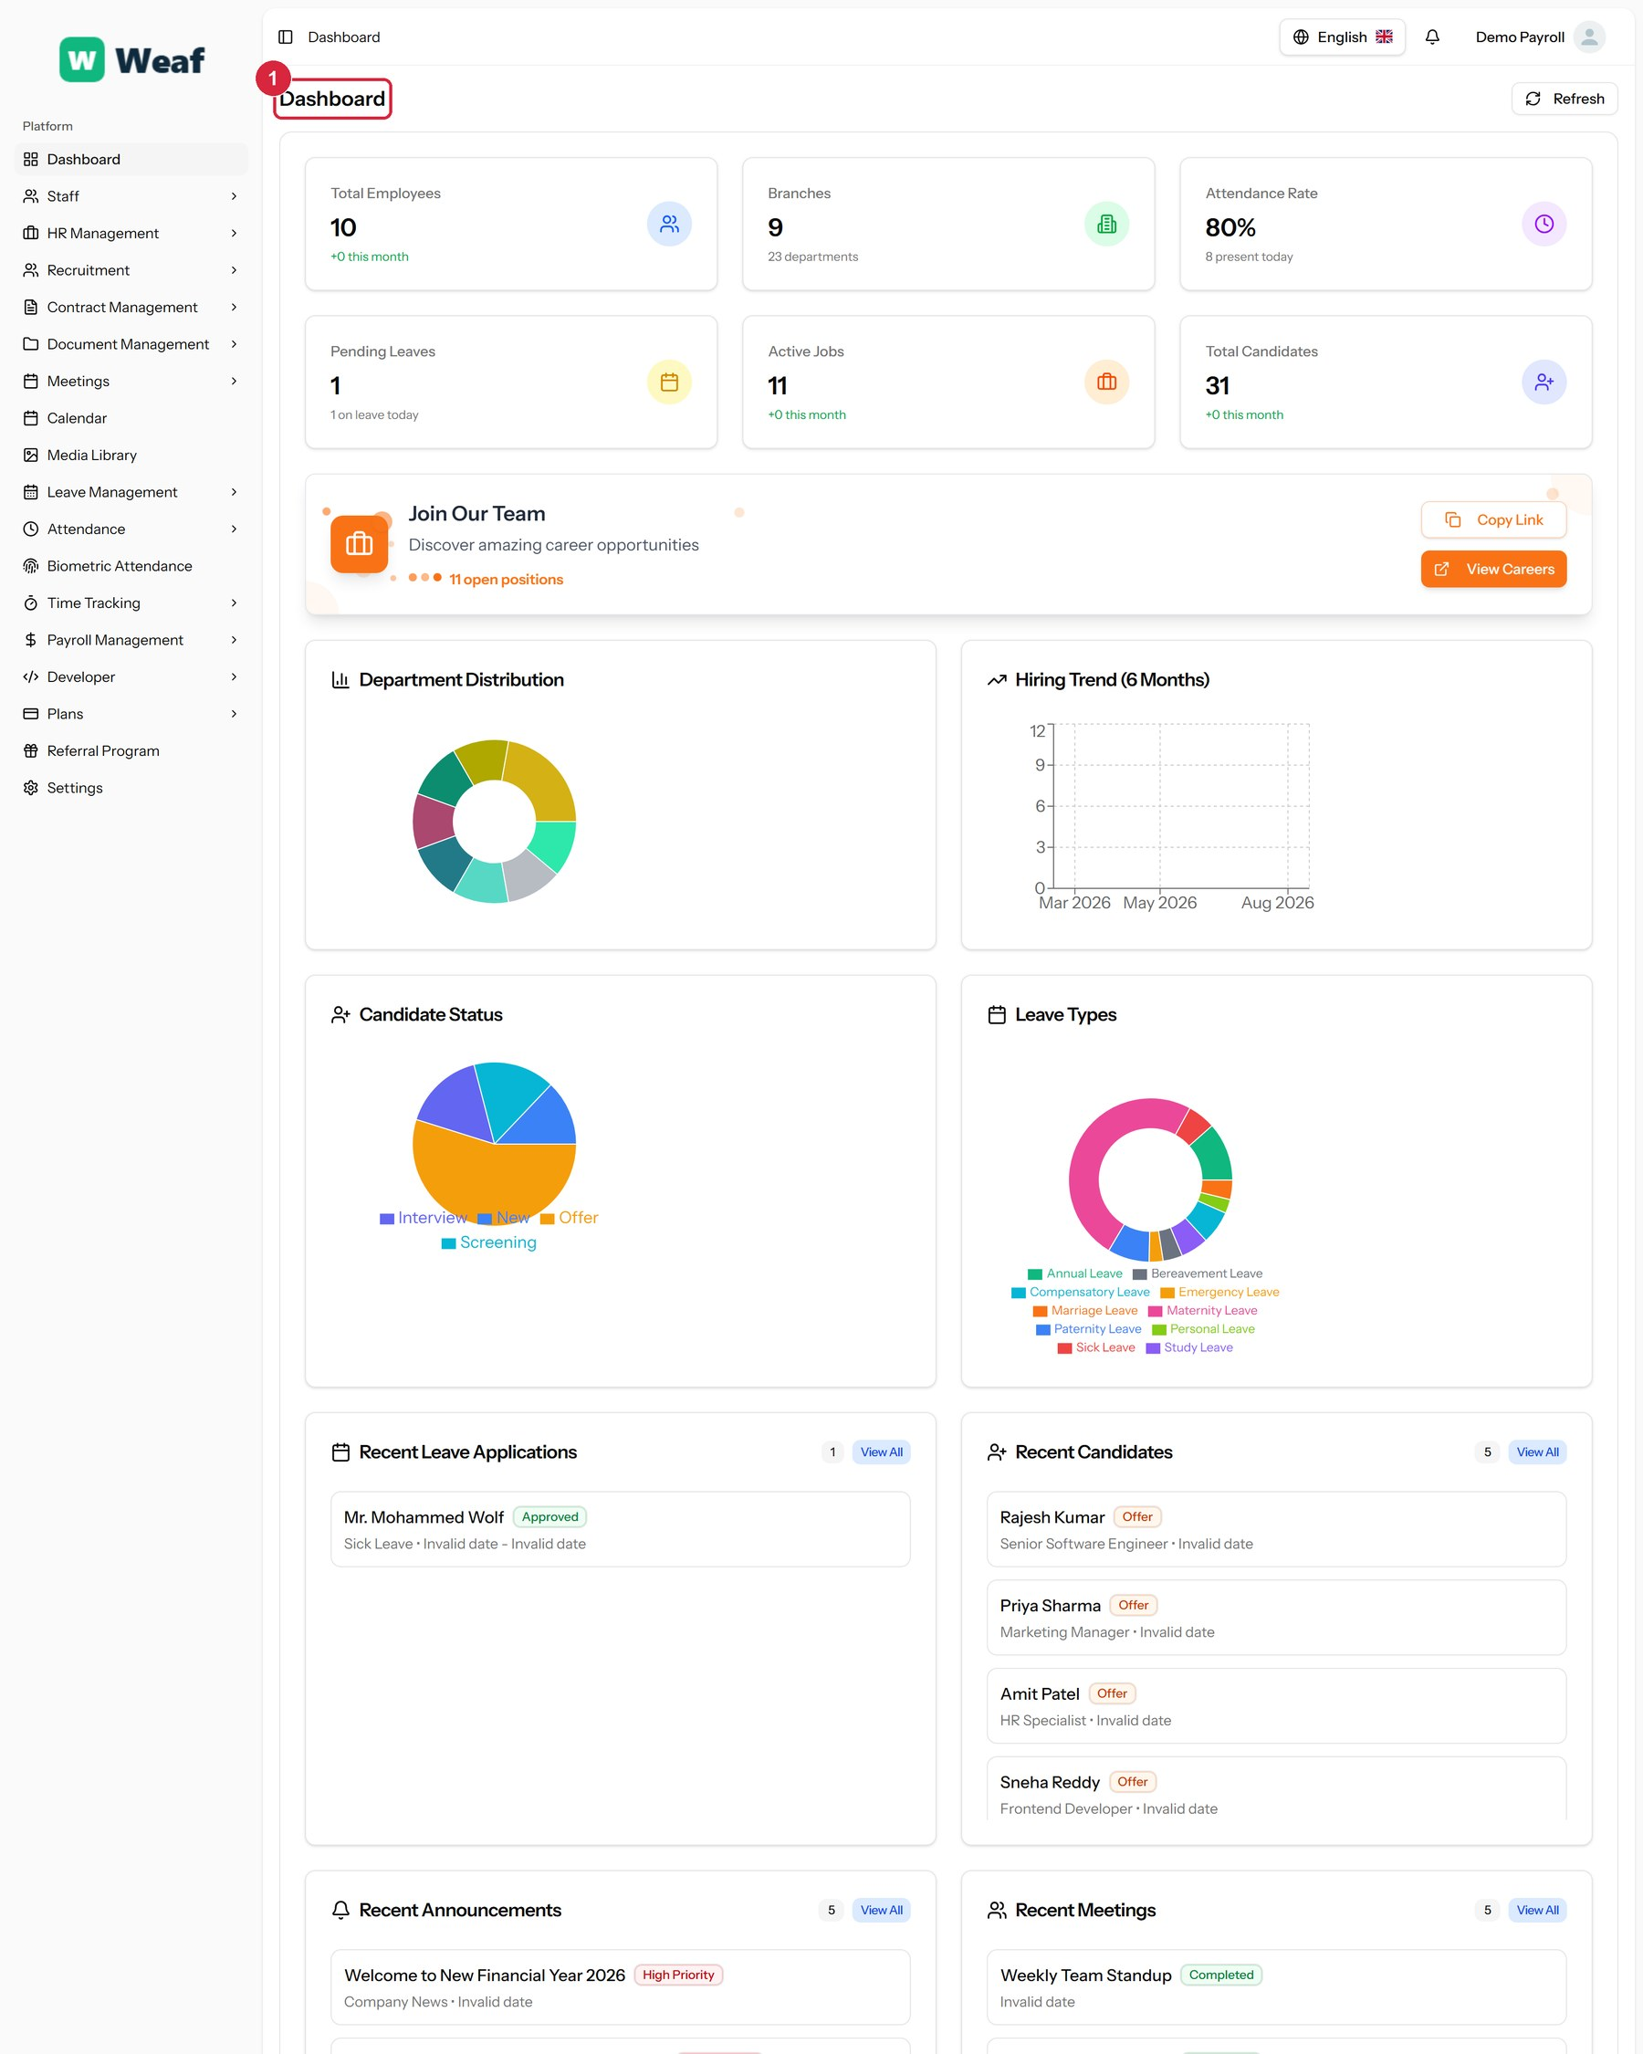
Figure 20: The dashboard
The counts are live. A figure that looks wrong here is usually a sign that records elsewhere are incomplete rather than that the dashboard is mistaken — an attendance rate below expectation, for instance, generally means attendance has not been recorded rather than that nobody came to work.

6.3 How every list page works
Most pages in Weaf HR list records of one kind and let you add, search, filter and edit them. They all share the same layout, shown below on the employee list.
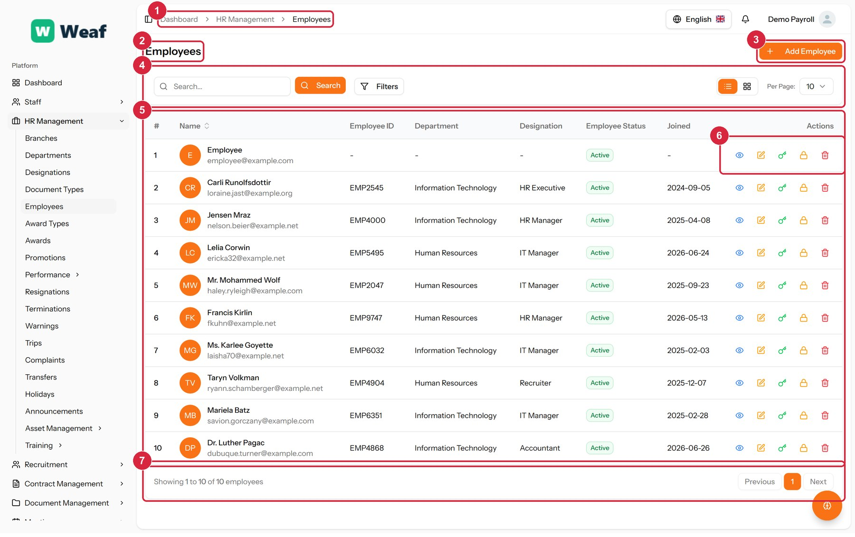
Figure 21: The anatomy of a list page, shown on Employees
1 Breadcrumb trail — which module and page you are in.
2 Page title — what this list holds.
3 Primary action — adds a new record. Always at the top right, always named after the record.
4 Rows per page — how many records to show at once.
5 Records table — the records themselves, one per row.
6 Row actions — what you can do to a single record — typically view, edit, and delete.
7 Paging — how many records there are, and the way to the rest.
From here on, this manual does not repeat these controls. Each page is shown with its title, its primary action and its table marked, and the text covers what is particular to that page.
Note: Row actions include deletion on most pages. Deleting a record that other records point at — a department with employees in it, for example — is refused or leaves those records incomplete. Prefer marking something inactive to deleting it.

Part III — Setting Up Your Organisation

7. Users, Roles and Access
Before anyone can use the system, they need a way in and a set of permissions. That is what this chapter covers.
Two ideas are easy to confuse and worth separating now. A user is a login — an email address and a password. An employee is an HR record — a person the company employs, with a salary, a department and a leave balance. Creating a user does not create an employee, and creating an employee does not automatically give that person a way to sign in.
Pages in this chapter: Users, Roles

7.1 Users
The people who can sign in. A user is a login; an employee is an HR record. They are related but separate — a cleaner with no computer access is an employee without a user, and an external auditor might be a user without being an employee.
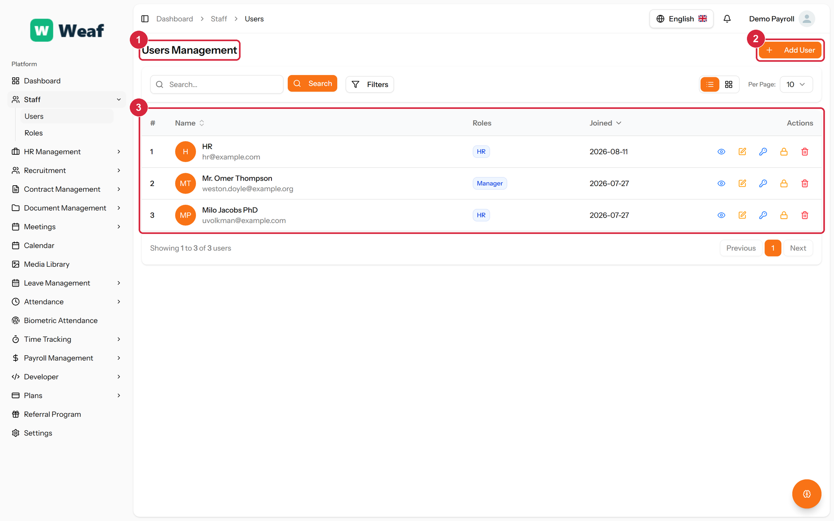
Figure 22: The Users page
1 page title · 2 primary action · 3 records table
Columns: #, Name, Roles, Joined, Actions
Actions on this page: Add User
1. Choose Add User at the top right. The form opens in a panel.
2. Complete the required fields: Name, Email, Password, Confirm Password.
3. Make the selections the form asks for: Role.
4. Choose Save. The new record appears in the list.
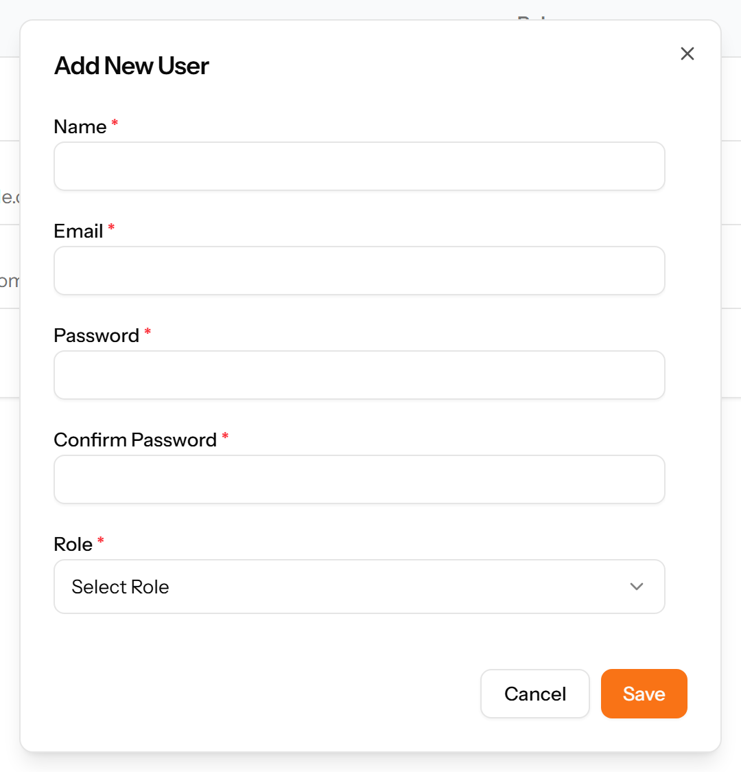
Figure 23: The Add User form
Note: Give each person their own login. Shared logins make every record that follows ambiguous — you can no longer tell who approved a leave request or changed a salary.

7.2 Roles
What a user is allowed to do. Permissions are attached to roles, not to people, so granting access means giving someone a role rather than ticking boxes for each individual.
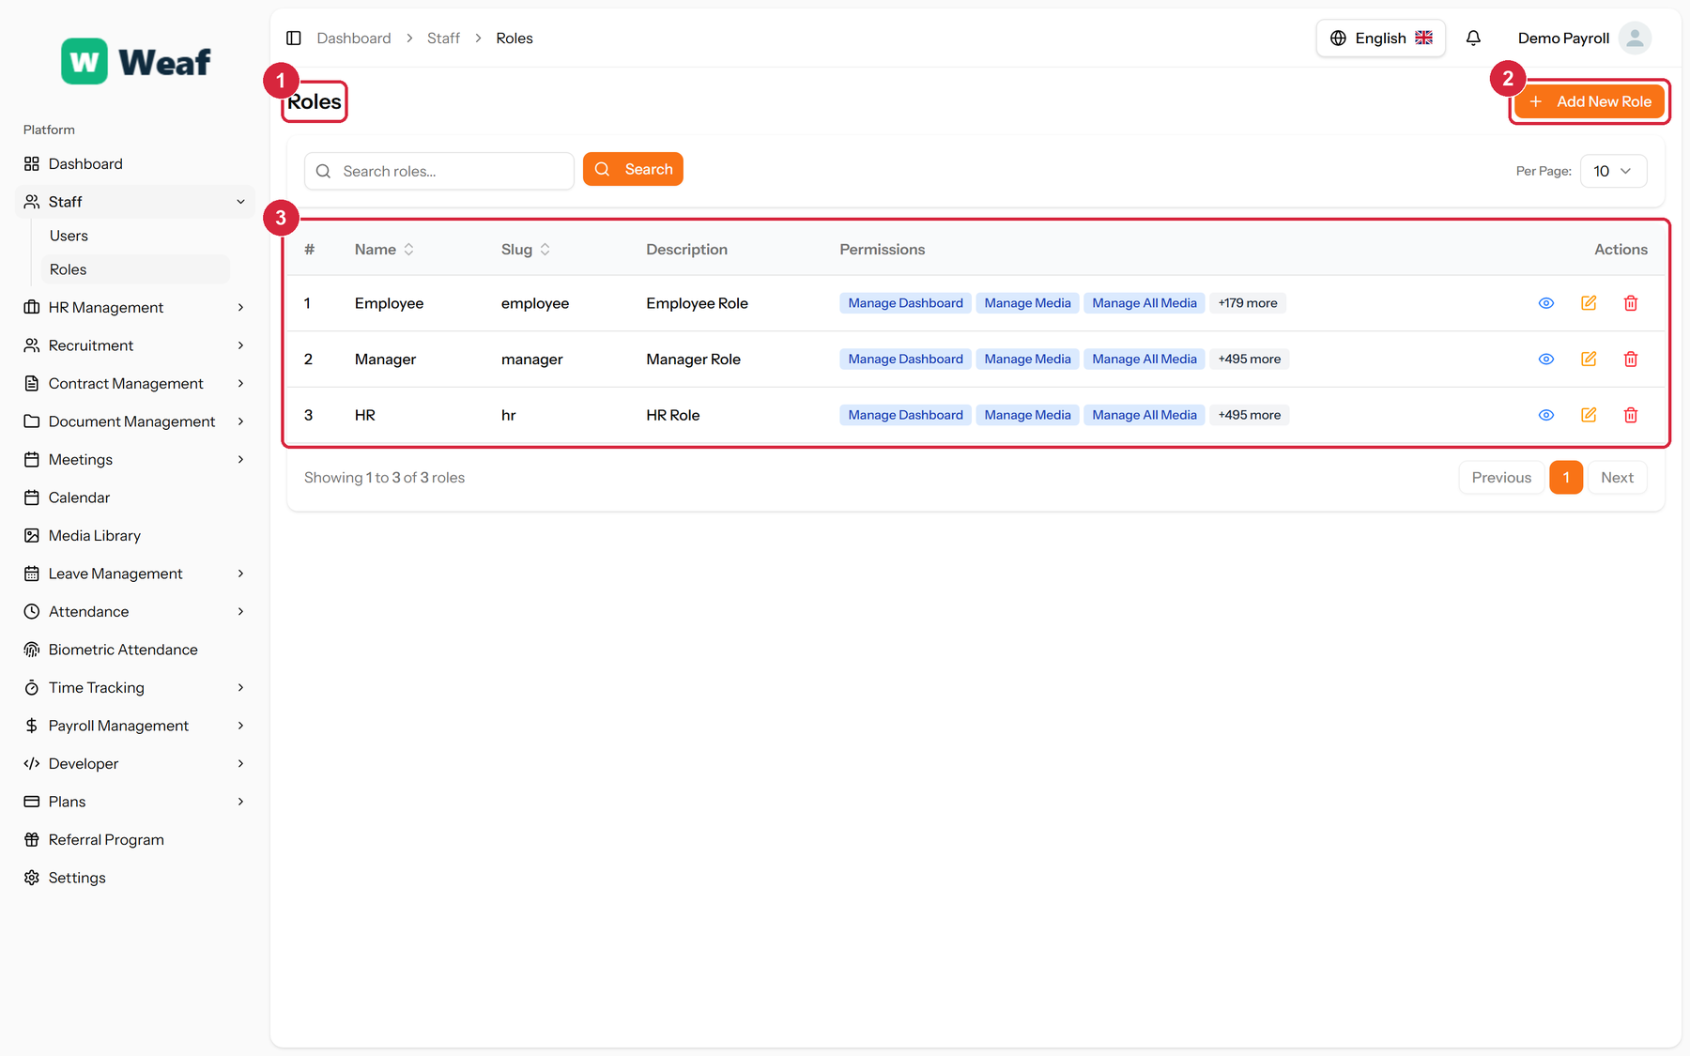
Figure 24: The Roles page
1 page title · 2 primary action · 3 records table
Columns: #, Name, Slug, Description, Permissions, Actions
Actions on this page: Add New Role
1. Choose Add New Role. The form opens in a panel.
2. Name the role after the job it describes — HR Officer, Payroll Clerk — rather than after the person who will hold it.
3. Work down the permission list and tick what the role may do. Permissions are grouped by module, and there is one for each action the system can perform.
4. Choose Save. The role can now be given to any number of users.
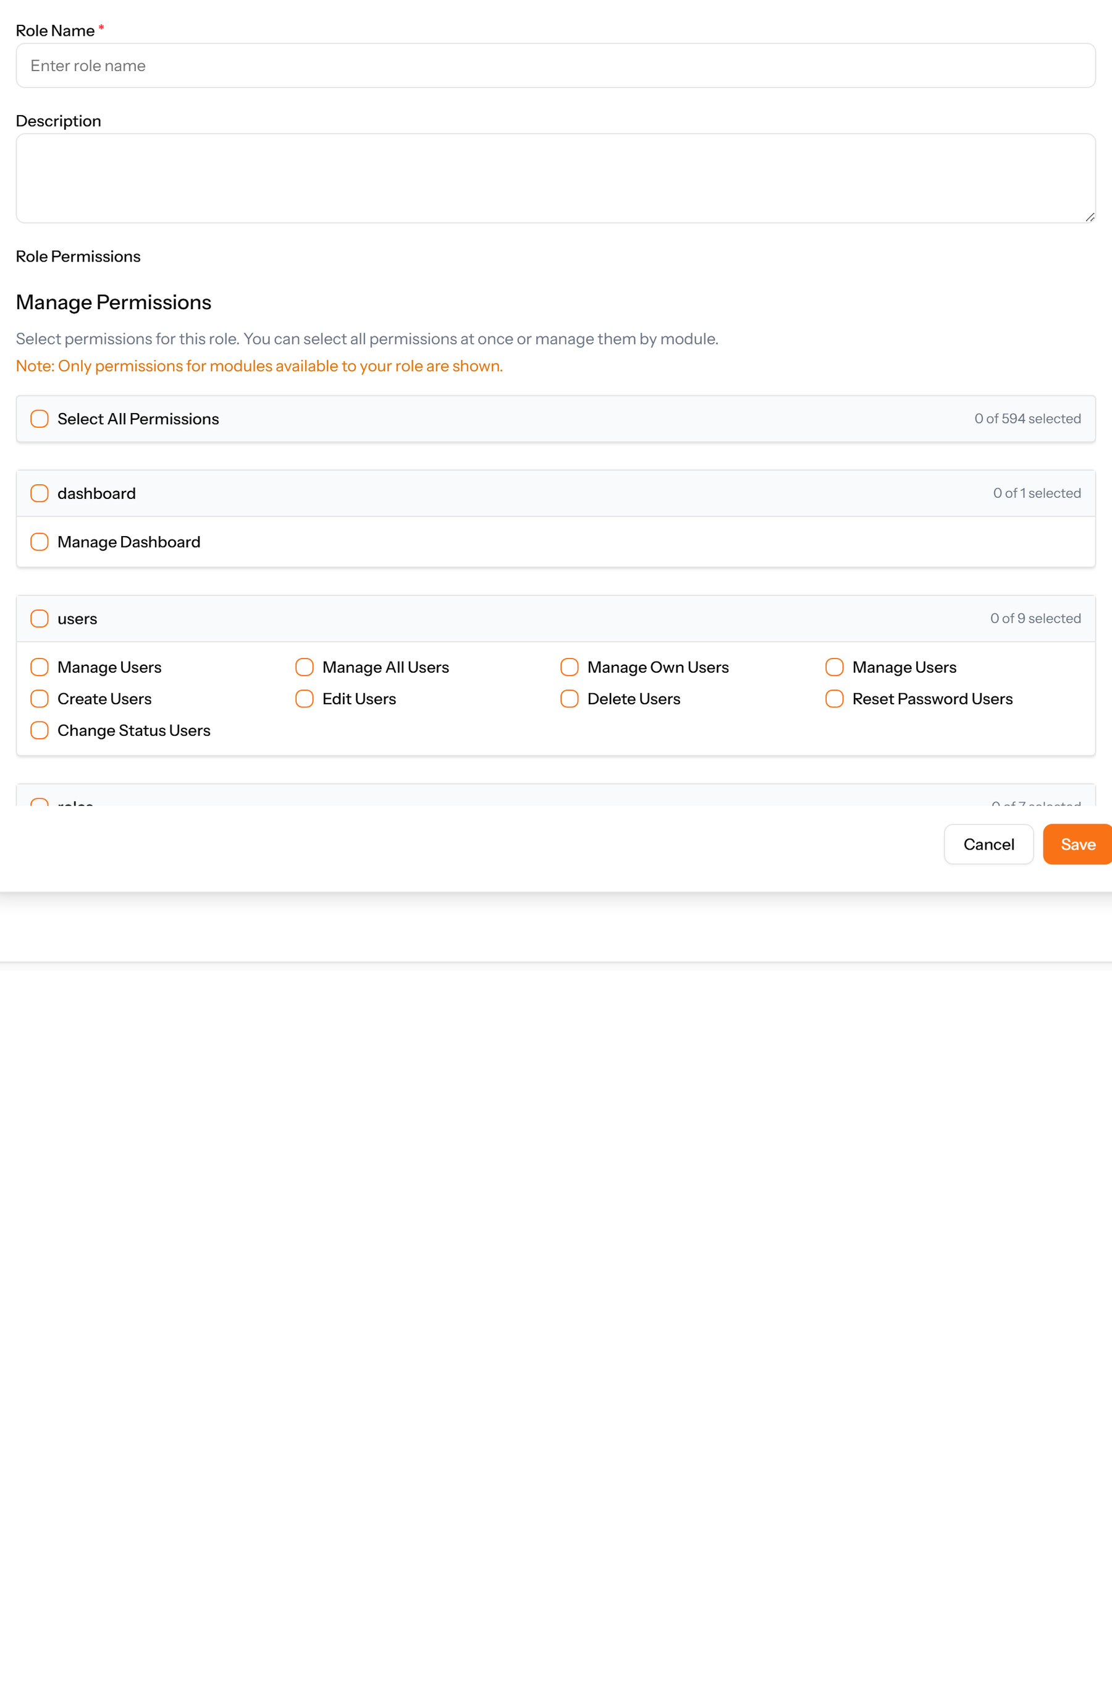
Figure 25: The Add New Role form

8. Company Structure
Everything else in the system hangs off the structure set up here, so it is worth getting right before employees are added.
The order matters. A department belongs to a branch, and a designation belongs to a department, so they are created in that order: branches, then departments, then designations. An employee record then places a person into all three at once.
Pages in this chapter: Branches, Departments, Designations, Document Types

8.1 Branches
The physical or legal locations your company operates from. Branches come first because departments, employees, holidays and attendance rules all hang off them.
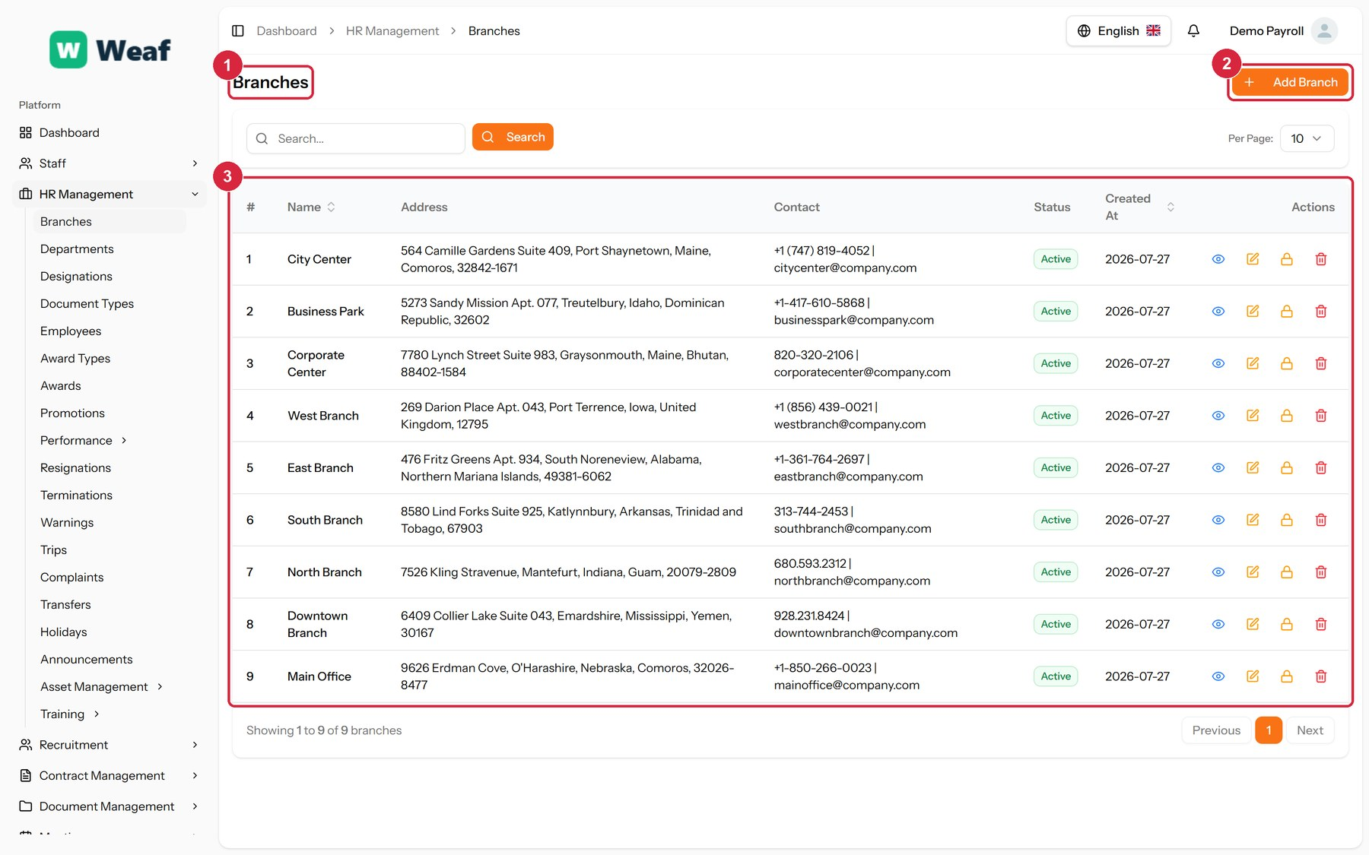
Figure 26: The Branches page
1 page title · 2 primary action · 3 records table
Columns: #, Name, Address, Contact, Status, Created At, Actions
Actions on this page: Add Branch
1. Choose Add Branch at the top right. The form opens in a panel.
2. Complete the required fields: Branch Name.
3. Fill in anything else that applies: Address, City, State/Province, Country, ZIP/Postal Code, Phone, Email.
4. Choose Save. The new record appears in the list.
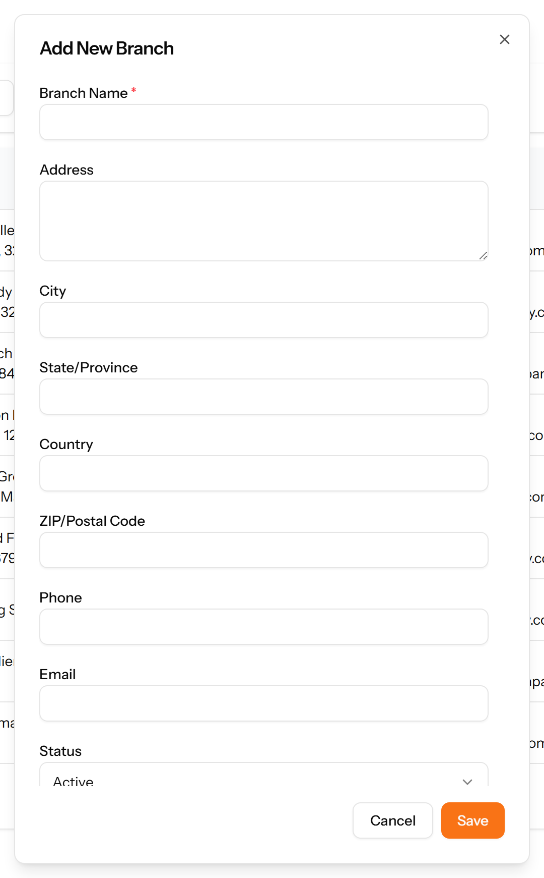
Figure 27: The Add Branch form
Note: Create branches before departments, and departments before designations. Each depends on the one before it.

8.2 Departments
Divisions within a branch — Finance, Human Resources, Information Technology. Each department belongs to a branch, which is why branches are set up first.
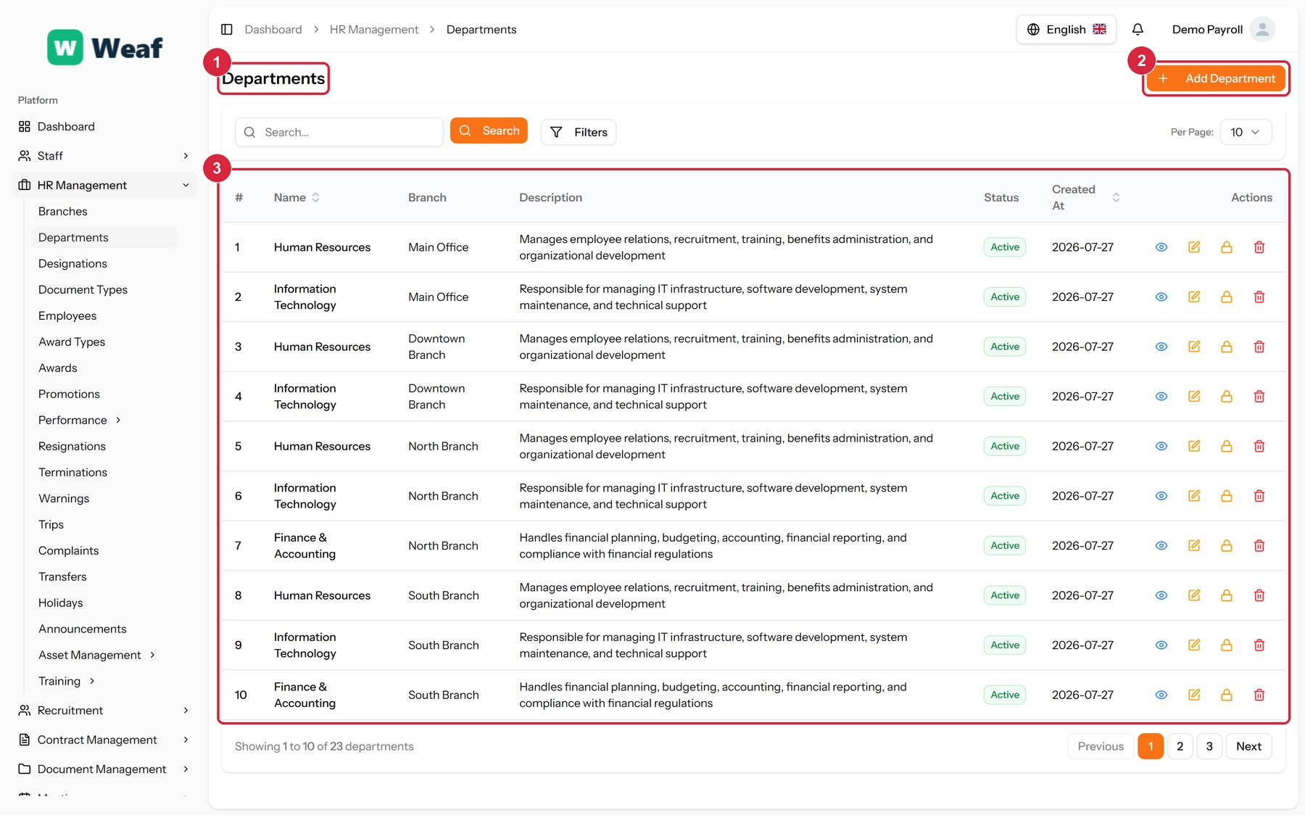
Figure 28: The Departments page
1 page title · 2 primary action · 3 records table
Columns: #, Name, Branch, Description, Status, Created At, Actions
Actions on this page: Add Department
1. Choose Add Department at the top right. The form opens in a panel.
2. Complete the required fields: Department Name.
3. Fill in anything else that applies: Description.
4. Make the selections the form asks for: Branch.
5. Choose Save. The new record appears in the list.
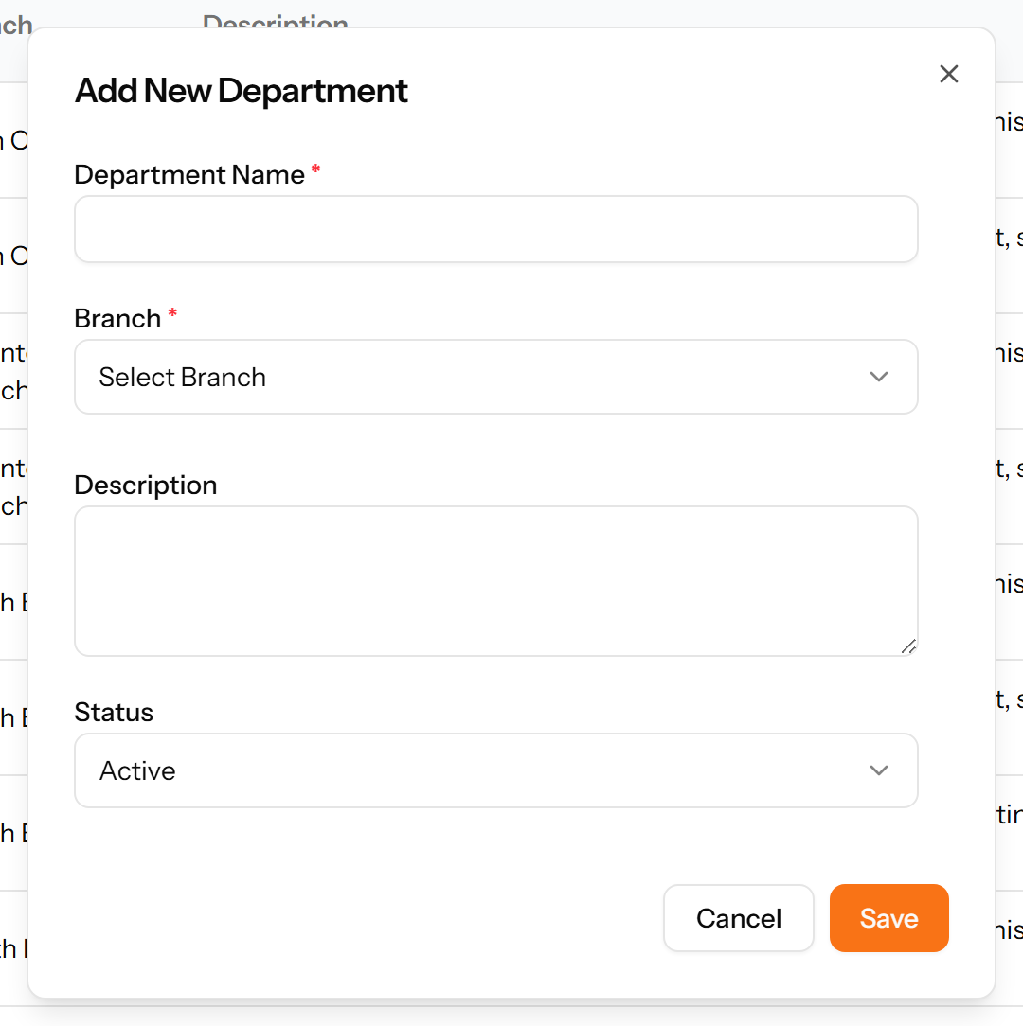
Figure 29: The Add Department form

8.3 Designations
Job titles within a department: HR Manager, IT Manager, Recruiter. A designation is the title an employee holds, distinct from the department they sit in.
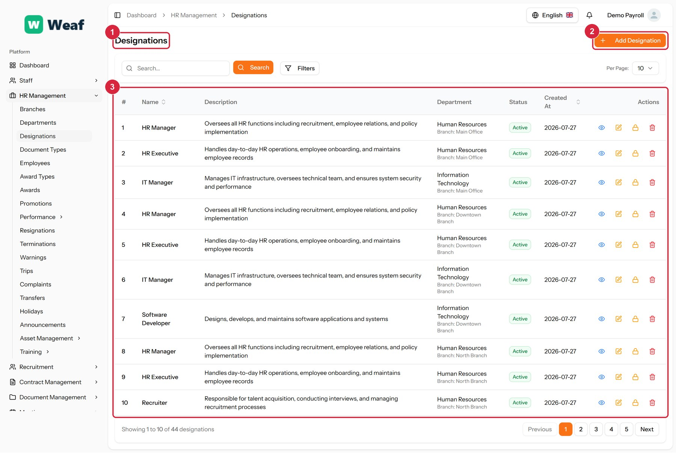
Figure 30: The Designations page
1 page title · 2 primary action · 3 records table
Columns: #, Name, Description, Department, Status, Created At, Actions
Actions on this page: Add Designation
1. Choose Add Designation at the top right. The form opens in a panel.
2. Complete the required fields: Designation Name.
3. Fill in anything else that applies: Description.
4. Make the selections the form asks for: Department.
5. Choose Save. The new record appears in the list.
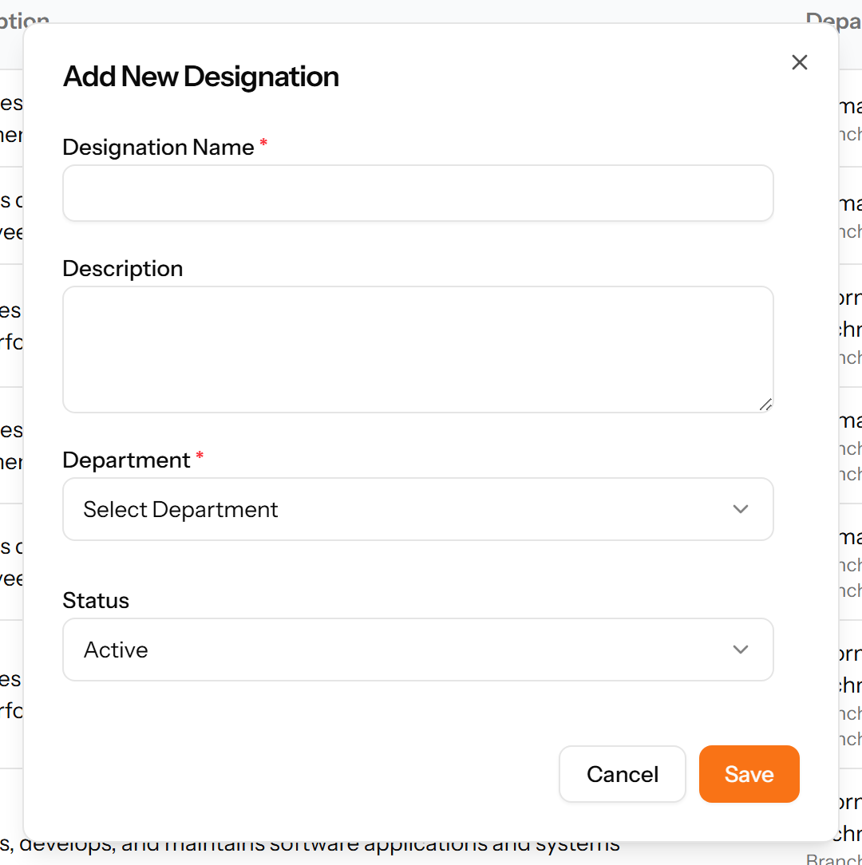
Figure 31: The Add Designation form

8.4 Document Types
The kinds of document an employee is expected to provide — contract, national ID, qualification. Marking a type as required makes its absence visible on the employee record.
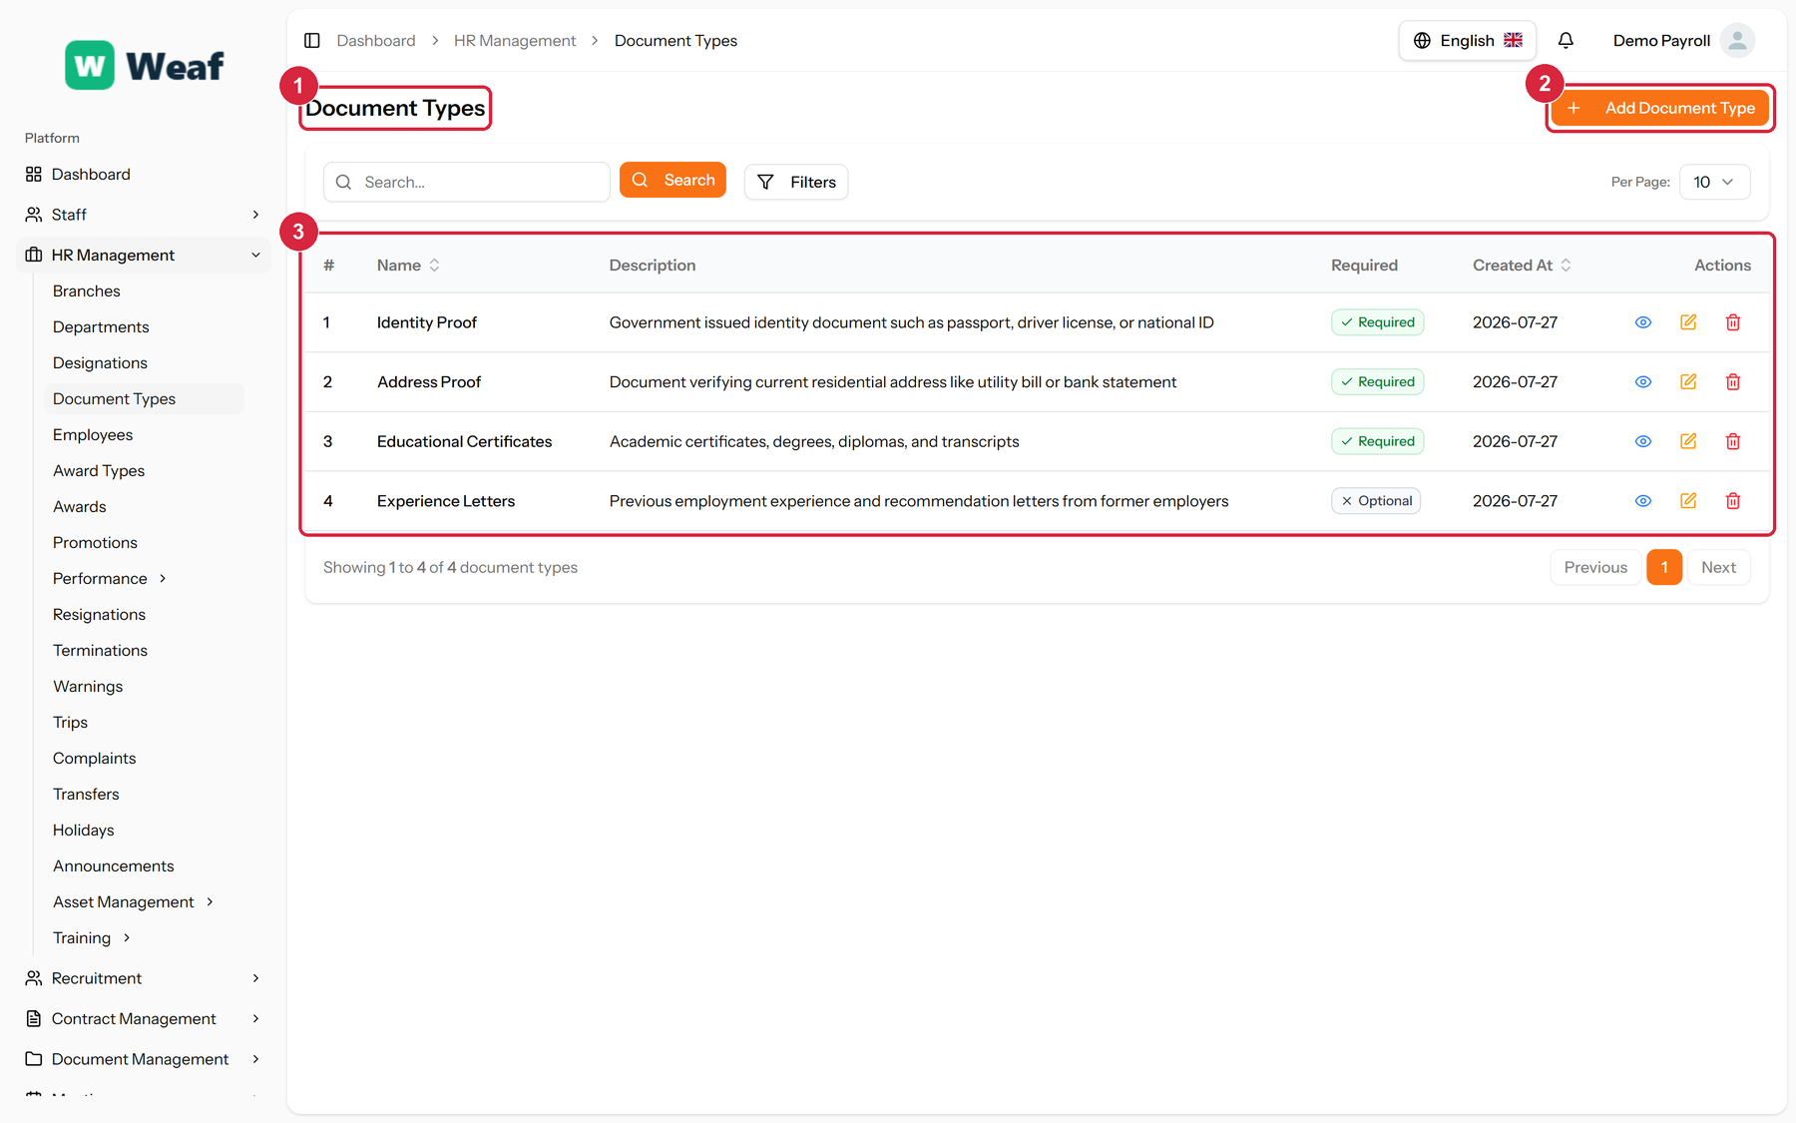
Figure 32: The Document Types page
1 page title · 2 primary action · 3 records table
Columns: #, Name, Description, Required, Created At, Actions
Actions on this page: Add Document Type
1. Choose Add Document Type at the top right. The form opens in a panel.
2. Complete the required fields: Document Type Name.
3. Fill in anything else that applies: Description, Required.
4. Choose Save. The new record appears in the list.
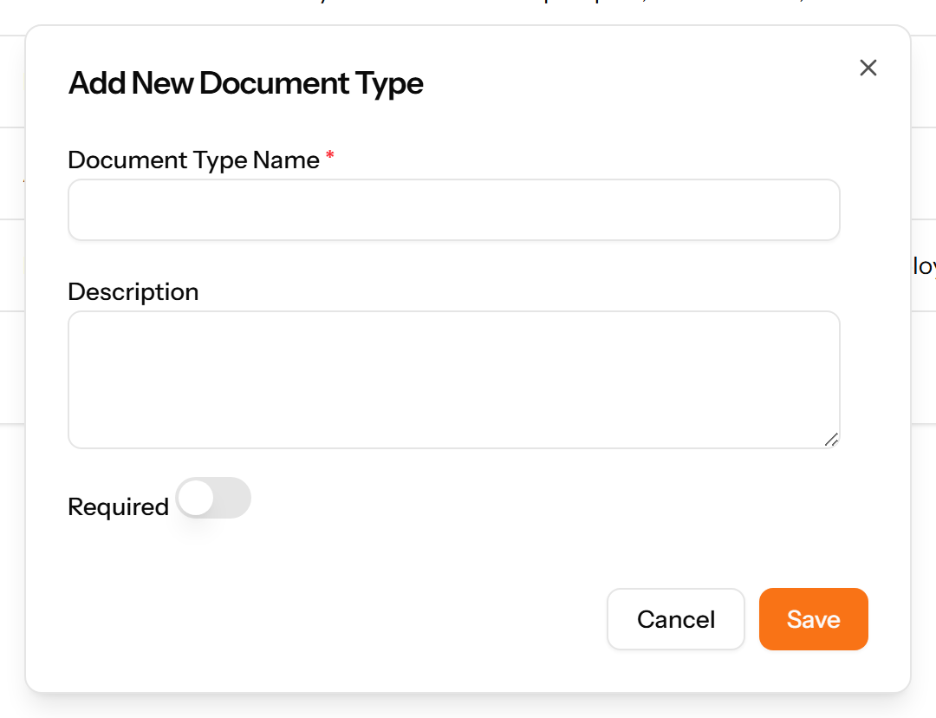
Figure 33: The Add Document Type form

9. Employees
The employee record is the centre of the system. Leave, attendance, payroll, appraisals, contracts and assets all point back to it, which is why this chapter sits before all of them.

9.1 Employees
The heart of the system: one record per person employed, holding their personal details, job placement, documents and salary. Almost every other module refers back to an employee record, so this is usually where a new implementation spends most of its setup time.
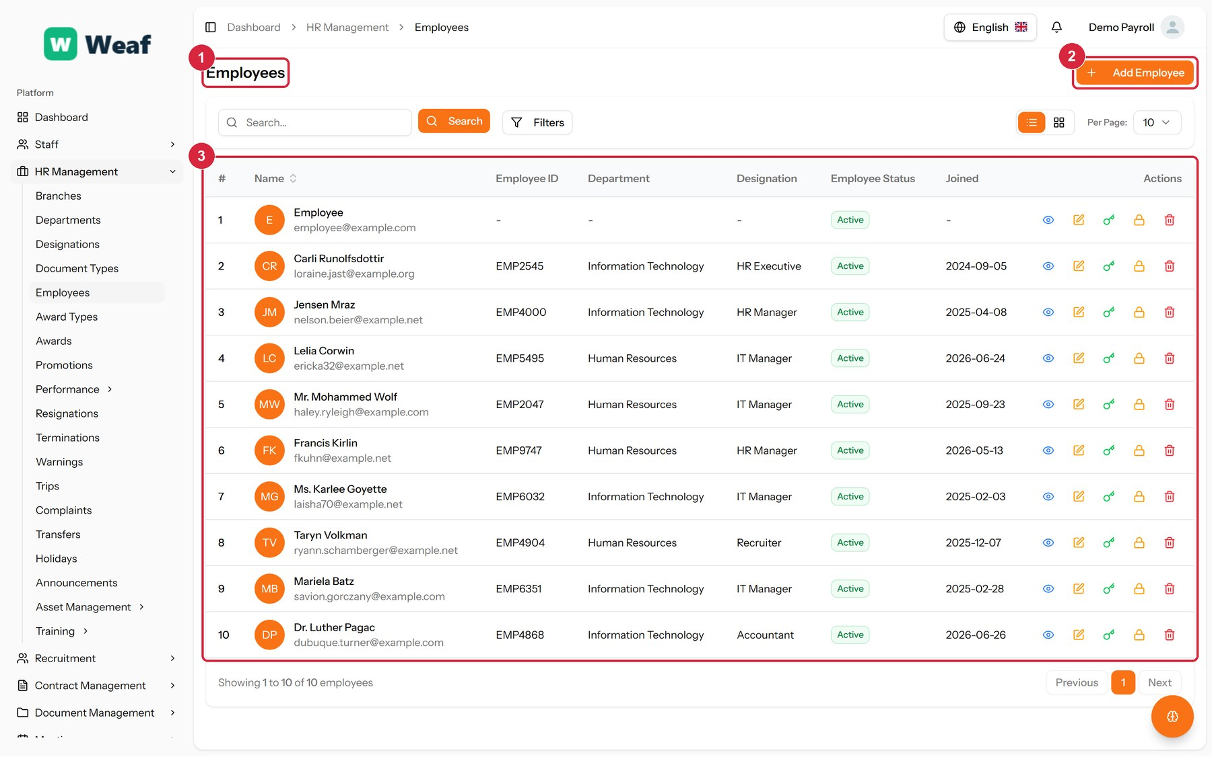
Figure 34: The Employees page
1 page title · 2 primary action · 3 records table
Columns: #, Name, Employee ID, Department, Designation, Employee Status, Joined, Actions
Actions on this page: Add Employee
1. Make sure the branch, department and designation this person will belong to already exist. The form offers them as choices; it does not create them.
2. Choose Add Employee. The form opens on its own page.
3. Complete the identity section: full name, employee code, email, password, phone, date of birth and date of joining.
4. Complete the address and emergency contact sections.
5. Complete the bank section — bank name, account holder, account number, BIC/SWIFT and branch — which payroll needs before this person can be paid.
6. Enter the base salary, then select the branch, department, designation and, if you use them, the shift and attendance policy.
7. Save. The employee appears in the list and can now be referenced everywhere else in the system.
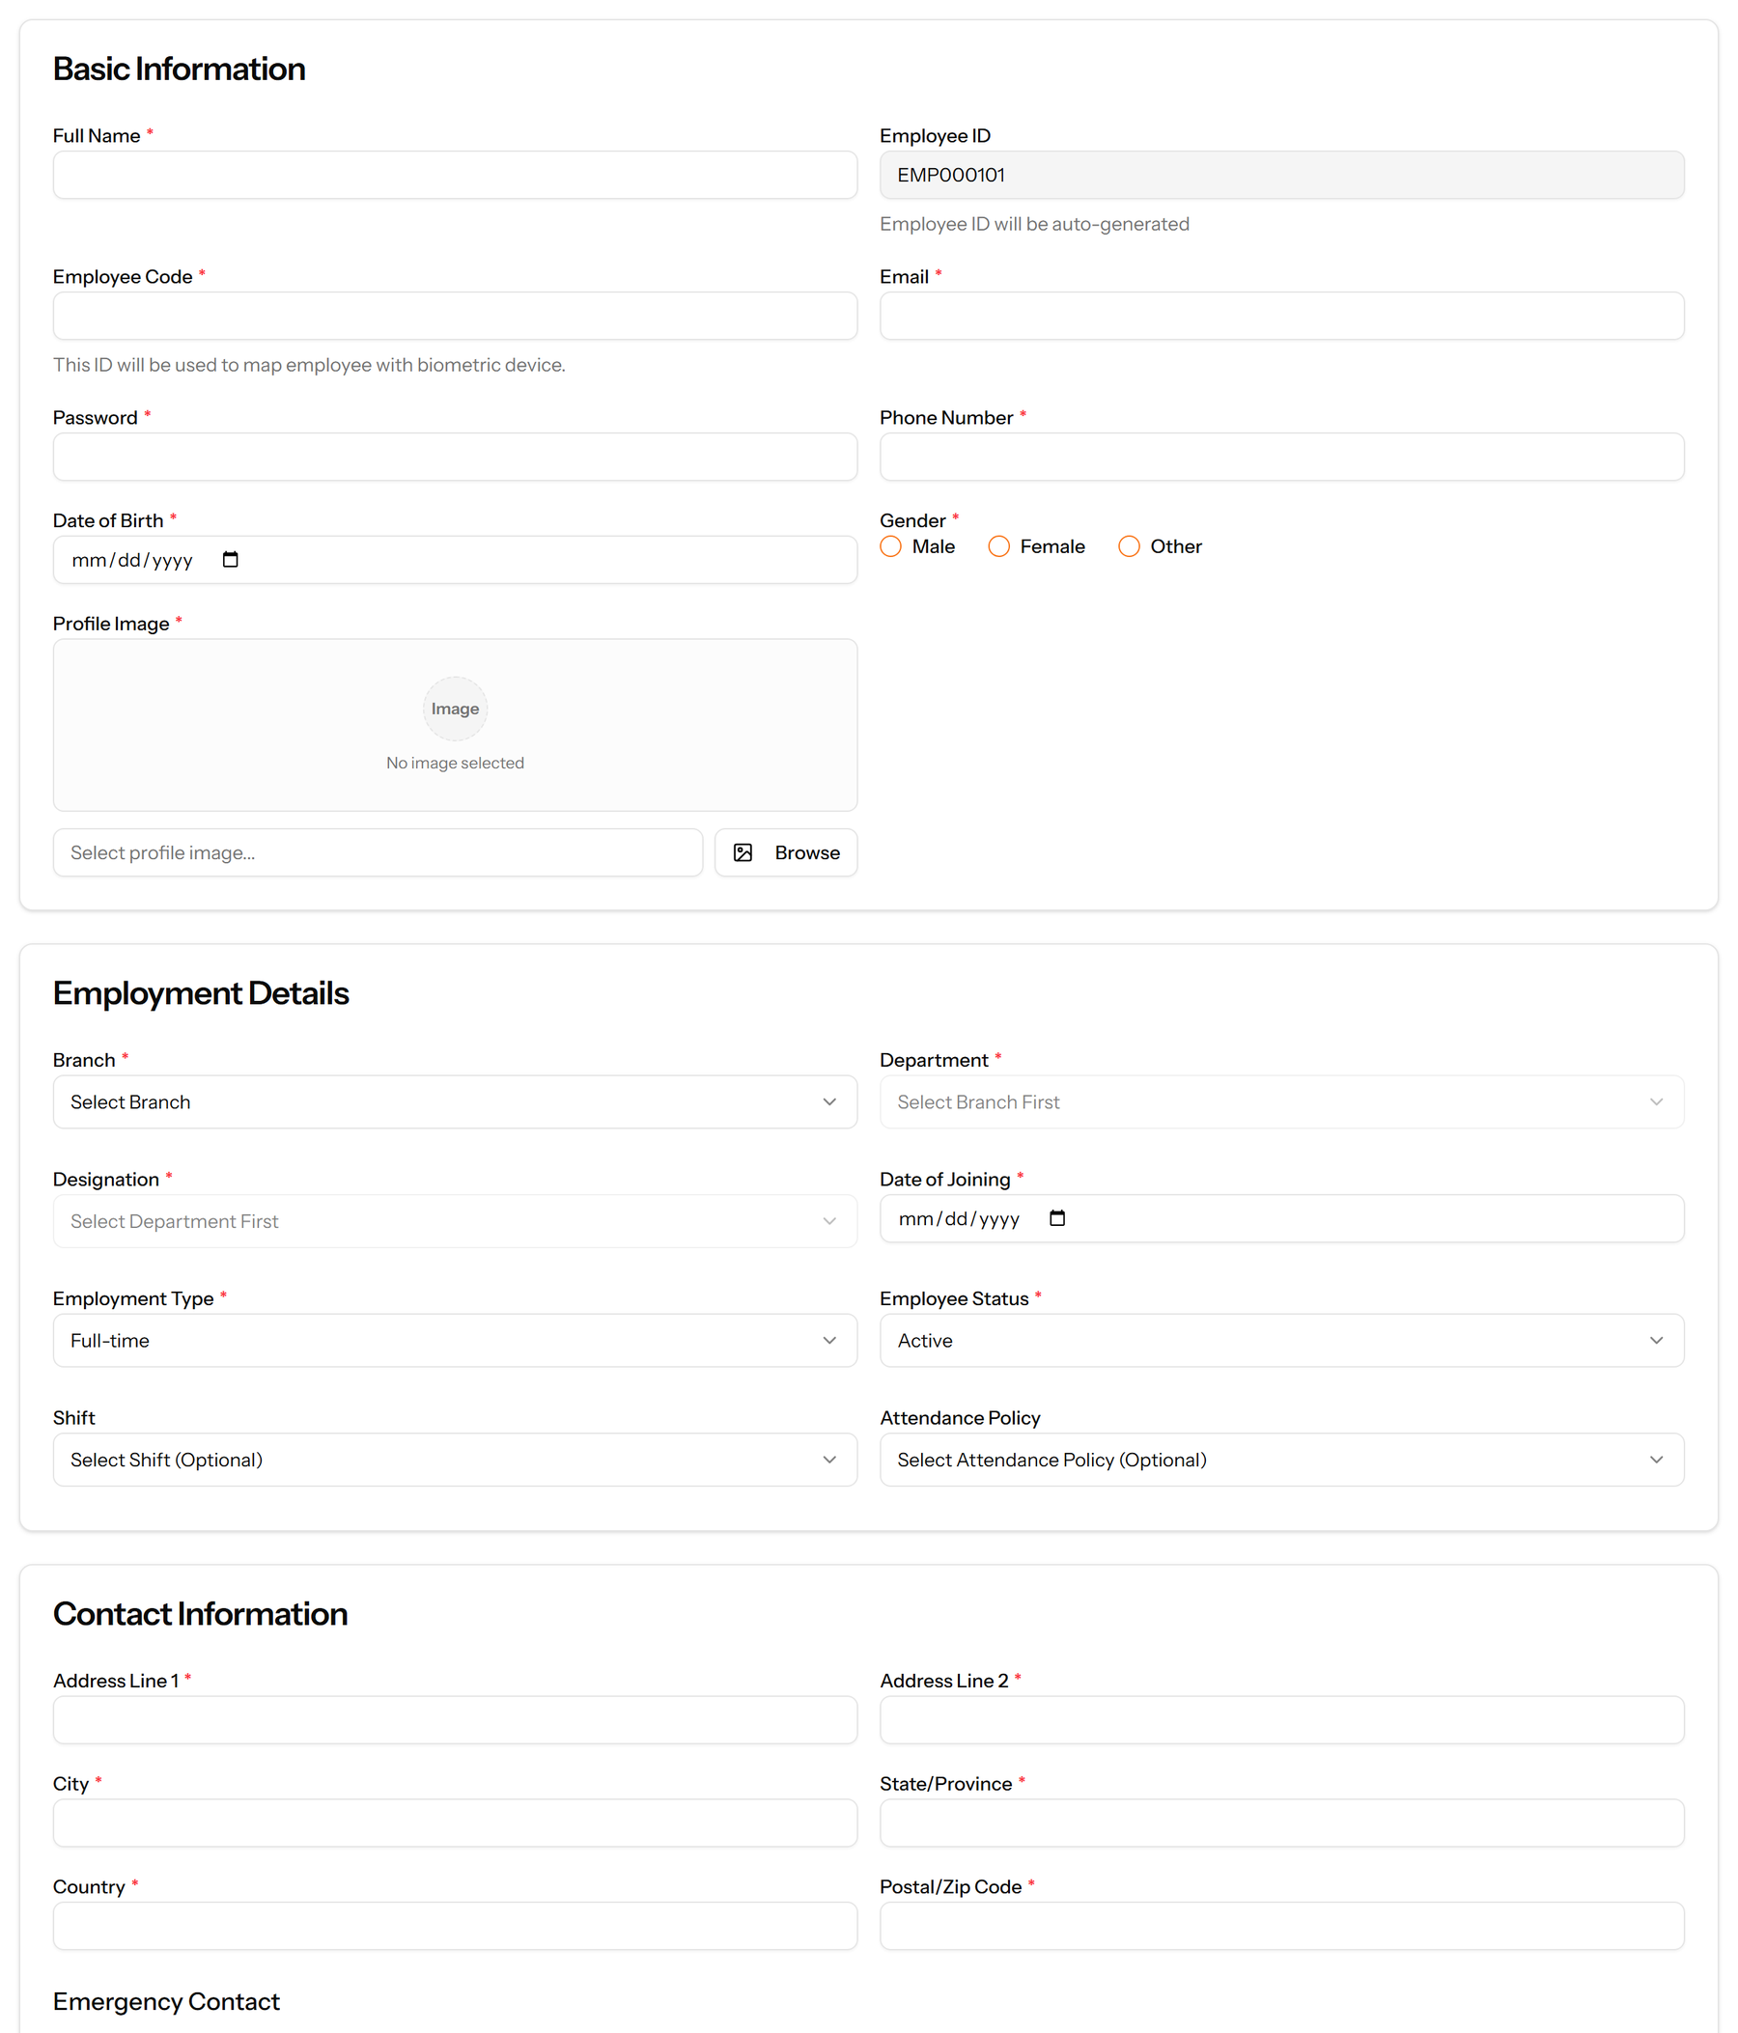
Figure 35: The Add Employee form

Part IV — Running HR Day to Day

10. Leave Management
Leave is set up in three layers and then used in one. You define the kinds of leave, attach a policy to each that says how it behaves, and from then on staff apply and the balances follow.
The layer most often missed is the policy. A leave type with no active policy cannot be applied for, which is the usual explanation when a leave type does not appear in the application form.
Pages in this chapter: Leave Types, Leave Policies, Leave Applications, Leave Balances

10.1 Leave Types
The kinds of leave your company grants — annual, sick, maternity — and the maximum days a year each allows.
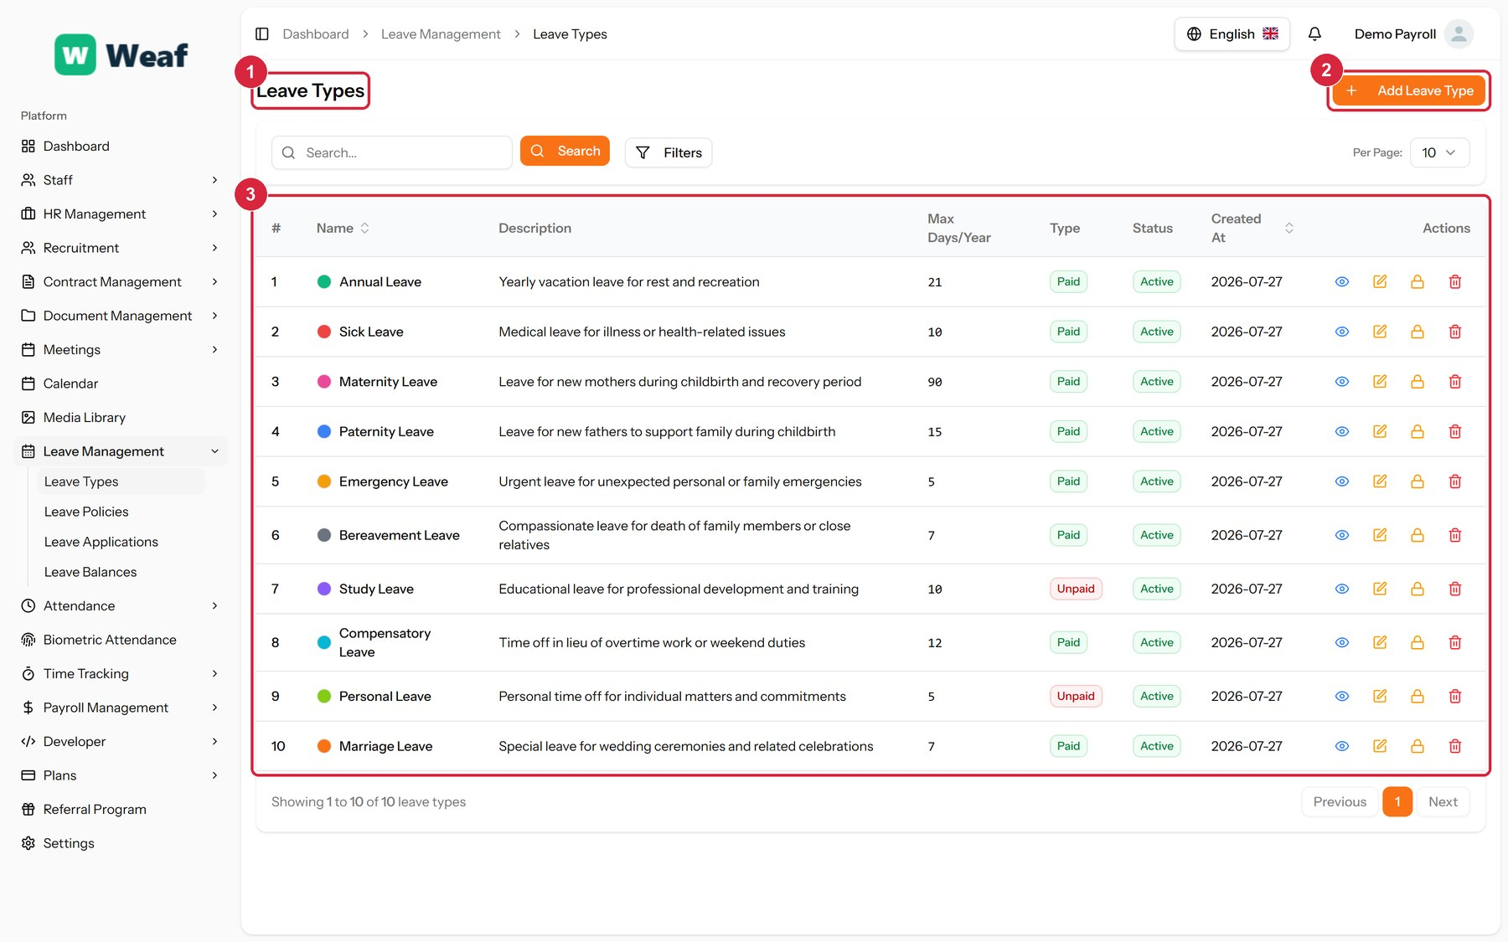
Figure 36: The Leave Types page
1 page title · 2 primary action · 3 records table
Columns: #, Name, Description, Max Days/Year, Type, Status, Created At, Actions
Actions on this page: Add Leave Type
1. Choose Add Leave Type at the top right. The form opens in a panel.
2. Complete the required fields: Leave Type Name, Maximum Days Per Year, Color.
3. Fill in anything else that applies: Description, Is Paid.
4. Choose Save. The new record appears in the list.
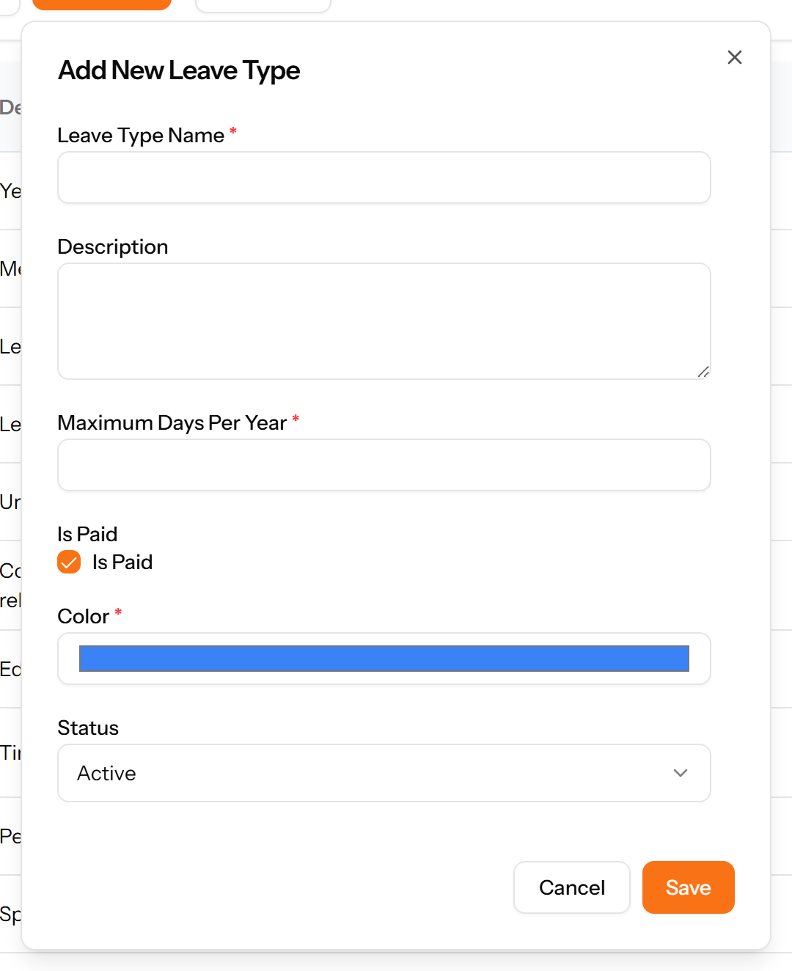
Figure 37: The Add Leave Type form

10.2 Leave Policies
The rules applied to a leave type: how entitlement accrues, whether unused days carry forward, and whether applications need approval. A leave type without an active policy cannot be applied for.
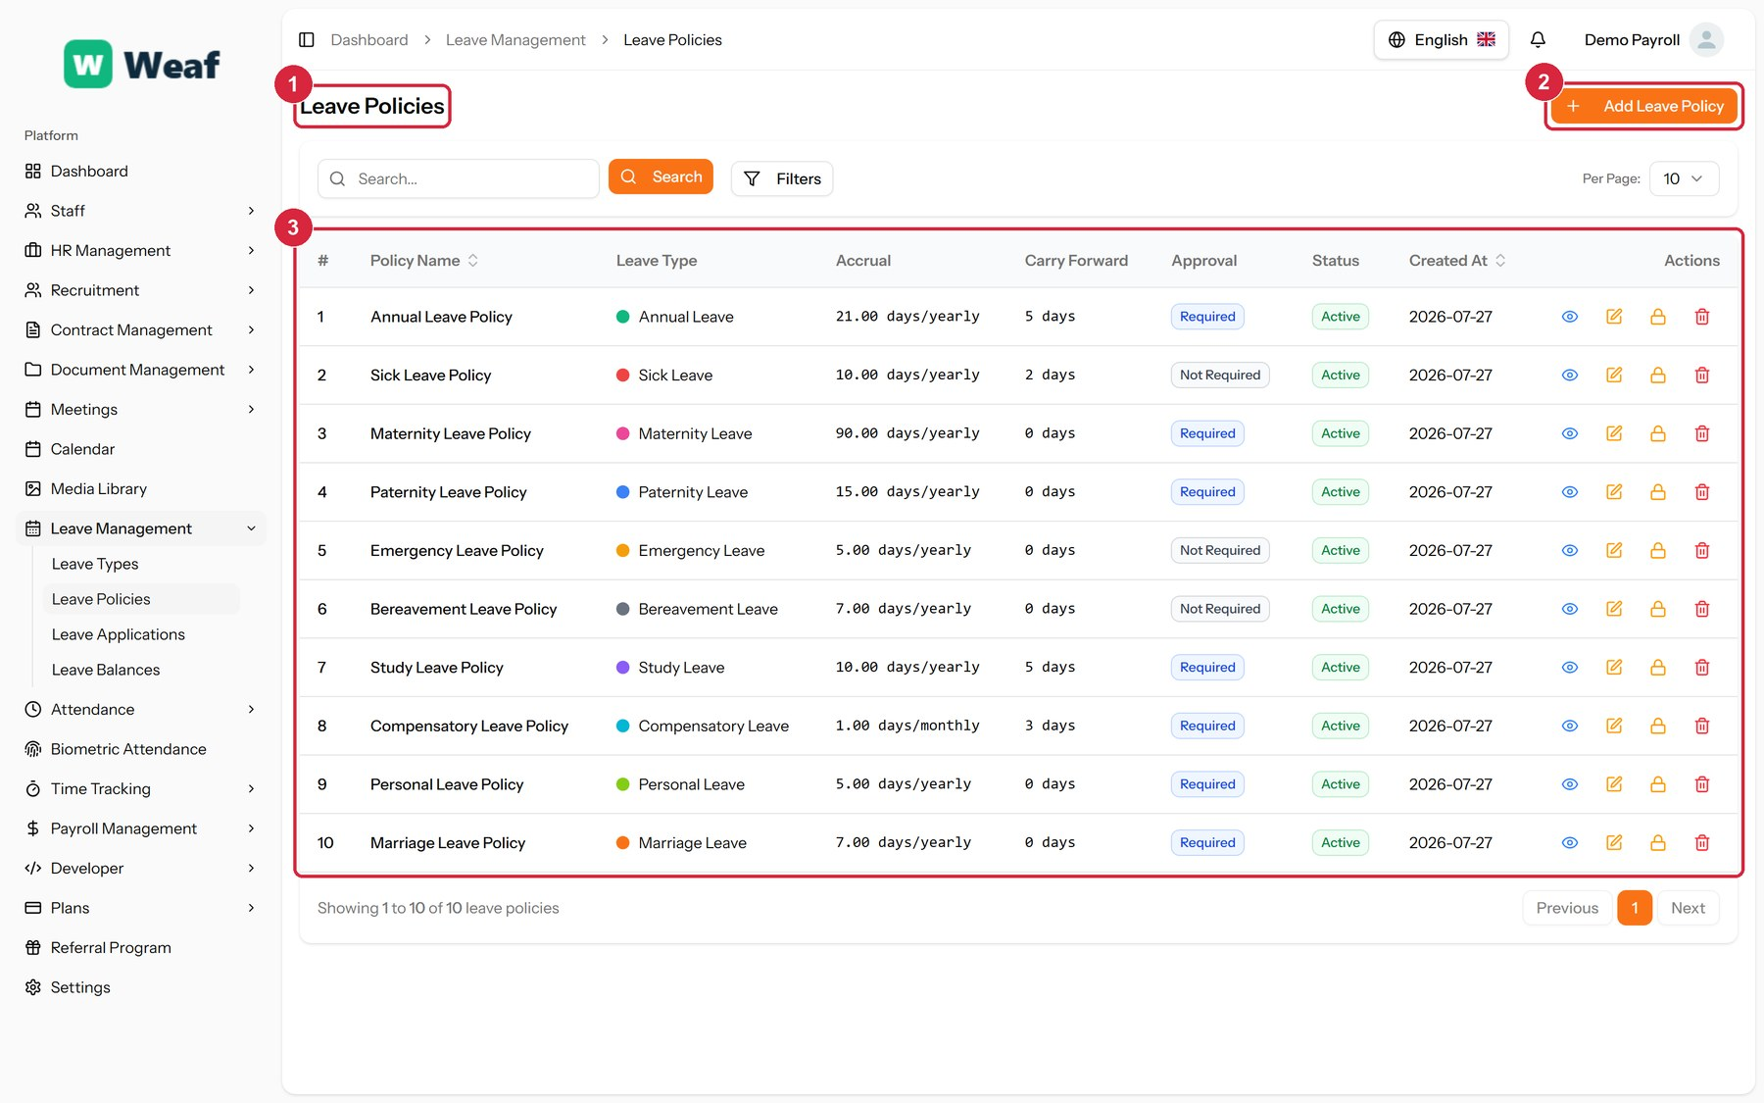
Figure 38: The Leave Policies page
1 page title · 2 primary action · 3 records table
Columns: #, Policy Name, Leave Type, Accrual, Carry Forward, Approval, Status, Created At, Actions
Actions on this page: Add Leave Policy
1. Choose Add Leave Policy at the top right. The form opens in a panel.
2. Complete the required fields: Policy Name, Accrual Rate (Days), Carry Forward Limit (Days), Min Days Per Application, Max Days Per Application.
3. Fill in anything else that applies: Description, Carried Days Expire, Expire After (Months Into New Year), Requires Approval.
4. Make the selections the form asks for: Leave Type, Accrual Type.
5. Choose Save. The new record appears in the list.
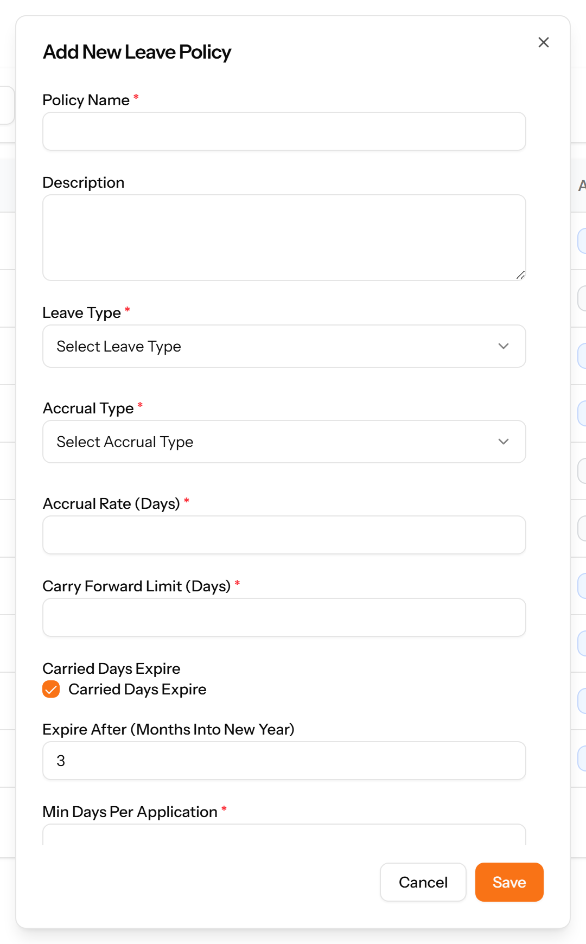
Figure 39: The Add Leave Policy form
Note: A leave type with no active policy cannot be applied for. If a type is missing from the leave application form, this is almost always why.

10.3 Leave Applications
Requests to take leave, with their dates, the number of days and their approval status. This is the page most staff interact with.
Figure 40: The Leave Applications page
1 page title · 2 primary action · 3 records table
Columns: #, Employee, Leave Type, Start Date, End Date, Days, Status, Applied On, Actions
Actions on this page: Add Leave Application
1. Choose Add Leave Application at the top right. The form opens in a panel.
2. Complete the required fields: Start Date, End Date, Reason.
3. Fill in anything else that applies: Select attachment file....
4. Make the selections the form asks for: Employee, Leave Type.
5. Choose Save. The new record appears in the list.
Figure 41: The Add Leave Application form

10.4 Leave Balances
What each employee has been allocated, used and has left, by leave type and year.
Figure 42: The Leave Balances page
1 page title · 2 primary action · 3 records table
Columns: #, Employee, Leave Type, Year, Allocated, Used, Remaining, Carried Forward, Adjustment, Actions
Actions on this page: Add Leave Balance
1. Choose Add Leave Balance at the top right. The form opens in a panel.
2. Complete the required fields: Year, Allocated Days.
3. Fill in anything else that applies: Carried Forward Days, Manual Adjustment, Adjustment Reason.
4. Make the selections the form asks for: Employee, Leave Type.
5. Choose Save. The new record appears in the list.
Figure 43: The Add Leave Balance form
Note: Balances follow from the policy and from approved applications. They are not edited directly, which is what keeps them reconcilable.

11. Attendance and Time
Attendance answers whether someone was at work. Shifts say what their day should look like, policies say how lateness and overtime are treated, records hold what actually happened, and regularisations are how a wrong record gets corrected.
Time tracking is a separate question — not whether someone was present, but what they spent the day on.
Pages in this chapter: Shifts, Attendance Policies, Attendance Records, Attendance Regularizations, Biometric Attendance, Time Entries

11.1 Shifts
Working patterns: start and end times, break length, the resulting working hours, and the grace period before a late arrival counts as late.
Figure 44: The Shifts page
1 page title · 2 primary action · 3 records table
Columns: #, Shift Name, Start Time, End Time, Break (mins), Working Hours, Grace (mins), Type, Status, Actions
Actions on this page: Add Shift
1. Choose Add Shift at the top right. The form opens in a panel.
2. Complete the required fields: Shift Name, Start Time, End Time, Break Duration (minutes), Grace Period (minutes).
3. Fill in anything else that applies: Description, Break Start Time, Break End Time, Night Shift.
4. Choose Save. The new record appears in the list.
Figure 45: The Add Shift form

11.2 Attendance Policies
How lateness, early departure and overtime are treated. Set once, applied to everyone the policy covers.
Figure 46: The Attendance Policies page
1 page title · 2 primary action · 3 records table
Columns: #, Policy Name, Late Grace (mins), Early Grace (mins), Overtime Rate, Status, Actions
Actions on this page: Add Attendance Policy
1. Choose Add Attendance Policy at the top right. The form opens in a panel.
2. Complete the required fields: Policy Name, Late Arrival Grace (minutes), Early Departure Grace (minutes), Overtime Rate Per Hour.
3. Fill in anything else that applies: Description.
4. Choose Save. The new record appears in the list.
Figure 47: The Add Attendance Policy form

11.3 Attendance Records
Daily attendance per employee: the shift they were on, when they clocked in and out and the hours that produced.
Figure 48: The Attendance Records page
1 page title · 2 primary action · 3 records table
Columns: #, Employee, Date, Shift, Clock In, Clock Out, Total Hours, Overtime, Status, Actions
Actions on this page: Add Record, ...
1. Choose Add Record at the top right. The form opens in a panel.
2. Complete the required fields: Date.
3. Fill in anything else that applies: Clock In Time, Clock Out Time, Break Hours, Holiday, Notes.
4. Make the selections the form asks for: Employee, Status.
5. Choose Save. The new record appears in the list.
Figure 49: The Add Record form

11.4 Attendance Regularizations
Corrections to attendance. When a clock-in is missing or wrong, the employee requests a change, the original and requested times are shown side by side, and a manager decides — so records are corrected with an audit trail rather than quietly edited.
Figure 50: The Attendance Regularizations page
1 page title · 2 primary action · 3 records table
Columns: #, Employee, Date, Original Times, Requested Times, Reason, Status, Requested On, Actions
Actions on this page: Add Request
1. Choose Add Request at the top right. The form opens in a panel.
2. Complete the required fields: Reason.
3. Fill in anything else that applies: Employee, Attendance Record, Requested Clock In, Requested Clock Out.
4. Choose Save. The new record appears in the list.
Figure 51: The Add Request form
Note: Correcting attendance through a regularisation keeps the original reading alongside the correction. Editing the record directly would lose that.

11.5 Biometric Attendance
Attendance collected from fingerprint or face devices, and the configuration that connects those devices to the system.
Figure 52: The Biometric Attendance page
1 page title

11.6 Time Entries
Hours booked against projects, as distinct from attendance. Attendance answers “were they at work?”; time entries answer “what were they working on?”
Figure 53: The Time Entries page
1 page title · 2 primary action · 3 records table
Columns: #, Employee, Date, Hours, Project, Description, Status, Submitted On, Actions
Actions on this page: Add Time Entry, ...
1. Choose Add Time Entry at the top right. The form opens in a panel.
2. Complete the required fields: Date, Hours, Description.
3. Fill in anything else that applies: Project.
4. Make the selections the form asks for: Employee.
5. Choose Save. The new record appears in the list.
Figure 54: The Add Time Entry form

12. Payroll
Payroll is built from the bottom up: components describe the parts of a pay packet, each employee is given a salary structure made of those components, and a payroll run applies the whole thing to a period and produces payslips.
An employee with no salary structure is skipped by a payroll run. If someone is missing from a run, that is the first thing to check.
Pages in this chapter: Salary Components, Employee Salaries, Payroll Runs, Payslips, Salary Advances

12.1 Salary Components
The building blocks of pay: basic pay, allowances, deductions and contributions. Each is either an earning or a deduction and is calculated as a fixed amount or a percentage.
Figure 55: The Salary Components page
1 page title · 2 primary action · 3 records table
Columns: #, Component Name, Type, Calculation, Amount/Percentage, Status, Actions
Actions on this page: Add Component
1. Choose Add Component at the top right. The form opens in a panel.
2. Complete the required fields: Component Name.
3. Fill in anything else that applies: Description, Fixed Amount, Percentage of Basic.
4. Make the selections the form asks for: Type, Calculation Type.
5. Choose Save. The new record appears in the list.
Figure 56: The Add Component form

12.2 Employee Salaries
What each employee is actually paid — their basic salary and the components attached to it. Payroll cannot be run for an employee with no salary structure.
Figure 57: The Employee Salaries page
1 page title · 2 records table
Columns: #, Employee, Basic Salary, Components, Status, Created At, Actions
Note: A salary structure is attached from the employee’s own record rather than created on this page. This page is where you check who has one.

12.3 Payroll Runs
A payroll for a period. The run gathers the employees to be paid, calculates gross and net pay from their salary structures, and produces the payslips.
Figure 58: The Payroll Runs page
1 page title · 2 primary action · 3 records table
Columns: #, Title, Frequency, Pay Period, Pay Date, Employees, Gross Pay, Net Pay, Status, Actions
Actions on this page: Add Payroll Run
1. Confirm that every employee to be paid has a salary structure on Employee Salaries. An employee without one is skipped.
2. Choose Add Payroll Run.
3. Give the run a title, set the frequency, and set the pay period and pay date.
4. Save. The run is created and gathers the employees it covers.
5. Review the gross and net totals shown on the list before doing anything further with the run.
Figure 59: The Add Payroll Run form

12.4 Payslips
The individual statements produced by a payroll run, each with its number, period, pay date and net pay.
Figure 60: The Payslips page
1 page title · 2 records table
Columns: #, Payslip Number, Employee, Pay Period, Pay Date, Net Pay, Status, Generated On, Actions
Note: Payslips are produced by a payroll run; there is no way to add one here. If a payslip is missing, look at the run that should have produced it, and at whether that employee has a salary structure.

12.5 Salary Advances
Money advanced against future pay, tracked through repayment: the amount, what has been repaid, what is outstanding and over how many instalments.
Figure 61: The Salary Advances page
1 page title · 2 records table
Columns: REFERENCE, EMPLOYEE, AMOUNT, REPAID, OUTSTANDING, INSTALMENTS, STATUS, ACTIONS
Actions on this page: All, pending approval, approved, disbursed, repaying, settled, Request Advance, View

13. Recruitment and Onboarding
Recruitment runs end to end here: you describe the job, publish it, collect candidates, interview them, record what the interviewers thought, make an offer, and onboard whoever accepts.
The first four pages in this chapter are reference lists. They feel like a detour, but they are what lets a posting be created in a minute rather than retyped each time.
Pages in this chapter: Job Categories, Job Types, Job Locations, Custom Questions, Job Postings, careers, Candidate Sources, Candidates, Interview Types, Interview Rounds, Interviews, Interview Feedback, Candidate Assessments, Offer Templates, Offers, Onboarding Checklists, Checklist Items, Candidate Onboarding

13.1 Job Categories
A reference list. Entries created here become the options offered when you create a job posting. Setting these up once, before the records that use them, saves correcting the same choice repeatedly later.
Figure 62: The Job Categories page
1 page title · 2 primary action · 3 records table
Columns: #, Name, Description, Status, Created At, Actions
Actions on this page: Add Job Category
1. Choose Add Job Category at the top right. The form opens in a panel.
2. Complete the required fields: Name.
3. Fill in anything else that applies: Description.
4. Make the selections the form asks for: Status.
5. Choose Save. The new record appears in the list.
Figure 63: The Add Job Category form

13.2 Job Types
A reference list. Entries created here become the options offered when you create a job posting. Setting these up once, before the records that use them, saves correcting the same choice repeatedly later.
Figure 64: The Job Types page
1 page title · 2 primary action · 3 records table
Columns: #, Name, Description, Status, Created At, Actions
Actions on this page: Add Job Type
1. Choose Add Job Type at the top right. The form opens in a panel.
2. Complete the required fields: Name.
3. Fill in anything else that applies: Description.
4. Make the selections the form asks for: Status.
5. Choose Save. The new record appears in the list.
Figure 65: The Add Job Type form

13.3 Job Locations
Where a job is based. Locations are reusable across postings and carry an address and a type, such as on-site or remote.
Figure 66: The Job Locations page
1 page title · 2 primary action · 3 records table
Columns: #, Name, Address, Type, Status, Created At, Actions
Actions on this page: Add Job Location
1. Choose Add Job Location at the top right. The form opens in a panel.
2. Complete the required fields: Name.
3. Fill in anything else that applies: Remote Work, Address, City, State, Country, Postal Code.
4. Make the selections the form asks for: Status.
5. Choose Save. The new record appears in the list.
Figure 67: The Add Job Location form

13.4 Custom Questions
Extra questions added to the application form, for information a CV does not reliably provide.
Figure 68: The Custom Questions page
1 page title · 2 primary action · 3 records table
Columns: #, Question, Required, Created At, Actions
Actions on this page: Add Custom Question
1. Choose Add Custom Question at the top right. The form opens in a panel.
2. Complete the required fields: Question.
3. Choose Save. The new record appears in the list.
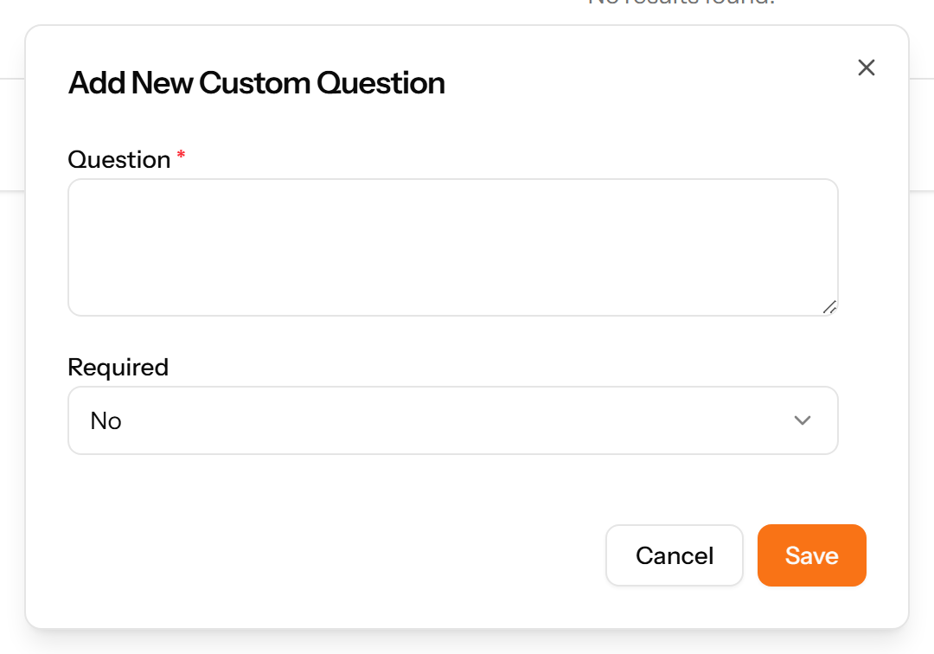
Figure 69: The Add Custom Question form

13.5 Job Postings
The vacancies themselves. A posting carries a code, a title, a type, a location and a salary range, and collects the applications made against it. Published postings appear on the public careers page.
Figure 70: The Job Postings page
1 page title · 2 primary action · 3 records table
Columns: #, Code, Title, Type, Location, Salary Range, Applications, Published, Status, Deadline, Actions
Actions on this page: Add Job Posting
1. Choose Add Job Posting at the top right. The form opens on its own page.
2. Complete the required fields: Job Title, Start Date, Application Deadline, Application URL, Number of Positions, Min Experience (Years), Max Experience (Years), Min Salary, Max Salary.
3. Fill in anything else that applies: Type Required Skills and press Enter, Featured Job, Gender, Date Of Birth, Cover Letter, Terms And Conditions.
4. Make the selections the form asks for: Job Type, Location, Branch, Department.
5. Choose Save. The new record appears in the list.
Figure 71: The Add Job Posting form

13.6 careers
The public careers page. This is what a job seeker sees; it needs no sign-in and lists every published posting. Its address carries your company slug, so each company has its own board.
Figure 72: The careers page
Note: This page is public. Anything published to a job posting is visible to anyone with the link, so check a posting before publishing it.

13.7 Candidate Sources
A reference list. Entries created here become the options offered when you create a candidate, to record where they came from. Setting these up once, before the records that use them, saves correcting the same choice repeatedly later.
Figure 73: The Candidate Sources page
1 page title · 2 primary action · 3 records table
Columns: #, Name, Description, Status, Created At, Actions
Actions on this page: Add Candidate Source
1. Choose Add Candidate Source at the top right. The form opens in a panel.
2. Complete the required fields: Name.
3. Fill in anything else that applies: Description.
4. Make the selections the form asks for: Status.
5. Choose Save. The new record appears in the list.
Figure 74: The Add Candidate Source form

13.8 Candidates
Everyone who has applied, with the job applied for, where they came from, their experience, their salary expectation and where they have reached in the process.
Figure 75: The Candidates page
1 page title · 2 records table
Columns: #, Name, Job, Source, Experience, Expected Salary, Status, Employee Converted, Applied, Actions
Note: Candidates arrive by applying to a posting, so there is no Add action here.

13.9 Interview Types
A reference list. Entries created here become the options offered when you create an interview. Setting these up once, before the records that use them, saves correcting the same choice repeatedly later.
Figure 76: The Interview Types page
1 page title · 2 primary action · 3 records table
Columns: #, Name, Description, Status, Created At, Actions
Actions on this page: Add Interview Type
1. Choose Add Interview Type at the top right. The form opens in a panel.
2. Complete the required fields: Name.
3. Fill in anything else that applies: Description.
4. Make the selections the form asks for: Status.
5. Choose Save. The new record appears in the list.
Figure 77: The Add Interview Type form

13.10 Interview Rounds
The stages a candidate passes through for a given job, in sequence — screening, technical, final. Defined per job so different roles can be hired differently.
Figure 78: The Interview Rounds page
1 page title · 2 primary action · 3 records table
Columns: #, Job, Sequence, Name, Description, Status, Created At, Actions
Actions on this page: Add Interview Round
1. Choose Add Interview Round at the top right. The form opens in a panel.
2. Complete the required fields: Name, Sequence Number.
3. Fill in anything else that applies: Description.
4. Make the selections the form asks for: Job, Status.
5. Choose Save. The new record appears in the list.
Figure 79: The Add Interview Round form

13.11 Interviews
Scheduled interviews: which candidate, which round, what type, when and where.
Figure 80: The Interviews page
1 page title · 2 records table
Columns: #, Candidate, Round, Type, Date & Time, Location, Status, Feedback, Actions
Actions on this page: Schedule Interview

13.12 Interview Feedback
What each interviewer thought, with an overall rating and a recommendation. Separating feedback from the interview itself allows several interviewers to report on the same conversation.
Figure 81: The Interview Feedback page
1 page title · 2 primary action · 3 records table
Columns: #, Candidate, Round, Interviewer, Overall Rating, Recommendation, Submitted, Actions
Actions on this page: Add Feedback
1. Choose Add Feedback at the top right. The form opens in a panel.
2. Fill in anything else that applies: Select Interviewer, Technical Rating (1-5), Communication Rating (1-5), Cultural Fit Rating (1-5), Overall Rating (1-5), Strengths, Weaknesses, Comments.
3. Make the selections the form asks for: Interview, Recommendation.
4. Choose Save. The new record appears in the list.
Figure 82: The Add Feedback form

13.13 Candidate Assessments
Tests or exercises set for a candidate, with the score achieved and who conducted it.
Figure 83: The Candidate Assessments page
1 page title · 2 primary action · 3 records table
Columns: #, Candidate, Assessment, Score, Status, Conducted By, Date, Actions
Actions on this page: Add Assessment
1. Choose Add Assessment at the top right. The form opens in a panel.
2. Complete the required fields: Assessment Name, Assessment Date.
3. Fill in anything else that applies: Score, Max Score, Comments.
4. Make the selections the form asks for: Candidate, Status, Employee.
5. Choose Save. The new record appears in the list.
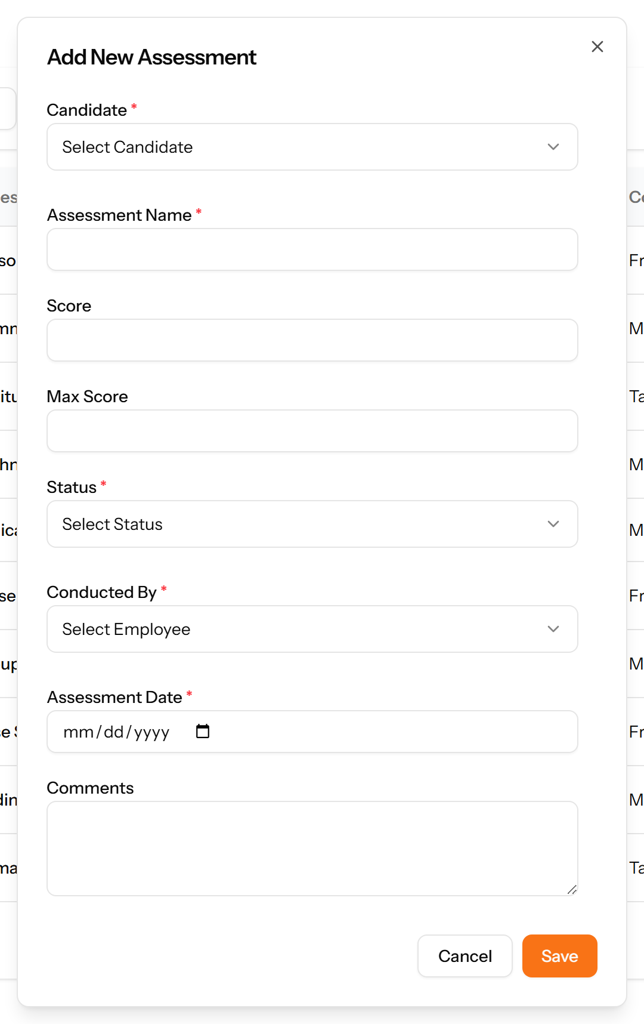
Figure 84: The Add Assessment form

13.14 Offer Templates
Reusable offer letter wording with placeholders that are filled in for each candidate, so every offer is consistent.
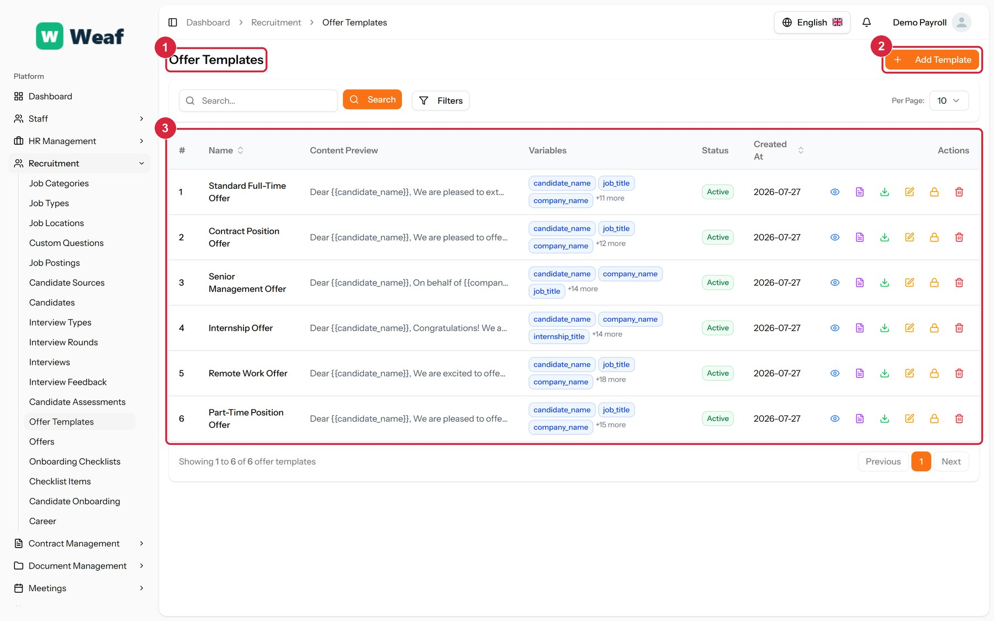
Figure 85: The Offer Templates page
1 page title · 2 primary action · 3 records table
Columns: #, Name, Content Preview, Variables, Status, Created At, Actions
Actions on this page: Add Template
1. Choose Add Template at the top right. The form opens in a panel.
2. Complete the required fields: Template Name, Template Content.
3. Fill in anything else that applies: Variables.
4. Make the selections the form asks for: Status.
5. Choose Save. The new record appears in the list.
Figure 86: The Add Template form

13.15 Offers
Offers made: the salary, the proposed start date, when the offer expires and whether it has been accepted.
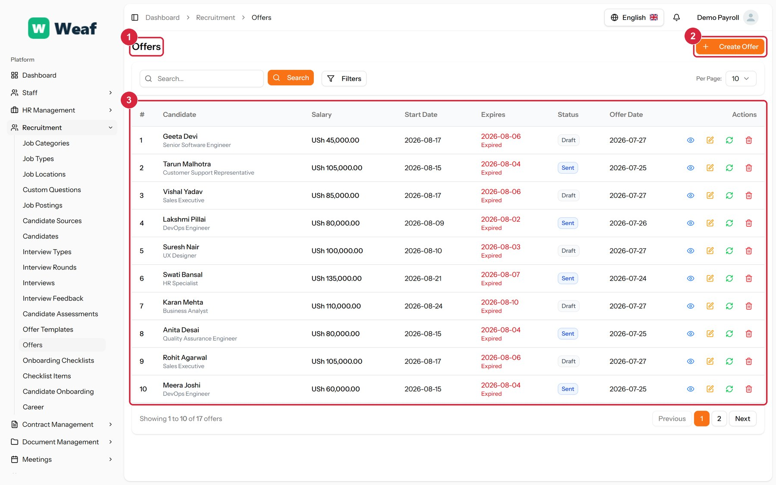
Figure 87: The Offers page
1 page title · 2 primary action · 3 records table
Columns: #, Candidate, Salary, Start Date, Expires, Status, Offer Date, Actions
Actions on this page: Create Offer
1. Choose Create Offer at the top right. The form opens in a panel.
2. Complete the required fields: Salary, Start Date, Expiration Date.
3. Fill in anything else that applies: Candidate, Position, Department, Benefits.
4. Choose Save. The new record appears in the list.
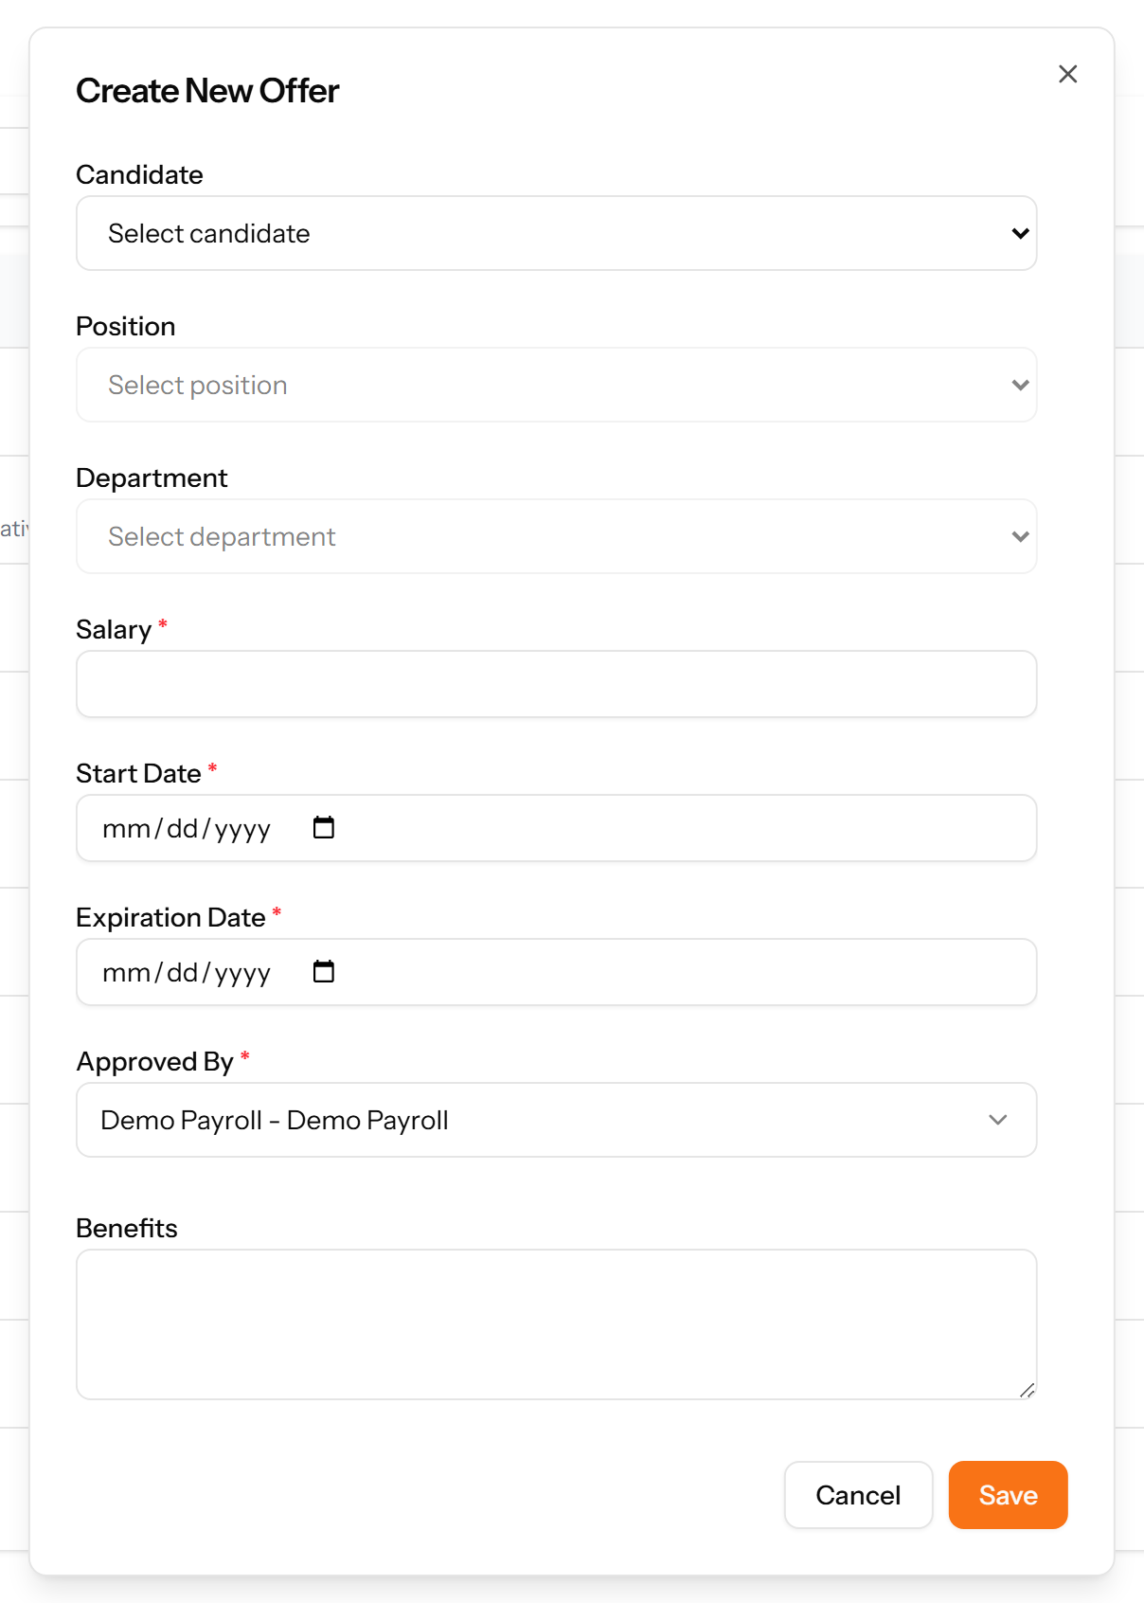
Figure 88: The Create Offer form

13.16 Onboarding Checklists
A named list of everything a new joiner must complete. Built once, then applied to each new starter.
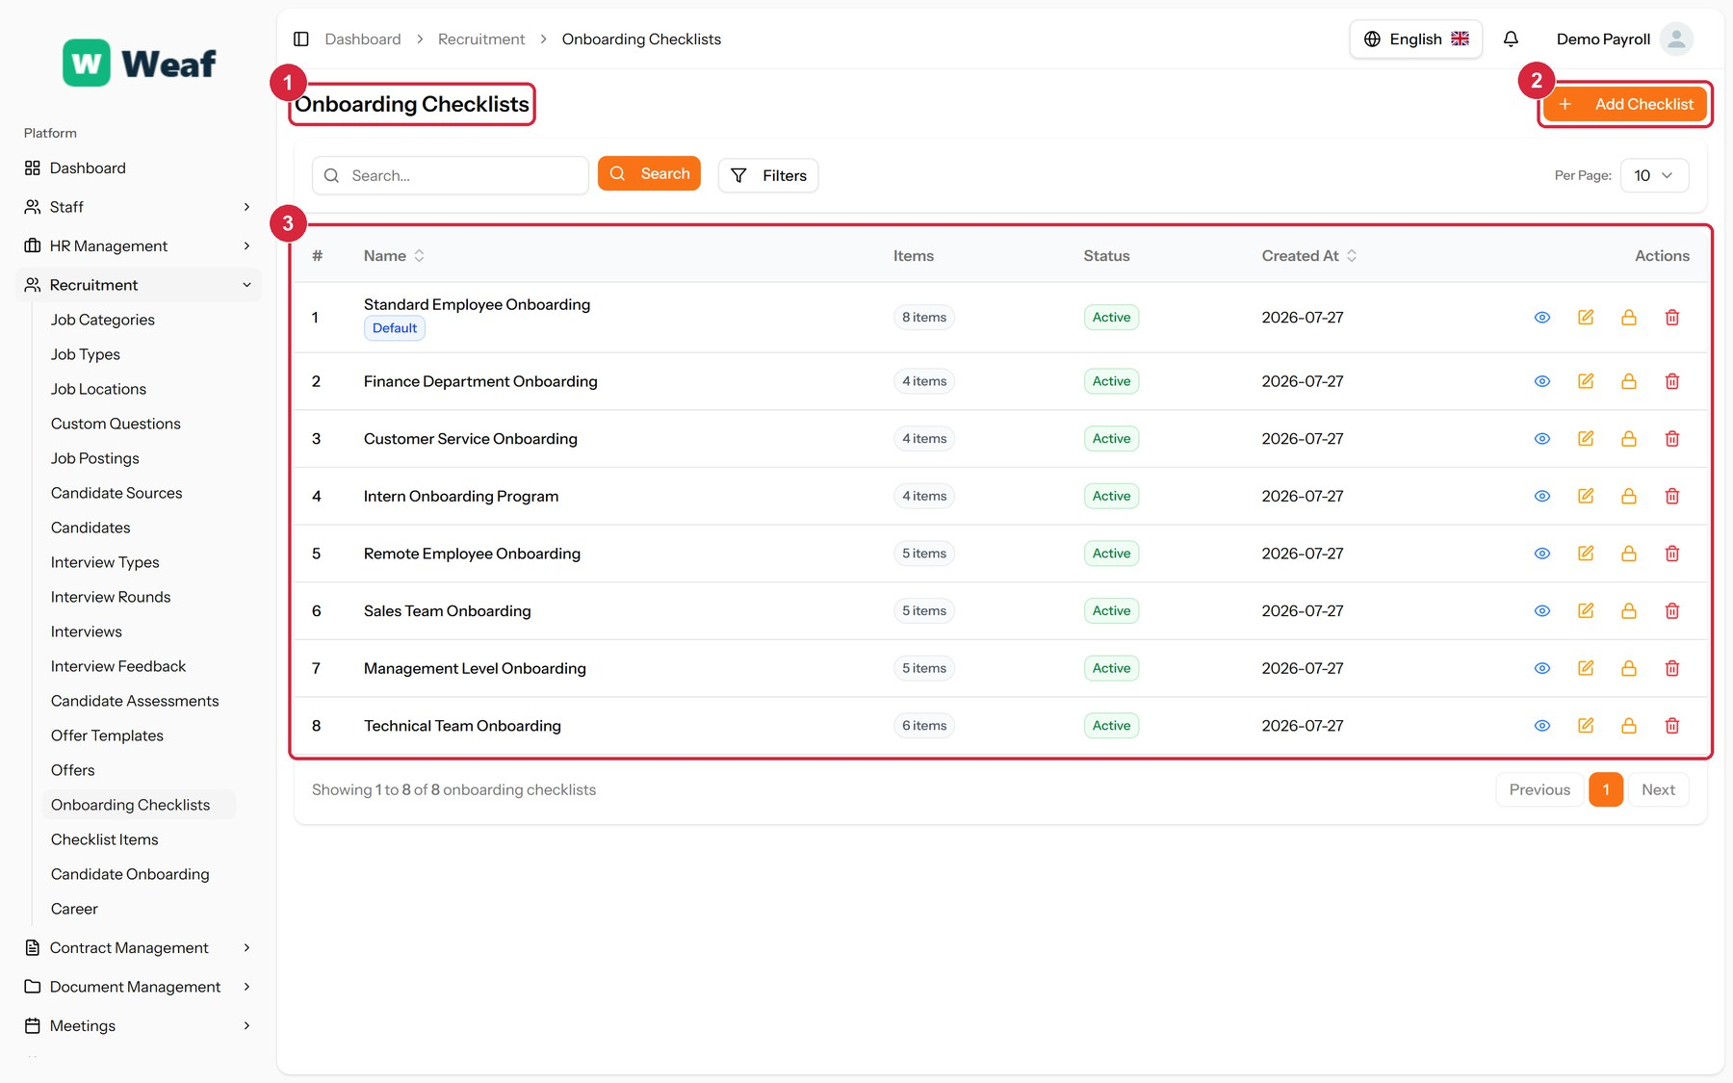
Figure 89: The Onboarding Checklists page
1 page title · 2 primary action · 3 records table
Columns: #, Name, Items, Status, Created At, Actions
Actions on this page: Add Checklist
1. Choose Add Checklist at the top right. The form opens in a panel.
2. Complete the required fields: Checklist Name.
3. Fill in anything else that applies: Description, Set as Default.
4. Make the selections the form asks for: Status.
5. Choose Save. The new record appears in the list.
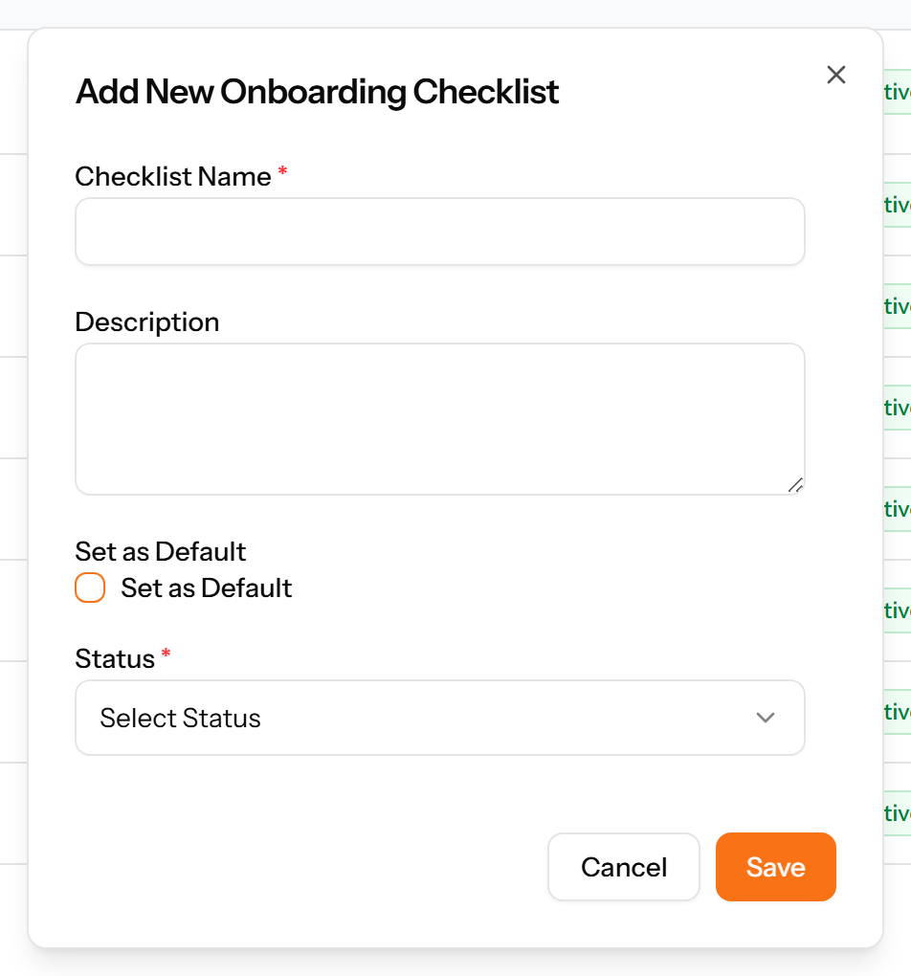
Figure 90: The Add Checklist form

13.17 Checklist Items
The individual tasks that make up the checklists, each belonging to a checklist and a category.
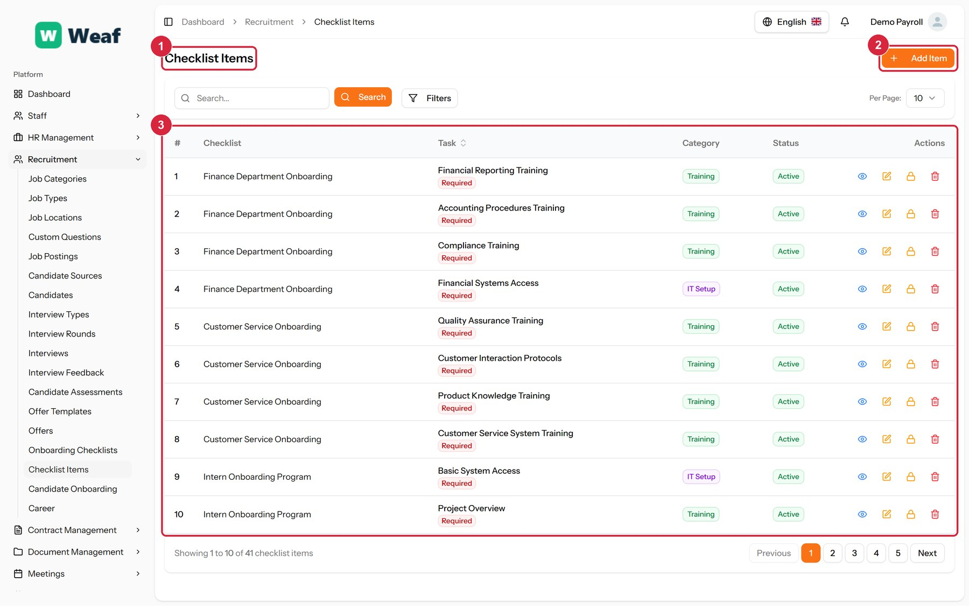
Figure 91: The Checklist Items page
1 page title · 2 primary action · 3 records table
Columns: #, Checklist, Task, Category, Status, Actions
Actions on this page: Add Item
1. Choose Add Item at the top right. The form opens in a panel.
2. Complete the required fields: Task Name.
3. Fill in anything else that applies: Description, Required Task.
4. Make the selections the form asks for: Checklist, Category, Status.
5. Choose Save. The new record appears in the list.
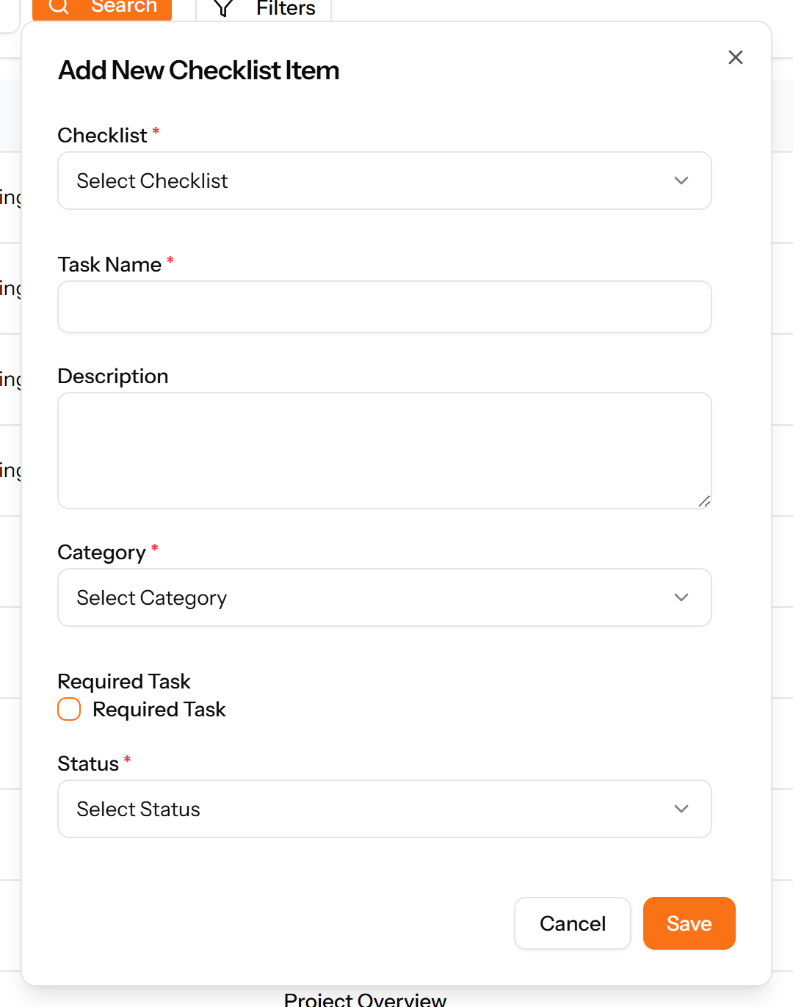
Figure 92: The Add Item form

13.18 Candidate Onboarding
Progress through onboarding for a specific new joiner, including the buddy assigned to them.
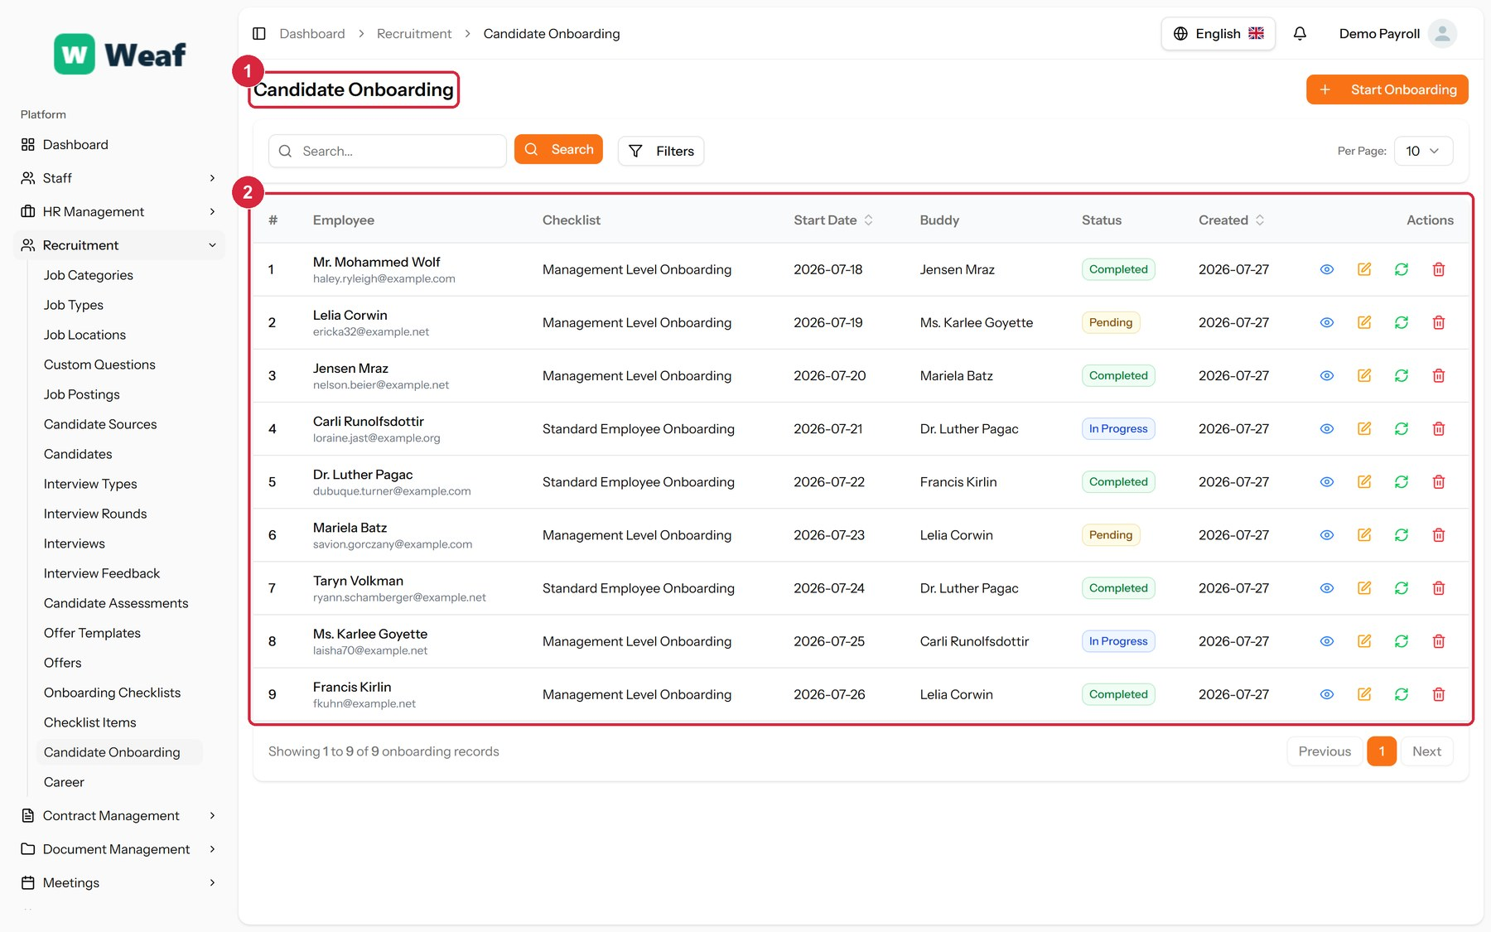
Figure 93: The Candidate Onboarding page
1 page title · 2 records table
Columns: #, Employee, Checklist, Start Date, Buddy, Status, Created, Actions
Actions on this page: Start Onboarding

14. Performance
Appraisal is made repeatable by defining what you measure before you measure it: categories group the indicators, indicators carry units and targets, and cycles set the rhythm. Goals and reviews are then recorded against individual employees.
Pages in this chapter: Indicator Categories, Indicators, Goal Types, Employee Goals, Review Cycles, Employee Reviews

14.1 Indicator Categories
A reference list. Entries created here become the options offered when you create a performance indicator. Setting these up once, before the records that use them, saves correcting the same choice repeatedly later.
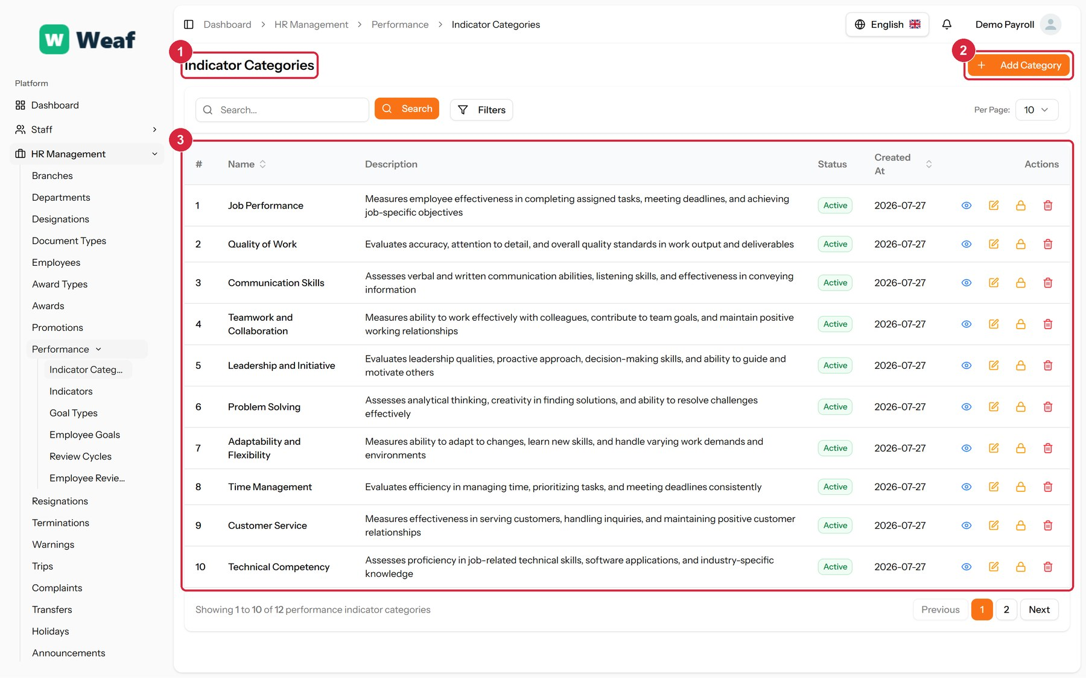
Figure 94: The Indicator Categories page
1 page title · 2 primary action · 3 records table
Columns: #, Name, Description, Status, Created At, Actions
Actions on this page: Add Category
1. Choose Add Category at the top right. The form opens in a panel.
2. Complete the required fields: Category Name.
3. Fill in anything else that applies: Description.
4. Choose Save. The new record appears in the list.
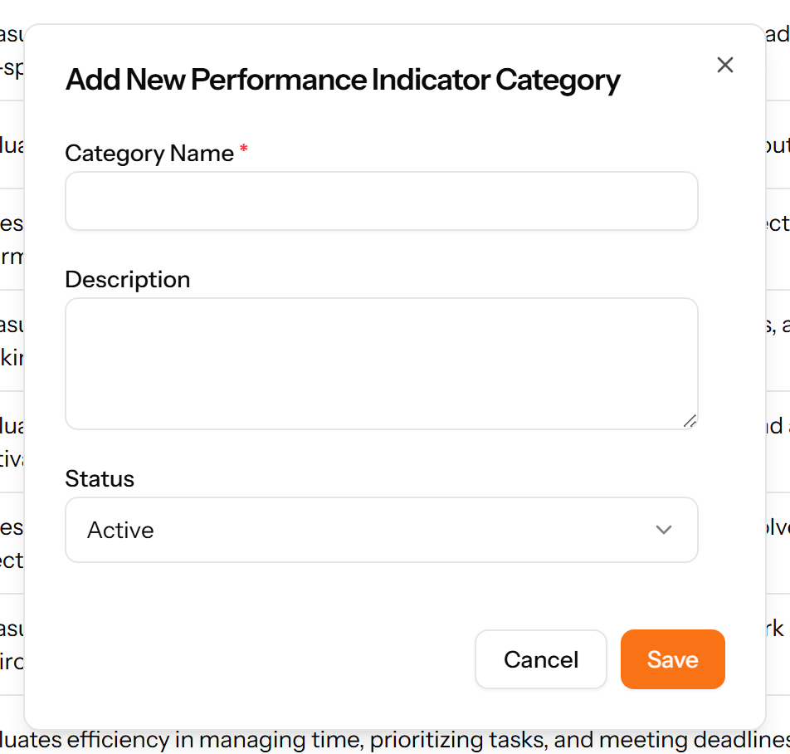
Figure 95: The Add Category form

14.2 Indicators
The things you measure. Each indicator belongs to a category and carries a measurement unit and a target value, which is what makes a review scoreable rather than a matter of opinion.
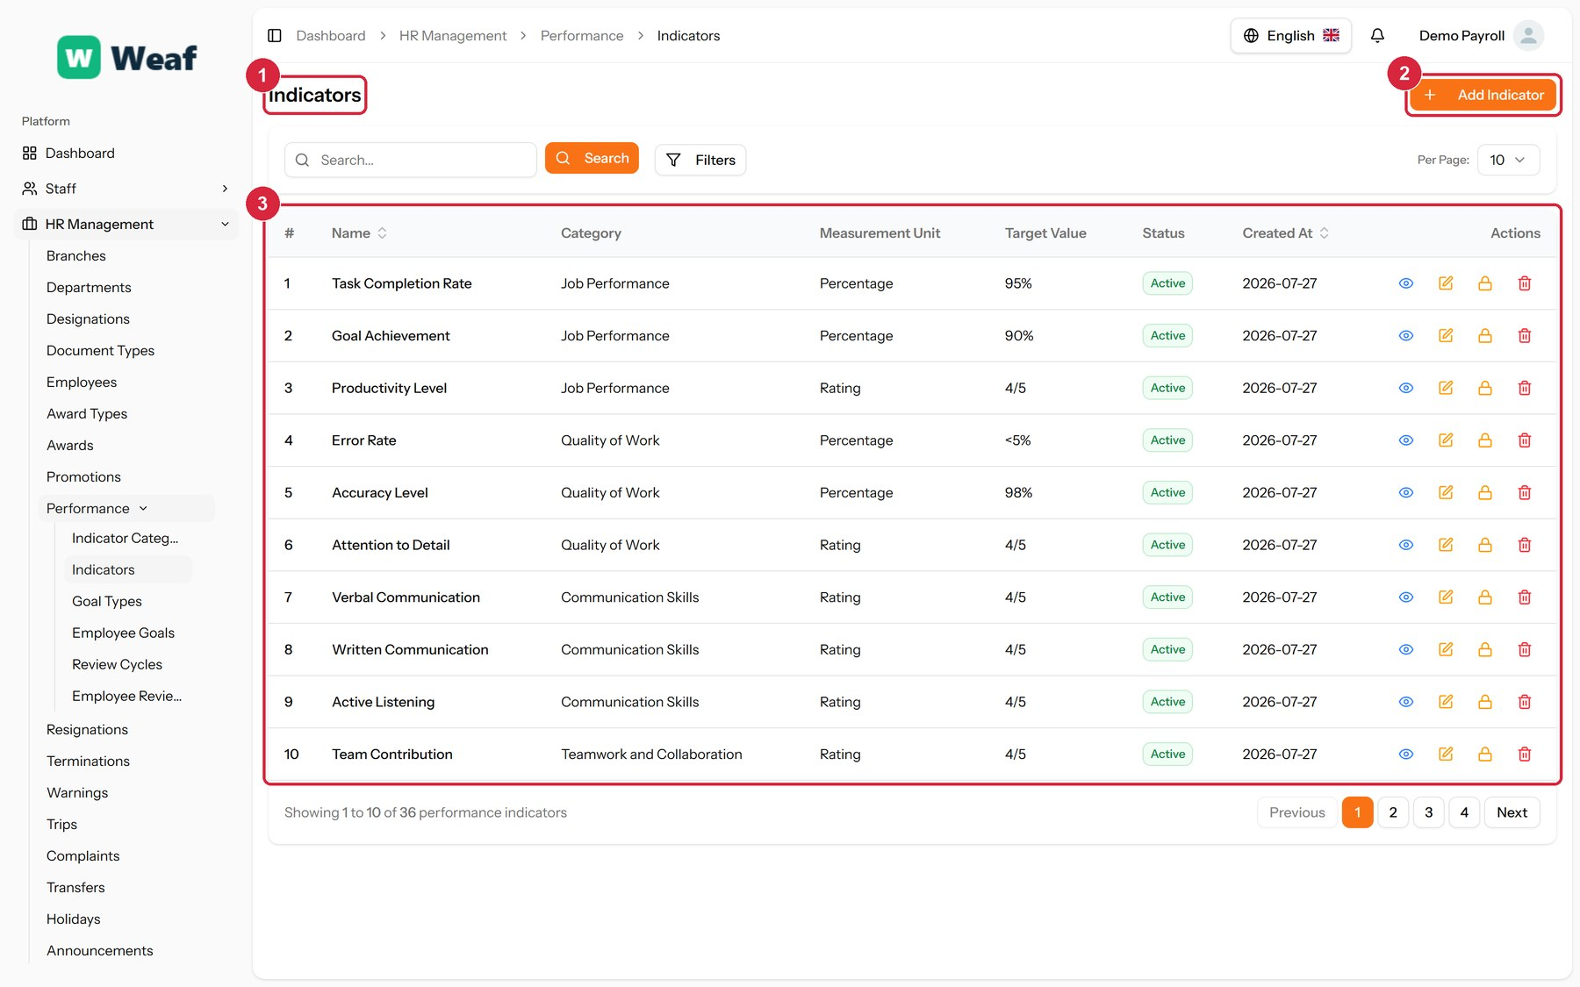
Figure 96: The Indicators page
1 page title · 2 primary action · 3 records table
Columns: #, Name, Category, Measurement Unit, Target Value, Status, Created At, Actions
Actions on this page: Add Indicator
1. Choose Add Indicator at the top right. The form opens in a panel.
2. Complete the required fields: Indicator Name.
3. Fill in anything else that applies: Description, Measurement Unit, Target Value.
4. Make the selections the form asks for: Category.
5. Choose Save. The new record appears in the list.
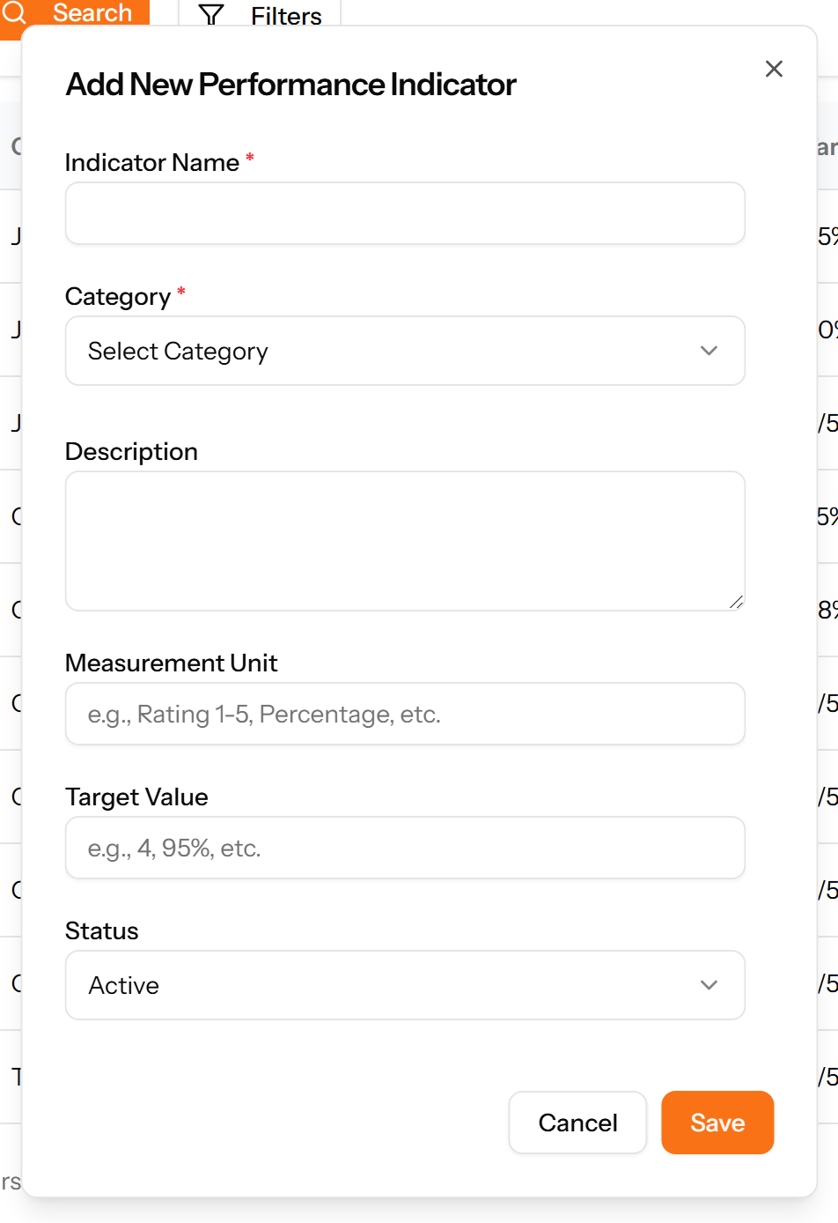
Figure 97: The Add Indicator form

14.3 Goal Types
A reference list. Entries created here become the options offered when you create an employee goal. Setting these up once, before the records that use them, saves correcting the same choice repeatedly later.
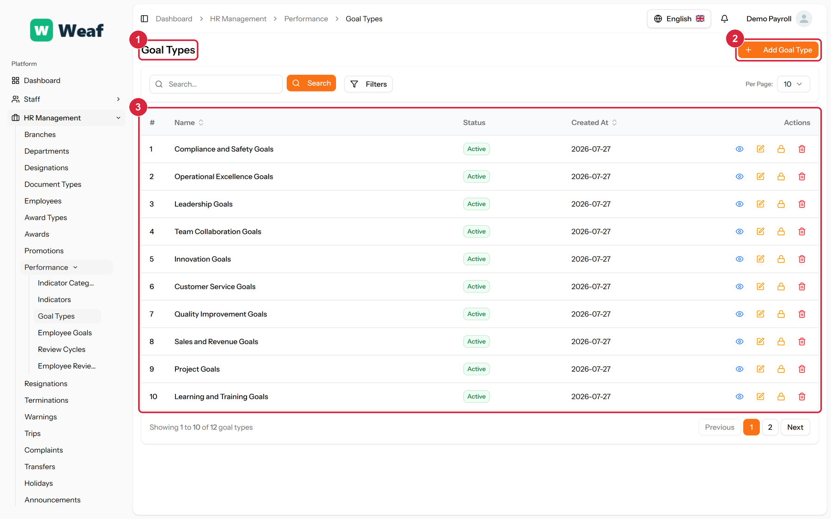
Figure 98: The Goal Types page
1 page title · 2 primary action · 3 records table
Columns: #, Name, Status, Created At, Actions
Actions on this page: Add Goal Type
1. Choose Add Goal Type at the top right. The form opens in a panel.
2. Complete the required fields: Goal Type Name.
3. Fill in anything else that applies: Description.
4. Choose Save. The new record appears in the list.
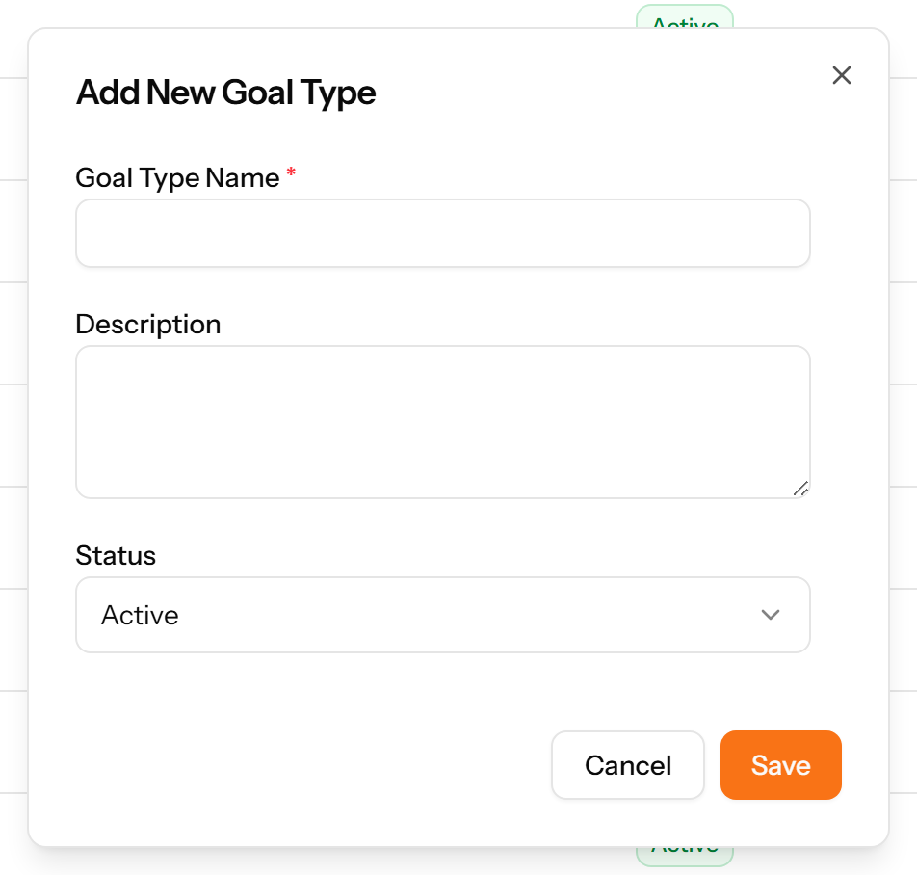
Figure 99: The Add Goal Type form

14.4 Employee Goals
Goals set for a named employee, each with a type, a period and a progress figure that is updated as the goal advances.
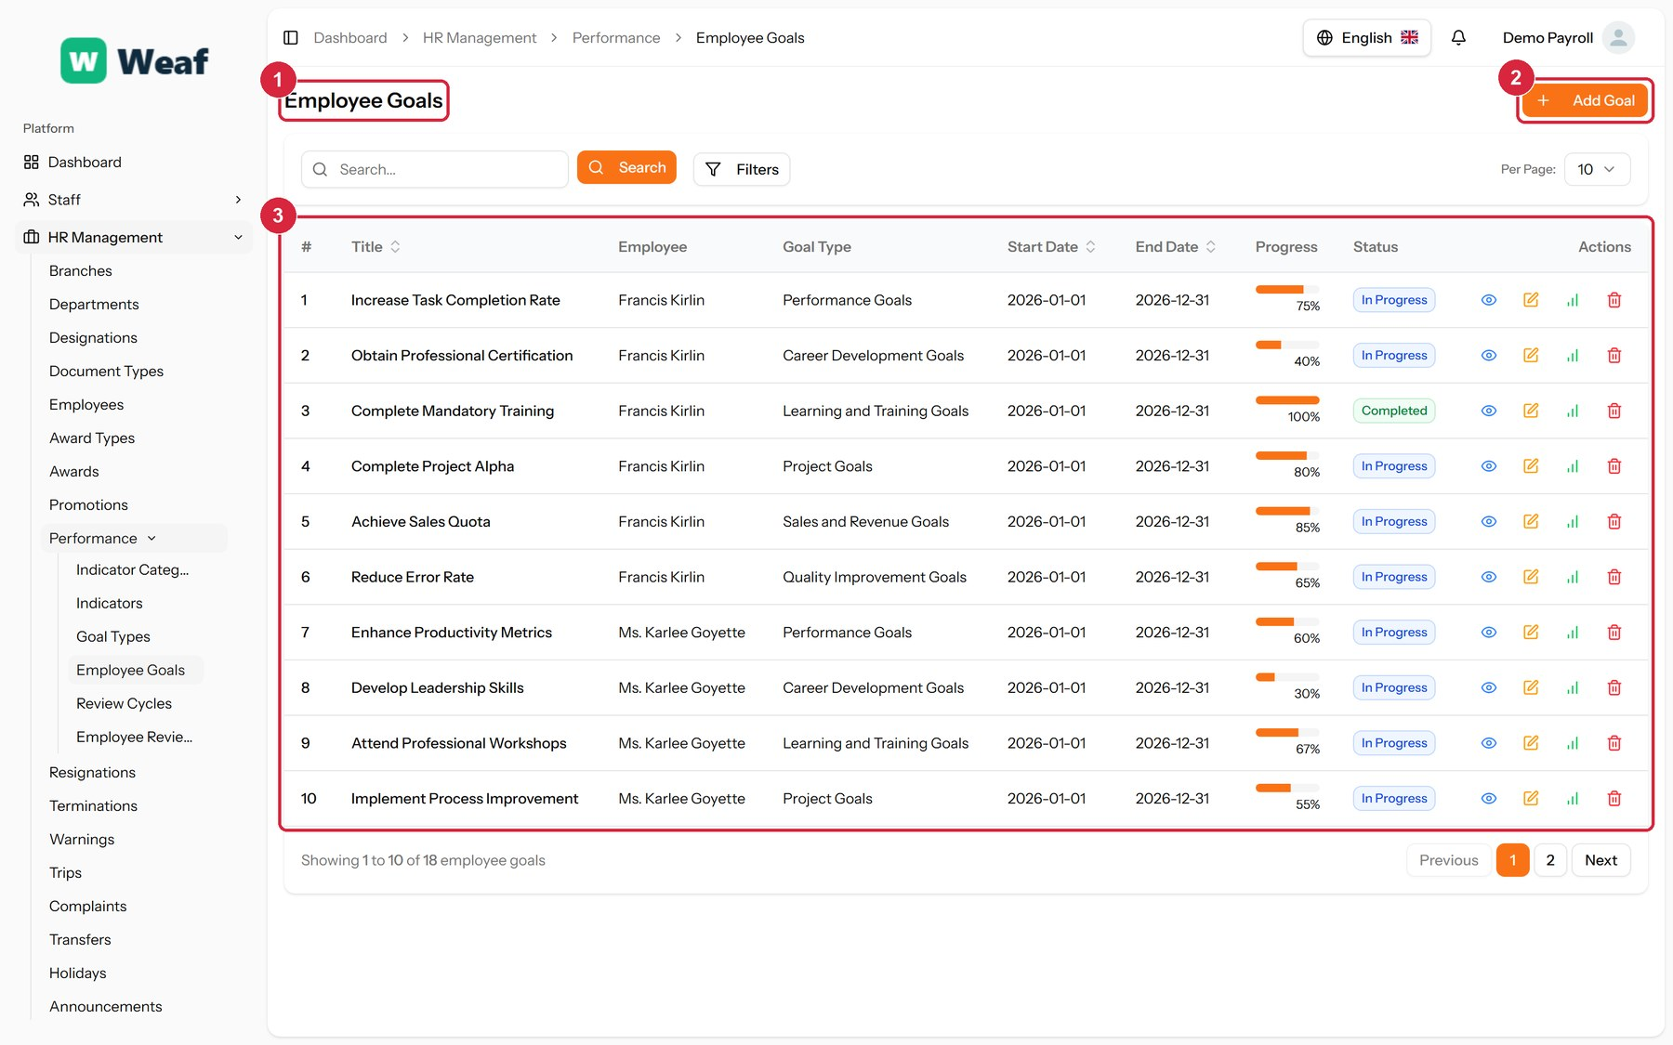
Figure 100: The Employee Goals page
1 page title · 2 primary action · 3 records table
Columns: #, Title, Employee, Goal Type, Start Date, End Date, Progress, Status, Actions
Actions on this page: Add Goal
1. Choose Add Goal at the top right. The form opens in a panel.
2. Complete the required fields: Goal Title, Start Date, End Date.
3. Fill in anything else that applies: Description, Target, Progress (%).
4. Make the selections the form asks for: Employee, Goal Type.
5. Choose Save. The new record appears in the list.
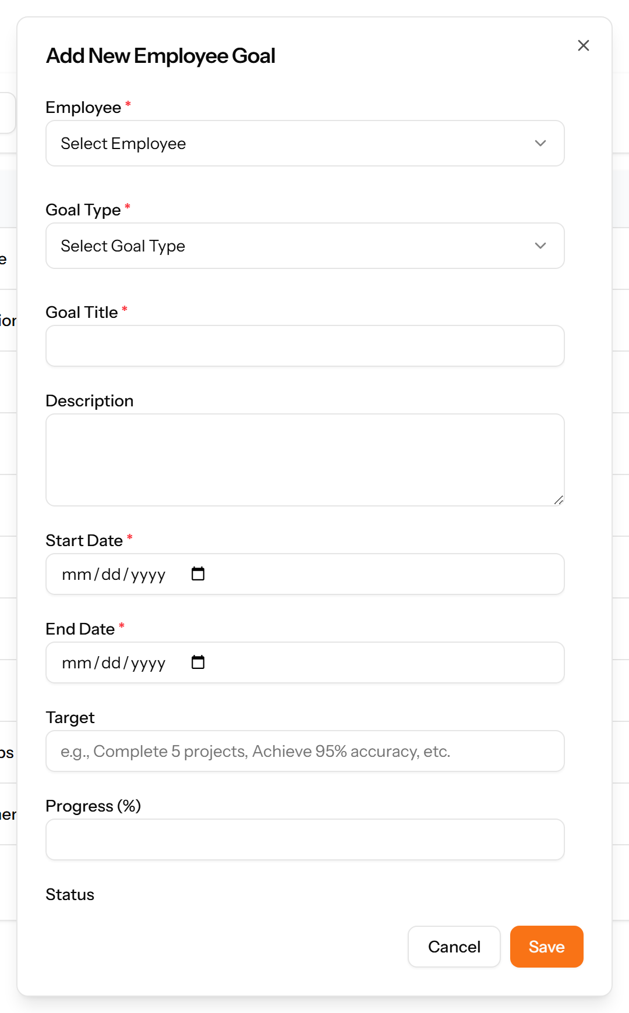
Figure 101: The Add Goal form

14.5 Review Cycles
The rhythm of appraisal — quarterly, half-yearly, annual. A cycle is created once and reused for every review that belongs to it.
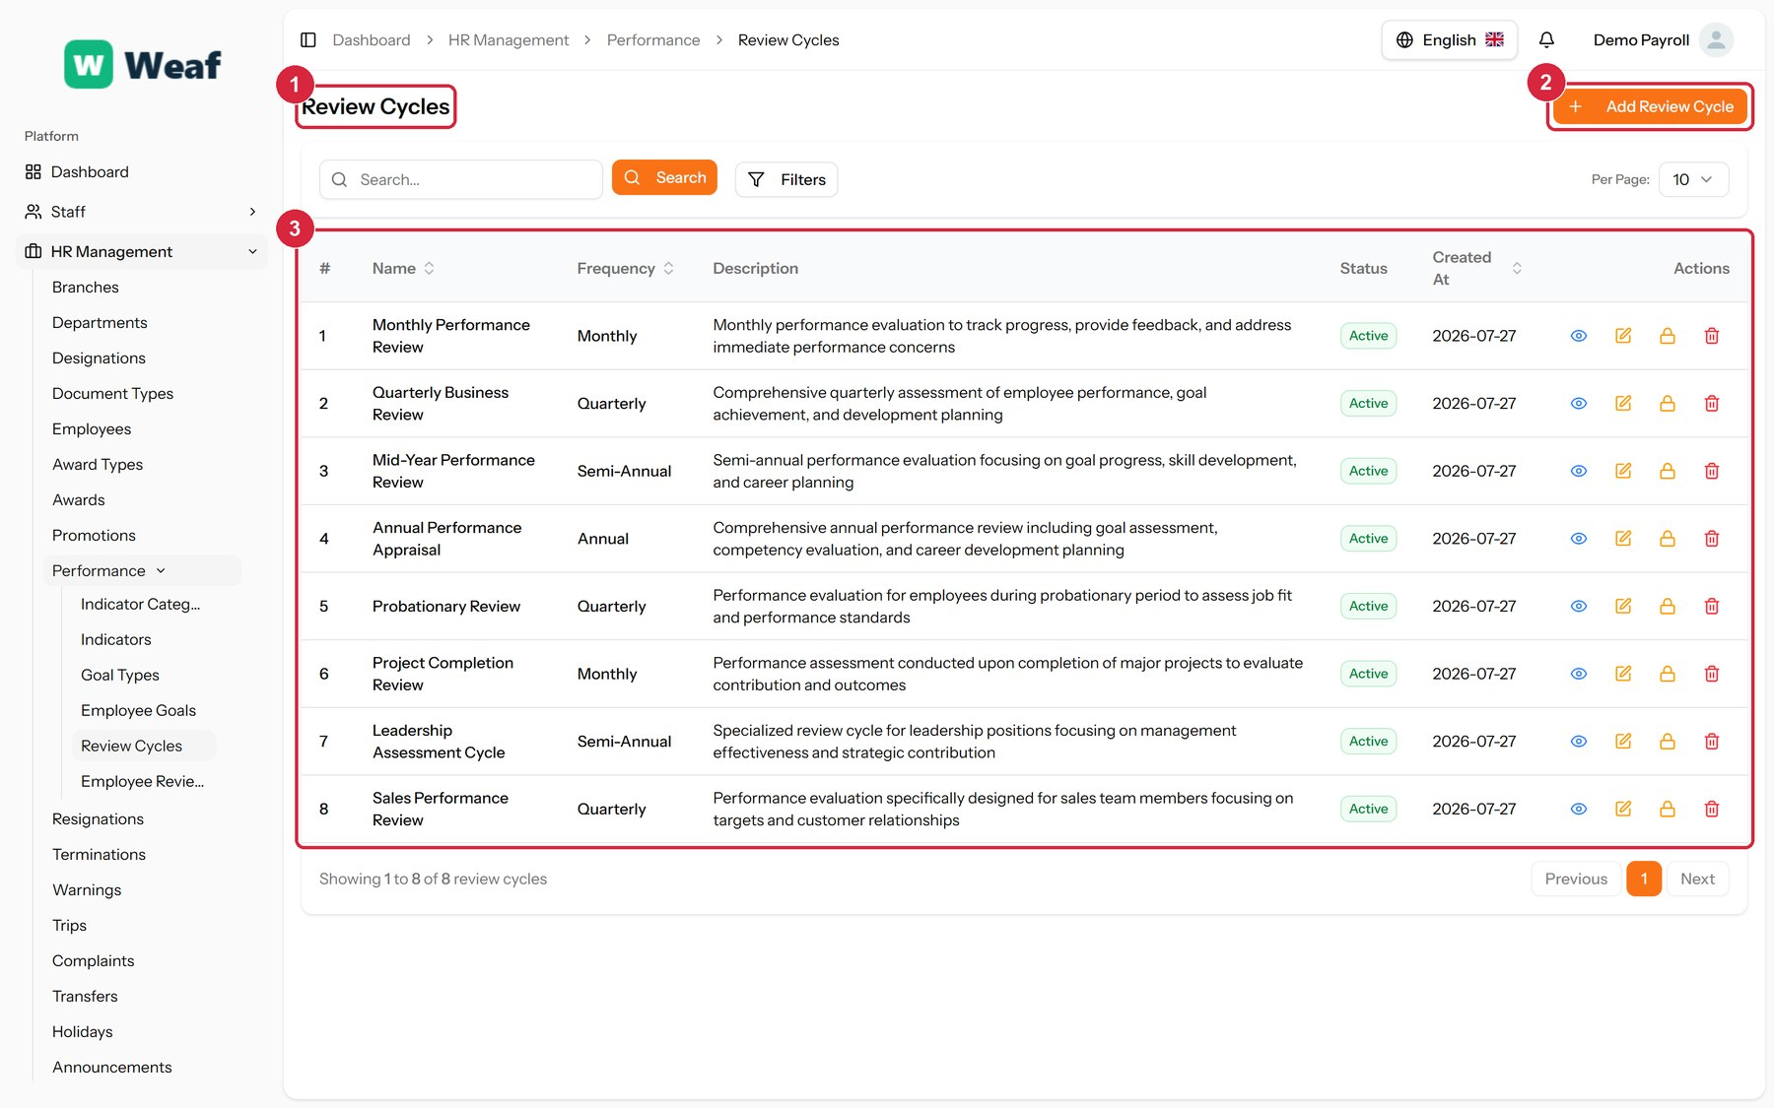
Figure 102: The Review Cycles page
1 page title · 2 primary action · 3 records table
Columns: #, Name, Frequency, Description, Status, Created At, Actions
Actions on this page: Add Review Cycle
1. Choose Add Review Cycle at the top right. The form opens in a panel.
2. Complete the required fields: Review Cycle Name.
3. Fill in anything else that applies: Description.
4. Make the selections the form asks for: Frequency.
5. Choose Save. The new record appears in the list.
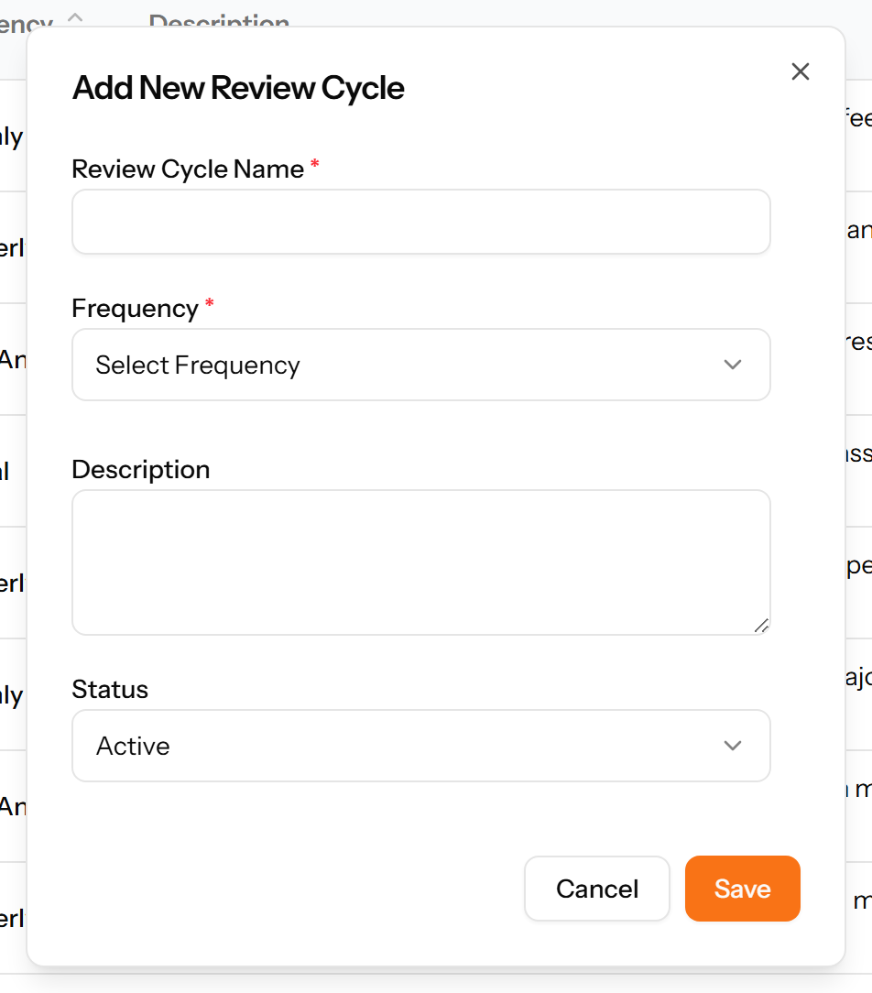
Figure 103: The Add Review Cycle form

14.6 Employee Reviews
An individual appraisal: who was reviewed, by whom, in which cycle, and the rating that resulted.
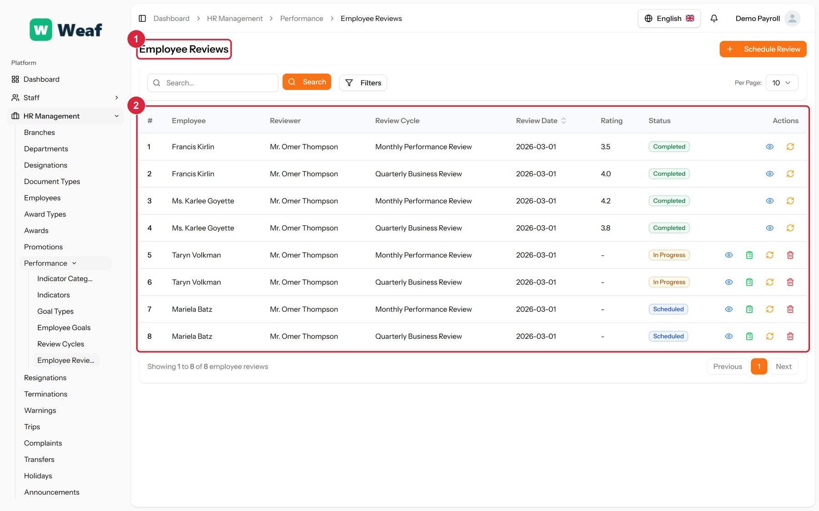
Figure 104: The Employee Reviews page
1 page title · 2 records table
Columns: #, Employee, Reviewer, Review Cycle, Review Date, Rating, Status, Actions
Actions on this page: Schedule Review

15. Training
A programme is a course; a session is one delivery of it; an employee training is one person's place on it. Separating the three means a course is described once however often it runs.
Pages in this chapter: Training Types, Training Programs, Training Sessions, Employee Trainings

15.1 Training Types
A reference list. Entries created here become the options offered when you create a training programme. Setting these up once, before the records that use them, saves correcting the same choice repeatedly later.
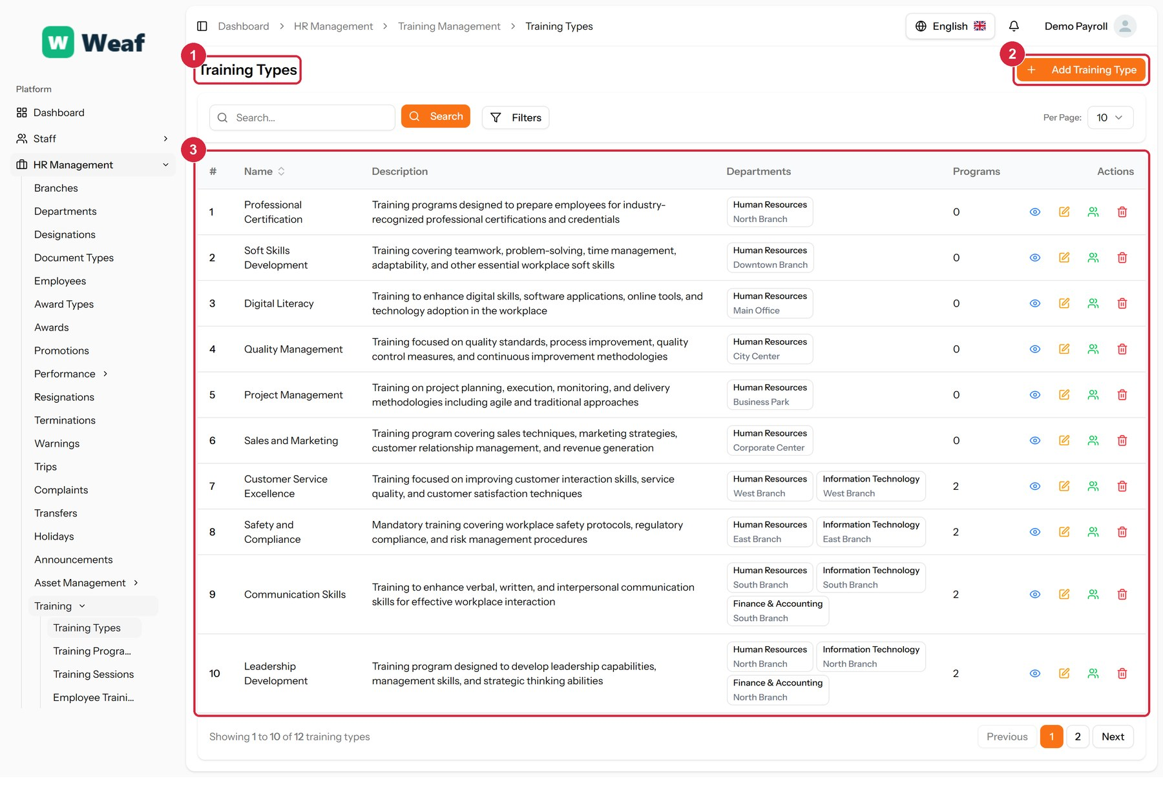
Figure 105: The Training Types page
1 page title · 2 primary action · 3 records table
Columns: #, Name, Description, Departments, Programs, Actions
Actions on this page: Add Training Type
1. Choose Add Training Type at the top right. The form opens in a panel.
2. Complete the required fields: Name.
3. Fill in anything else that applies: Description.
4. Make the selections the form asks for: Branch.
5. Choose Save. The new record appears in the list.
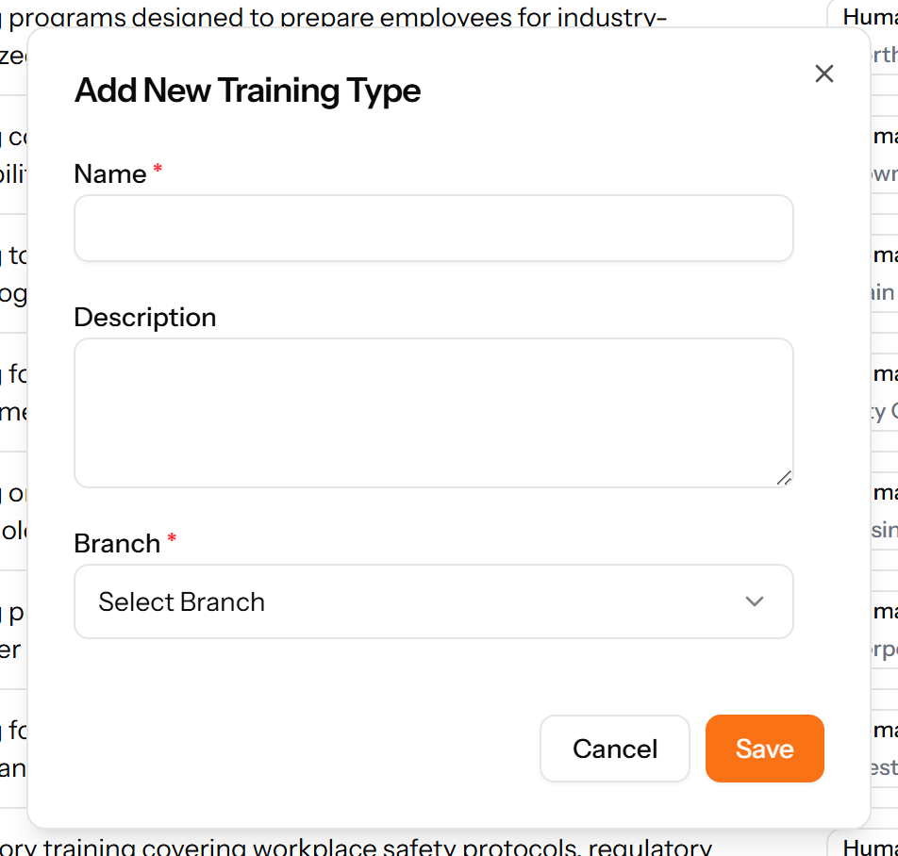
Figure 106: The Add Training Type form

15.2 Training Programs
A course that can be delivered more than once, with its duration, cost and capacity.
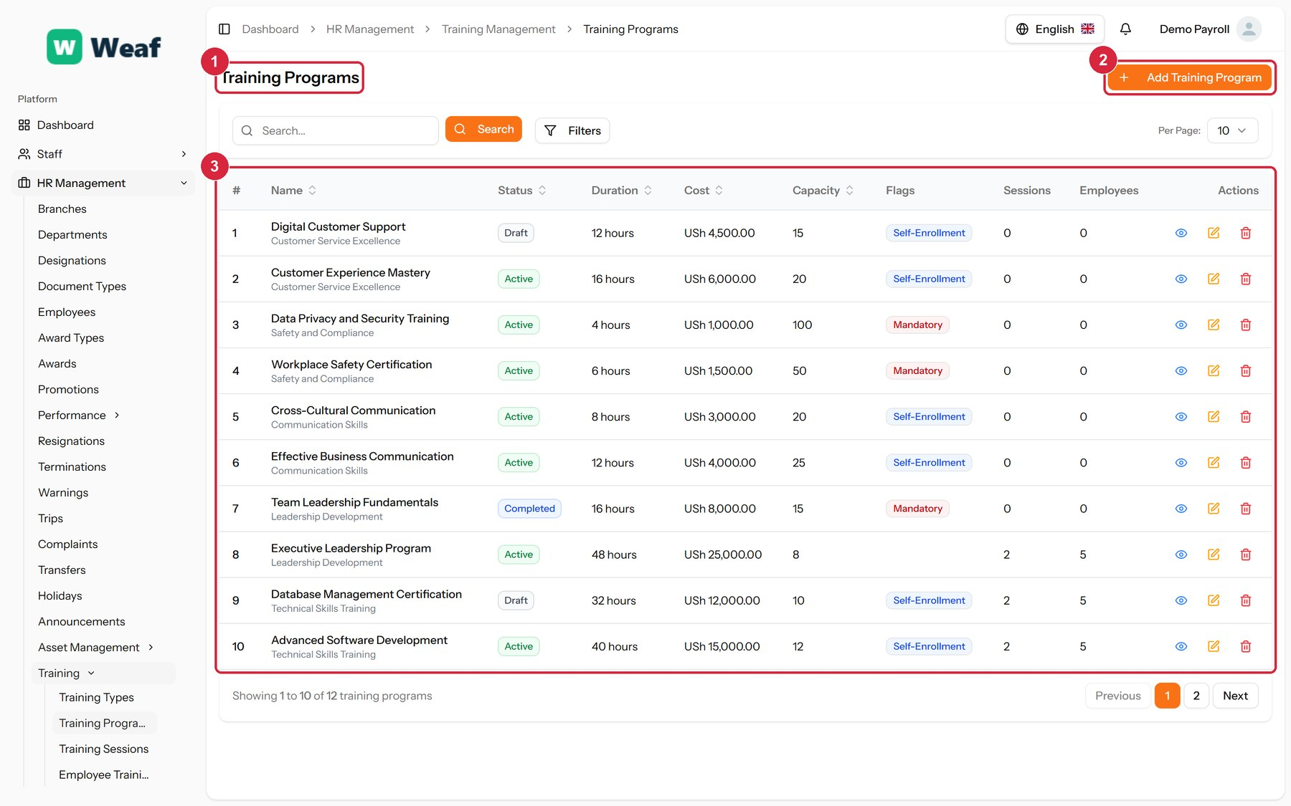
Figure 107: The Training Programs page
1 page title · 2 primary action · 3 records table
Columns: #, Name, Status, Duration, Cost, Capacity, Flags, Sessions, Employees, Actions
Actions on this page: Add Training Program
1. Choose Add Training Program at the top right. The form opens in a panel.
2. Complete the required fields: Name.
3. Fill in anything else that applies: Description, Duration (hours), Cost, Capacity, Select materials file..., Prerequisites, Mandatory Training, Allow Self-Enrollment.
4. Make the selections the form asks for: Training Type, Status.
5. Choose Save. The new record appears in the list.
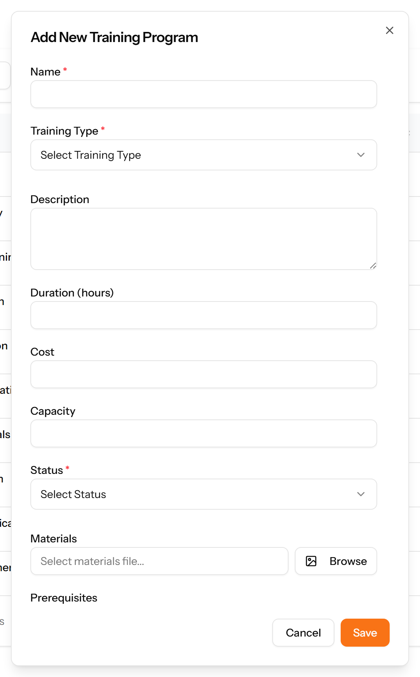
Figure 108: The Add Training Program form

15.3 Training Sessions
A specific delivery of a programme: when, where, by whom, and who attended.
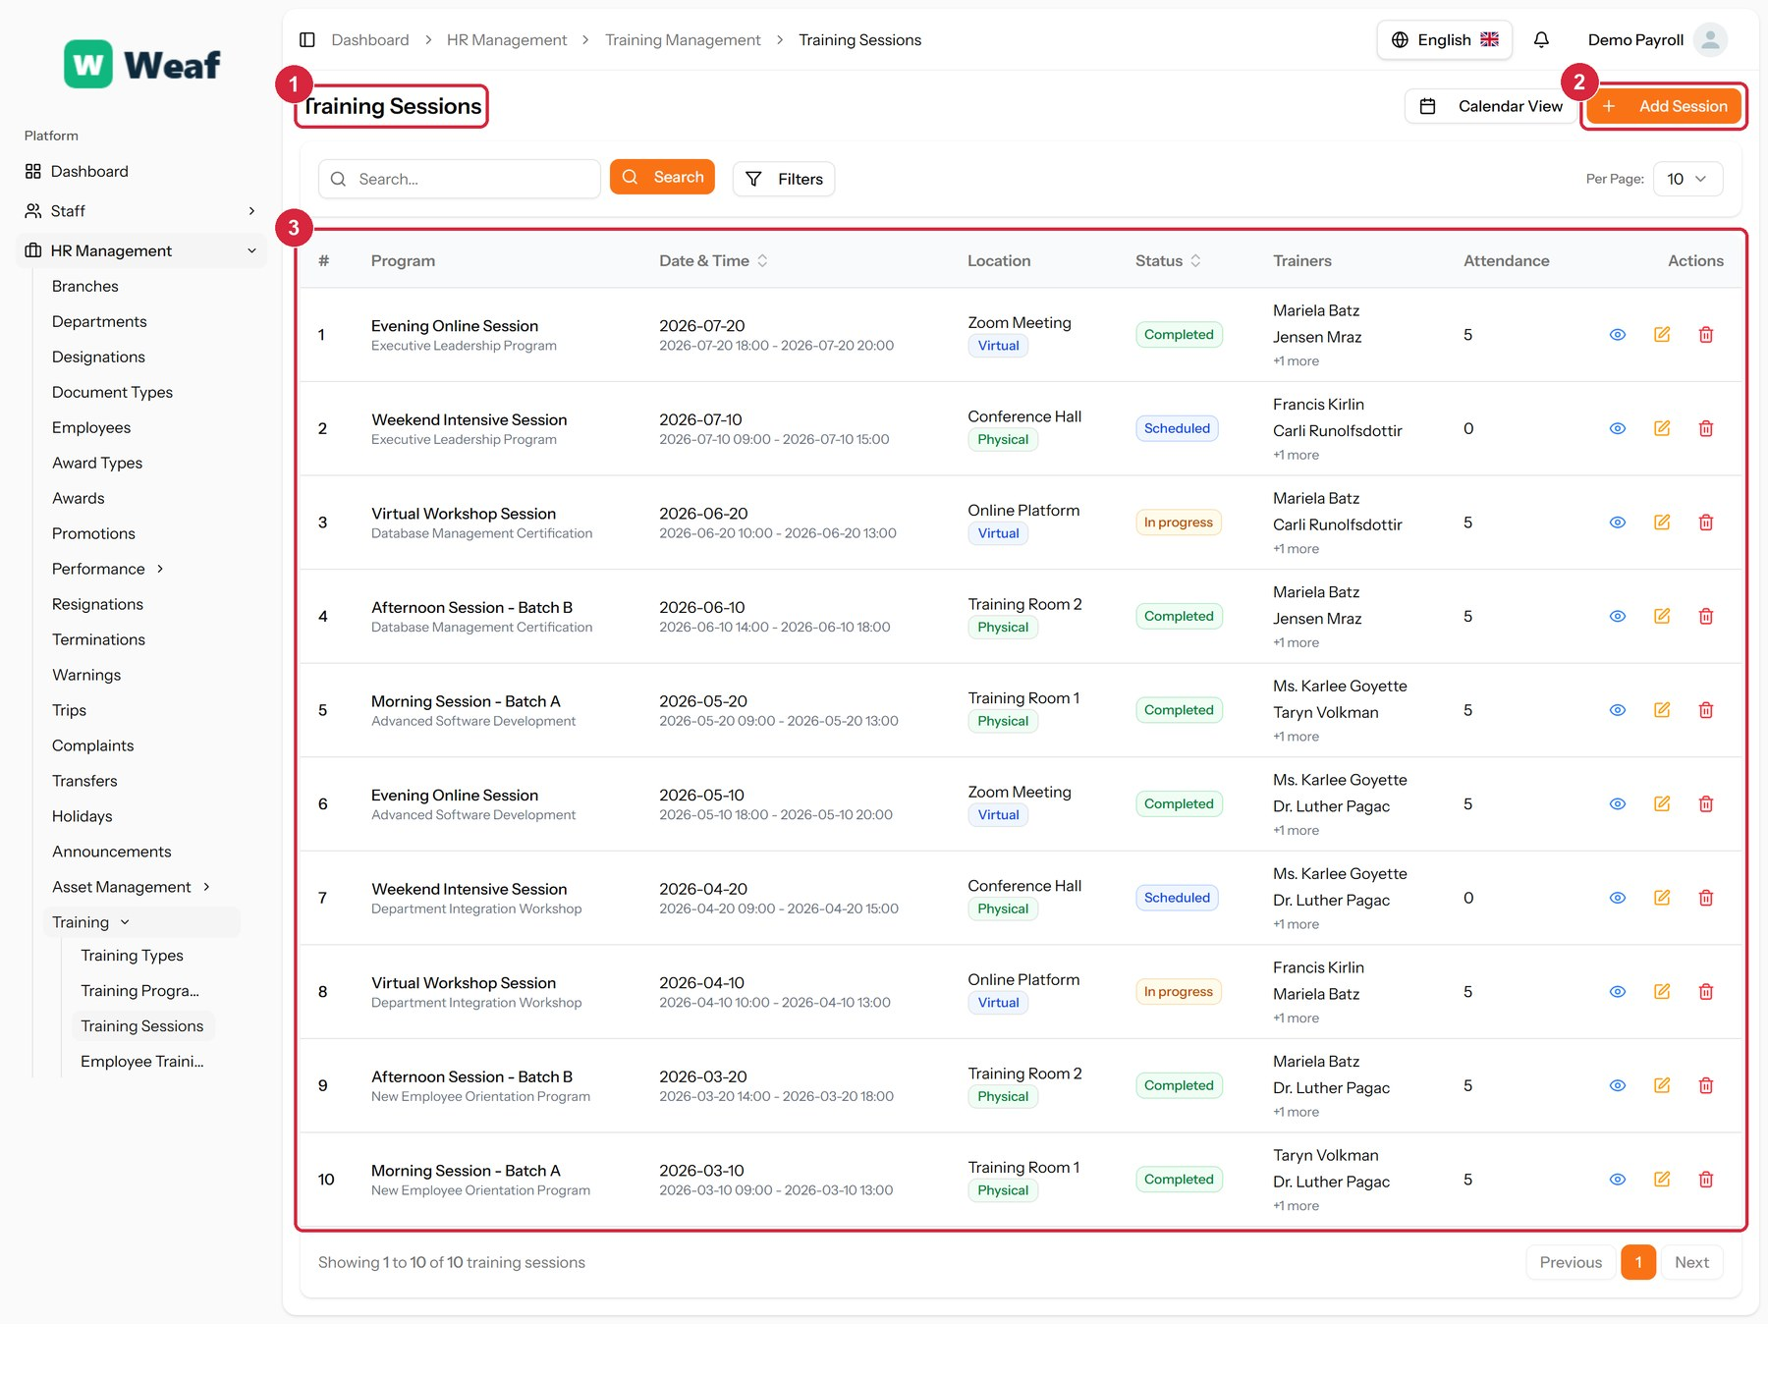
Figure 109: The Training Sessions page
1 page title · 2 primary action · 3 records table
Columns: #, Program, Date & Time, Location, Status, Trainers, Attendance, Actions
Actions on this page: Calendar View, Add Session
1. Choose Add Session at the top right. The form opens in a panel.
2. Complete the required fields: Start Date, End Date.
3. Fill in anything else that applies: Session Name, Location, Meeting Link, Notes, Select Trainers, Recurring Session, Number of Occurrences.
4. Make the selections the form asks for: Training Program, Location Type, Status, Recurrence Pattern.
5. Choose Save. The new record appears in the list.
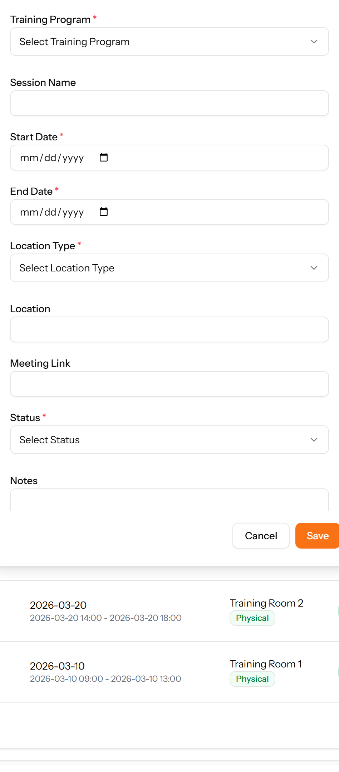
Figure 110: The Add Session form

15.4 Employee Trainings
Which employee is assigned to which programme, and how far they have got with it.
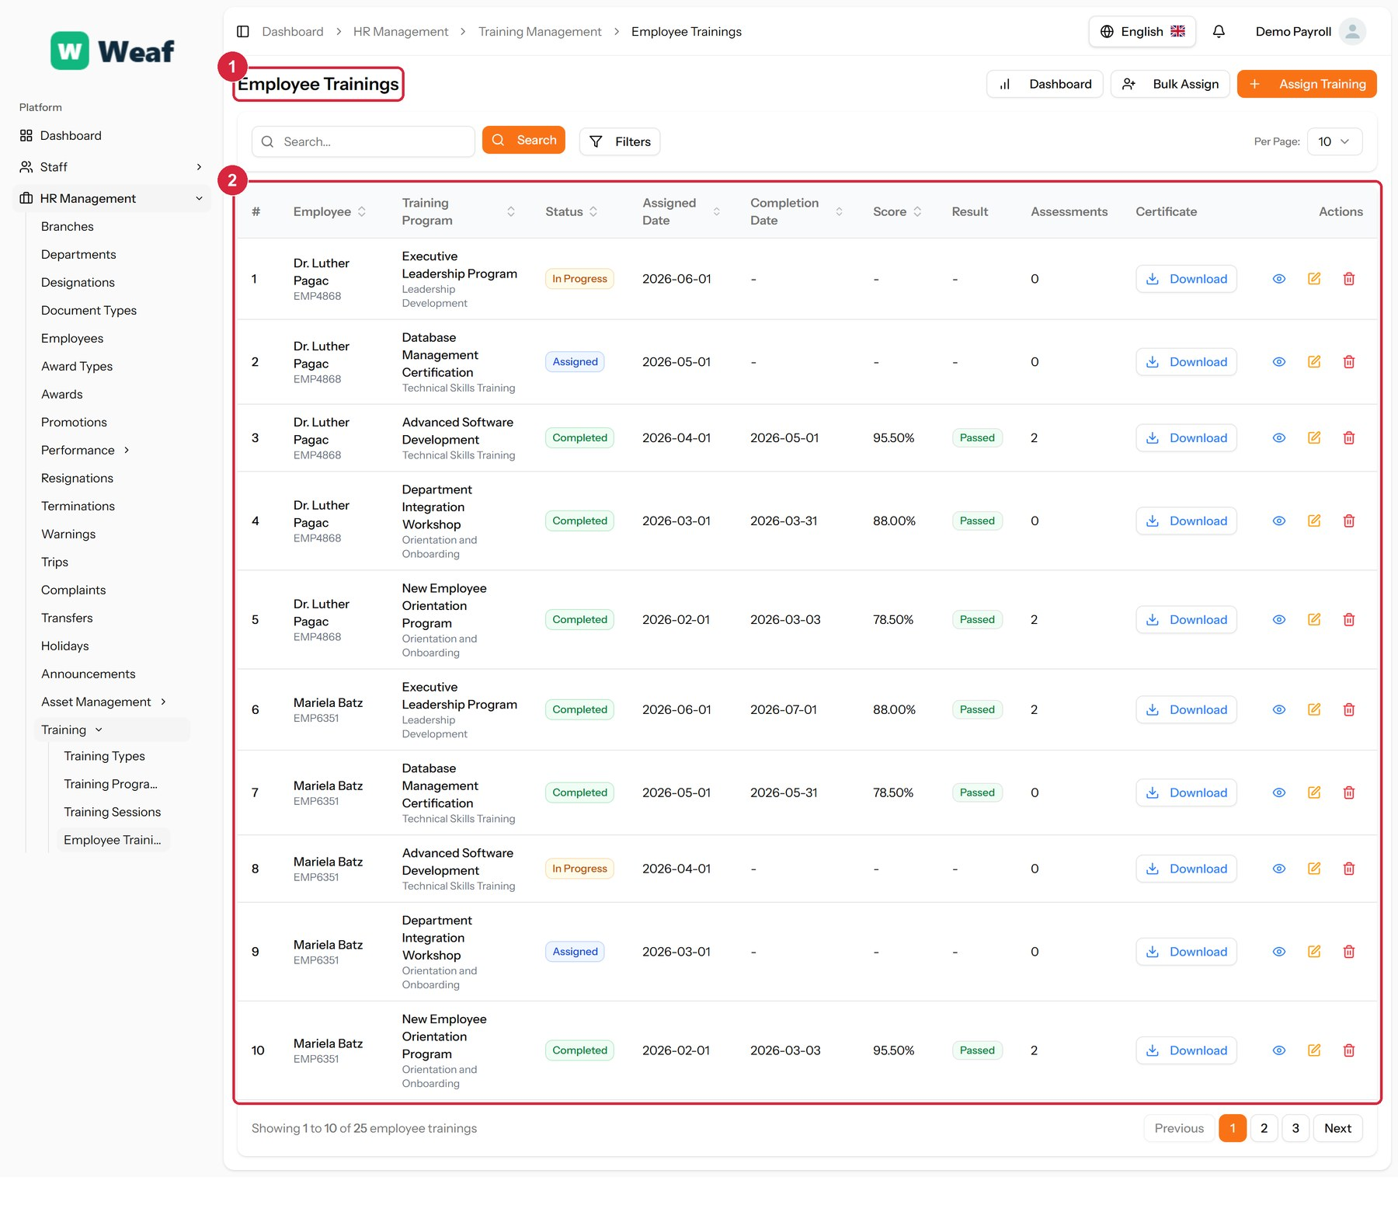
Figure 111: The Employee Trainings page
1 page title · 2 records table
Columns: #, Employee, Training Program, Status, Assigned Date, Completion Date, Score, Result, Assessments, Certificate, Actions
Actions on this page: Dashboard, Bulk Assign, Assign Training, Download

16. Asset Management
Company property is tracked here, together with who holds it and what it is now worth.
Pages in this chapter: Asset Types, Assets, Dashboard, Depreciation

16.1 Asset Types
A reference list. Entries created here become the options offered when you create an asset. Setting these up once, before the records that use them, saves correcting the same choice repeatedly later.
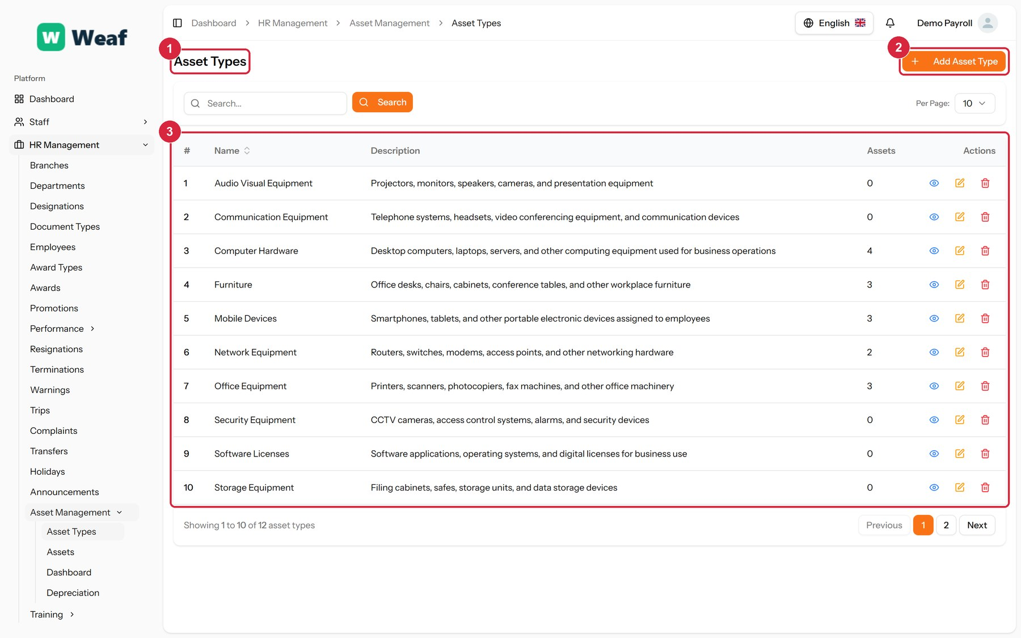
Figure 112: The Asset Types page
1 page title · 2 primary action · 3 records table
Columns: #, Name, Description, Assets, Actions
Actions on this page: Add Asset Type
1. Choose Add Asset Type at the top right. The form opens in a panel.
2. Complete the required fields: Name.
3. Fill in anything else that applies: Description.
4. Choose Save. The new record appears in the list.
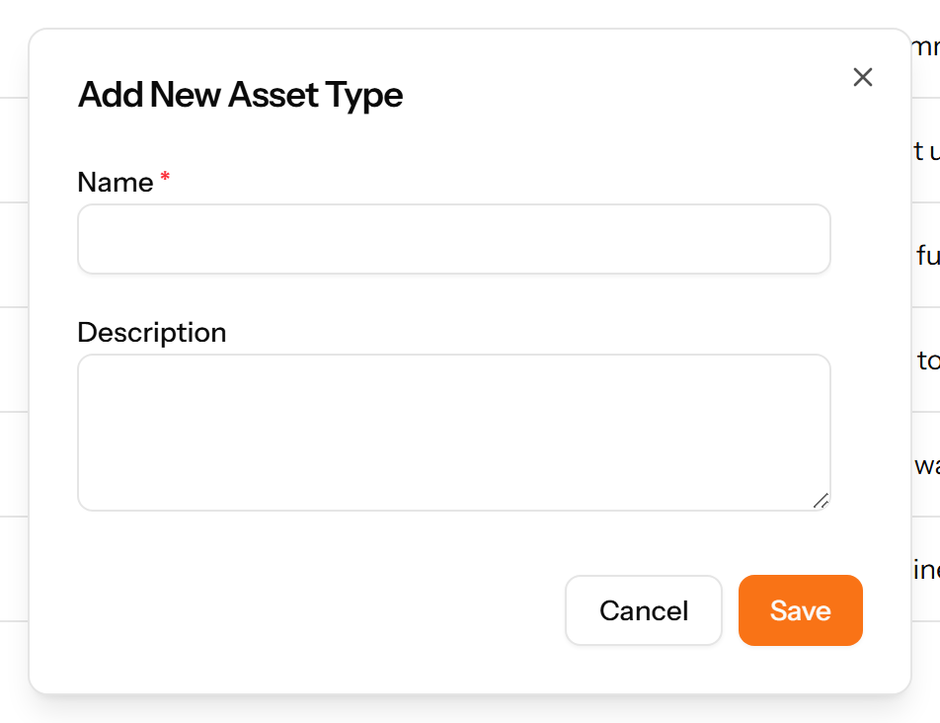
Figure 113: The Add Asset Type form

16.2 Assets
Company property and who currently holds it. Each asset has a code, a status, a purchase date and cost, and may be assigned to an employee.
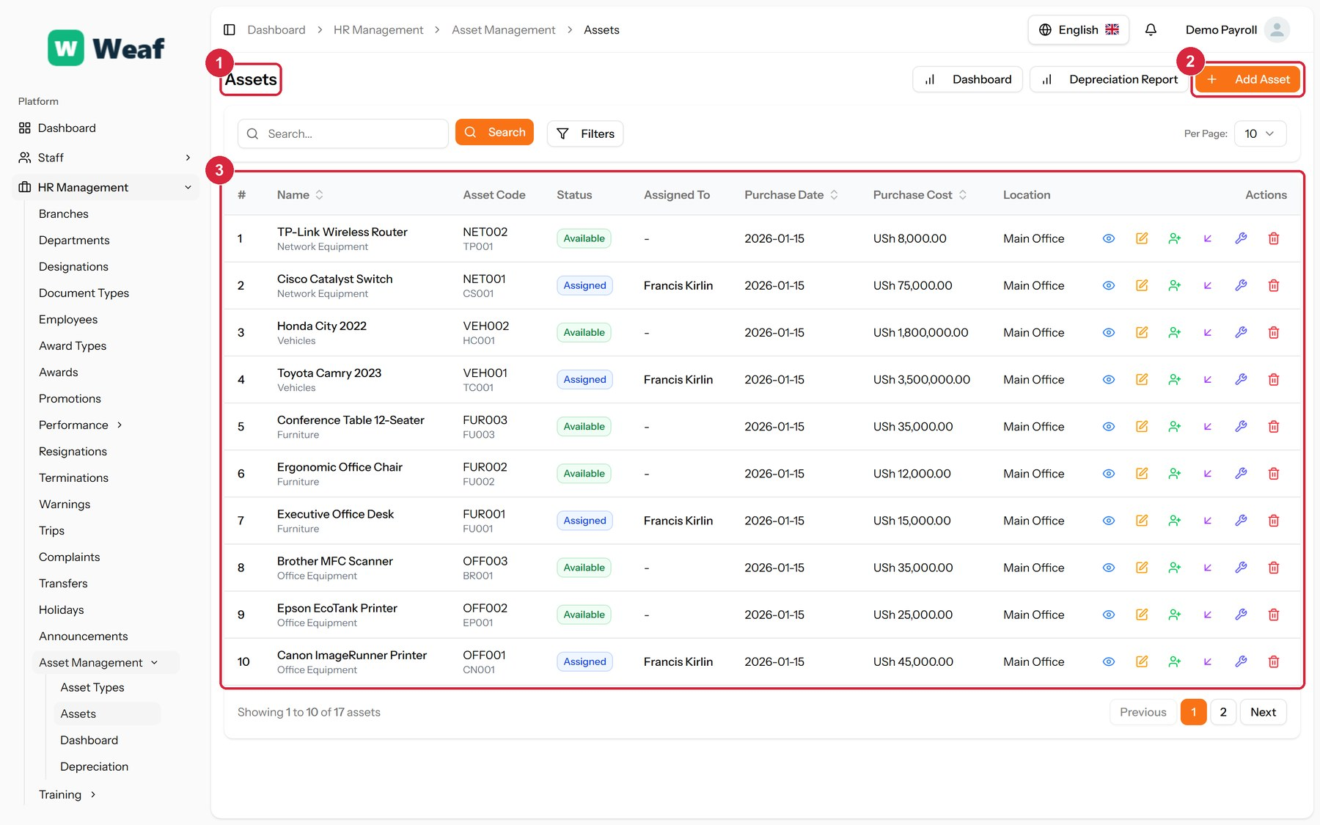
Figure 114: The Assets page
1 page title · 2 primary action · 3 records table
Columns: #, Name, Asset Code, Status, Assigned To, Purchase Date, Purchase Cost, Location, Actions
Actions on this page: Dashboard, Depreciation Report, Add Asset
1. Choose Add Asset at the top right. The form opens in a panel.
2. Complete the required fields: Name.
3. Fill in anything else that applies: Serial Number, Asset Code, Purchase Date, Purchase Cost, Description, Location, Supplier, Warranty Information.
4. Make the selections the form asks for: Asset Type, Status, Condition, Depreciation Method.
5. Choose Save. The new record appears in the list.
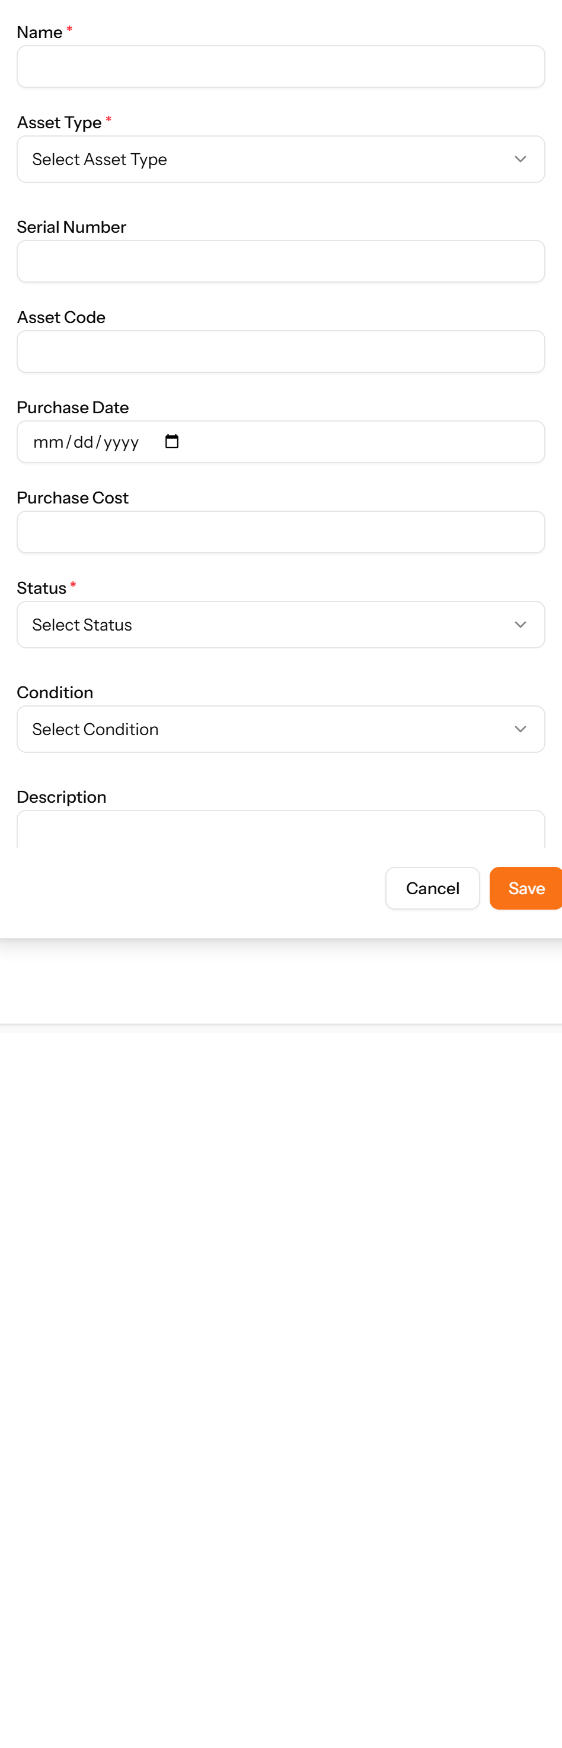
Figure 115: The Add Asset form

16.3 Dashboard
A summary of the asset register: what is held, what is assigned and what it is worth.
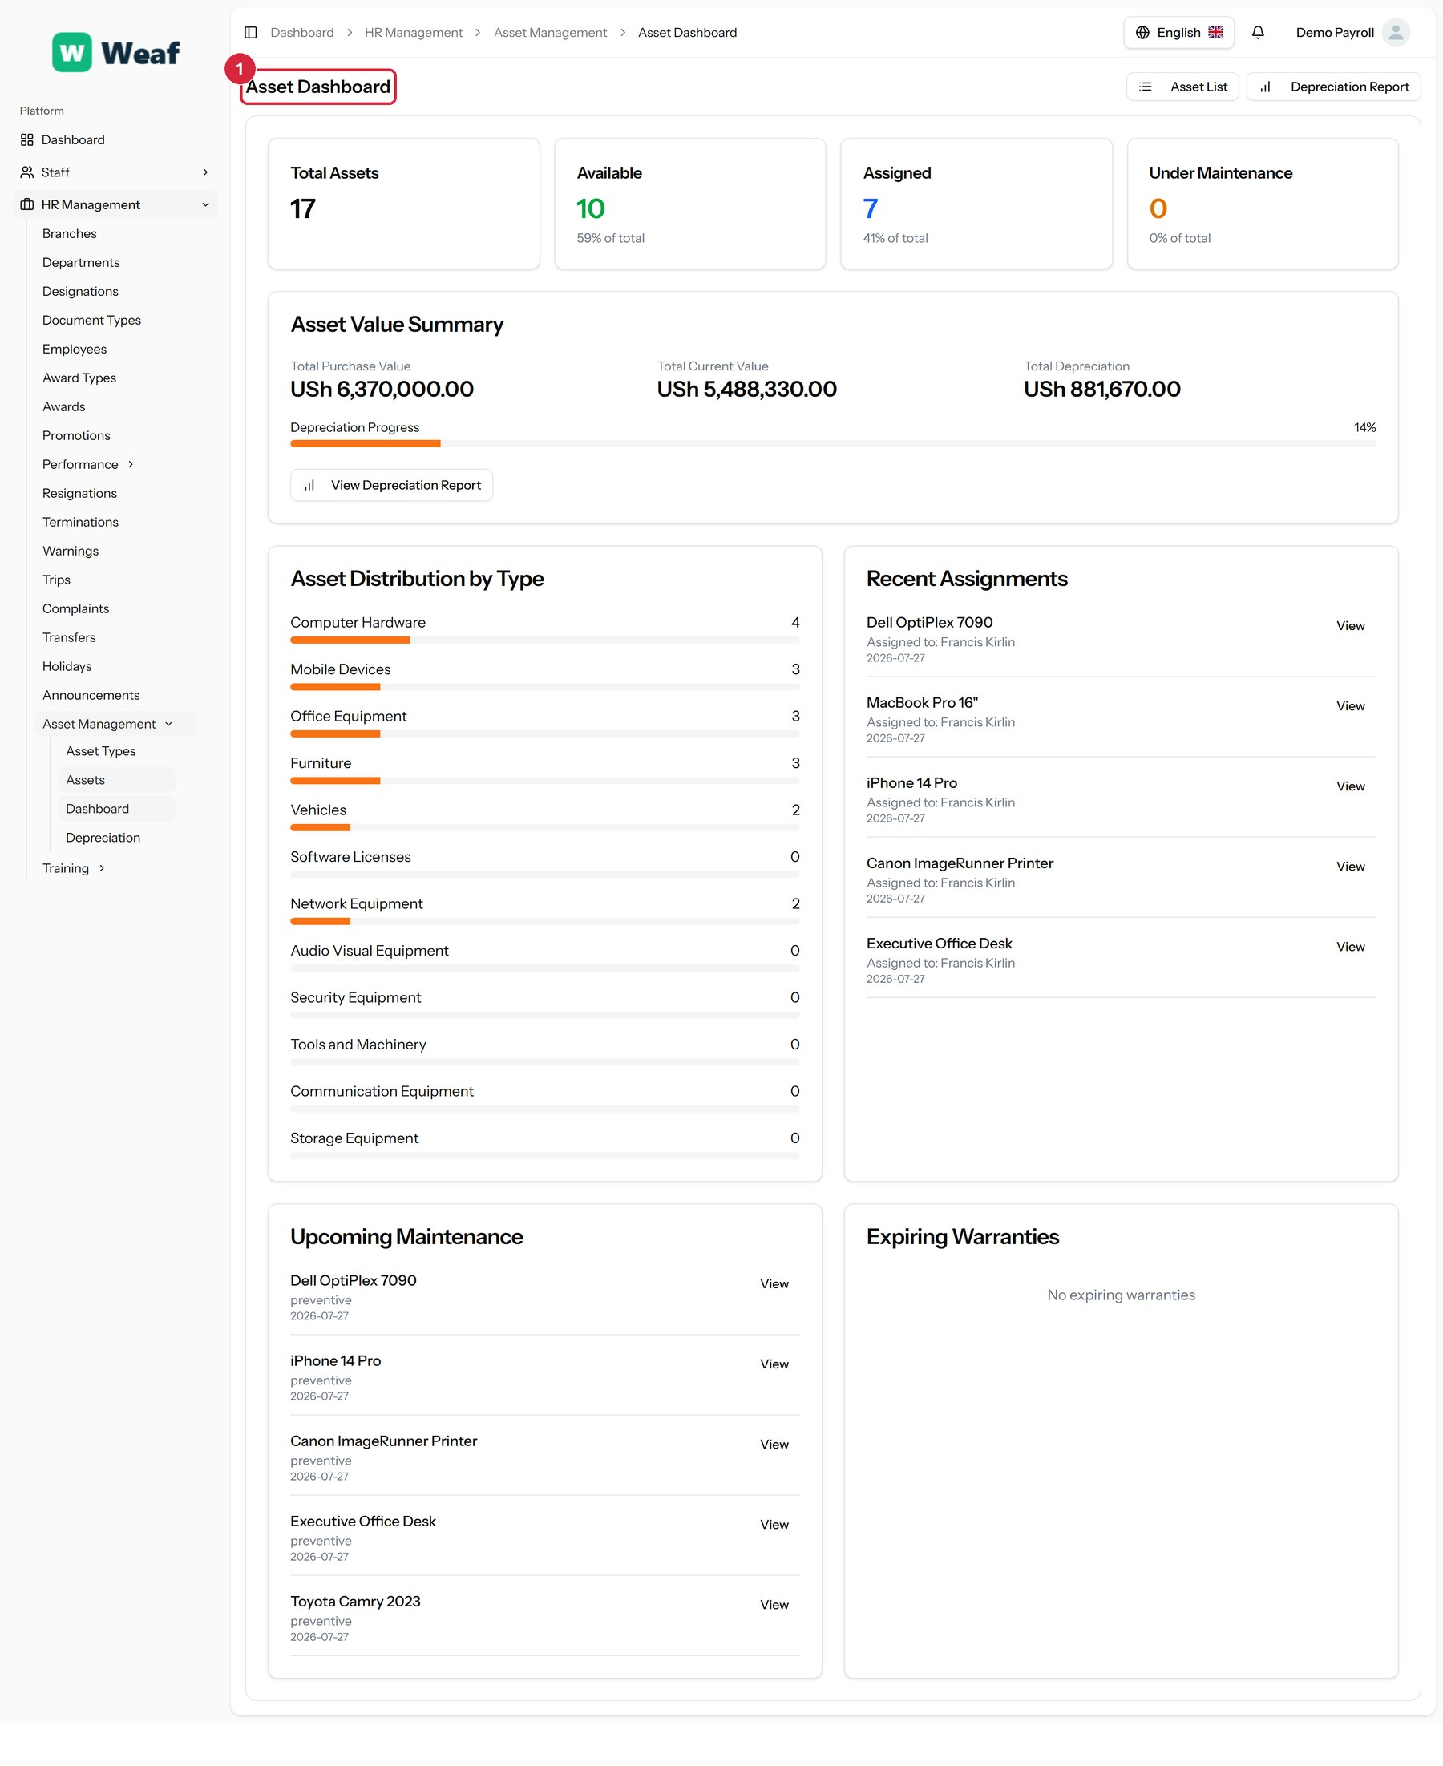
Figure 116: The Dashboard page
1 page title
Actions on this page: Asset List, Depreciation Report, View Depreciation Report, View

16.4 Depreciation
What the asset register is worth now rather than when it was bought, using each asset's depreciation method to give a current value.
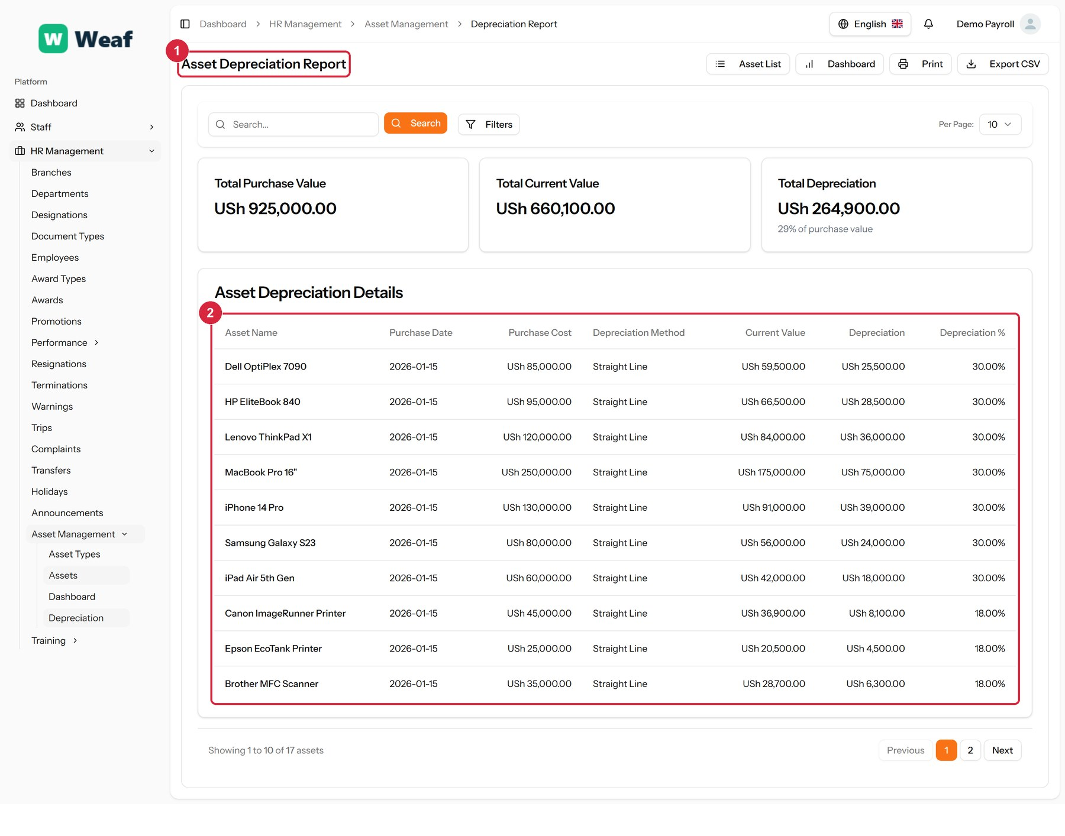
Figure 117: The Depreciation page
1 page title · 2 records table
Columns: Asset Name, Purchase Date, Purchase Cost, Depreciation Method, Current Value, Depreciation, Depreciation %
Actions on this page: Asset List, Dashboard, Print, Export CSV

17. Contracts
Contract types describe the kinds of agreement you offer, templates hold the wording, and employee contracts are the agreements actually in force.
Pages in this chapter: Contract Types, Employee Contracts, Contract Templates

17.1 Contract Types
The shapes of employment you offer — permanent, fixed term, probationary — each with its duration, probation, notice period and whether it can be renewed.
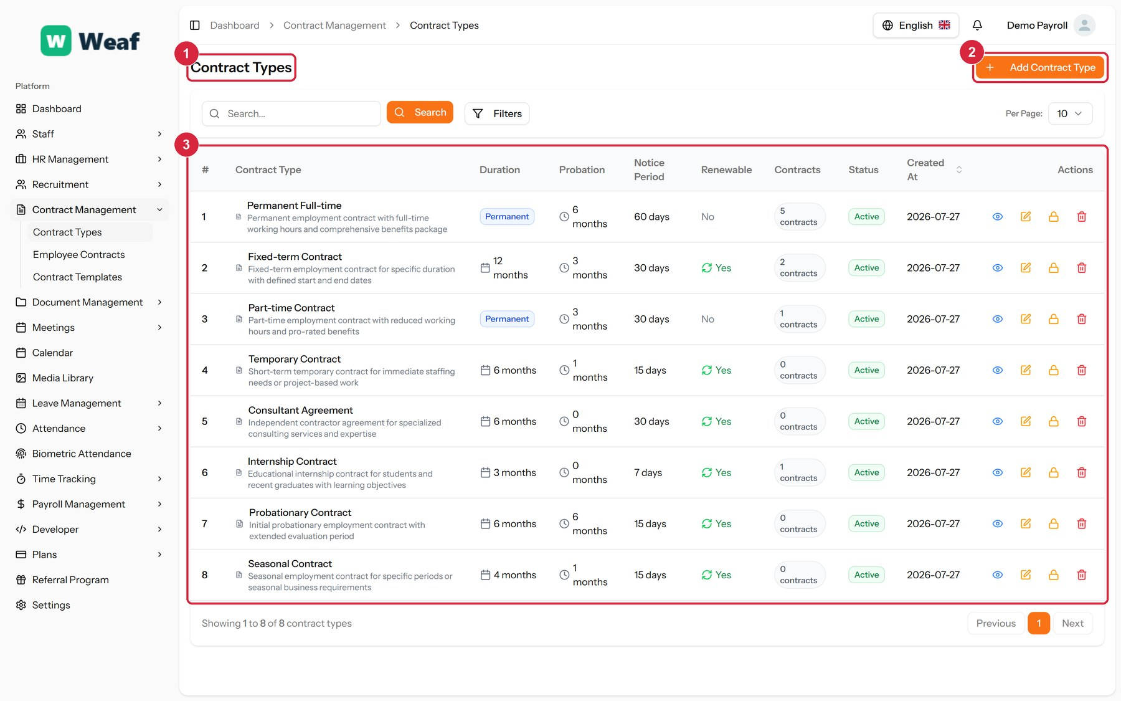
Figure 118: The Contract Types page
1 page title · 2 primary action · 3 records table
Columns: #, Contract Type, Duration, Probation, Notice Period, Renewable, Contracts, Status, Created At, Actions
Actions on this page: Add Contract Type
1. Choose Add Contract Type at the top right. The form opens in a panel.
2. Complete the required fields: Contract Type Name, Probation Period (months), Notice Period (days).
3. Fill in anything else that applies: Description, Default Duration (months), Is Renewable.
4. Make the selections the form asks for: Status.
5. Choose Save. The new record appears in the list.
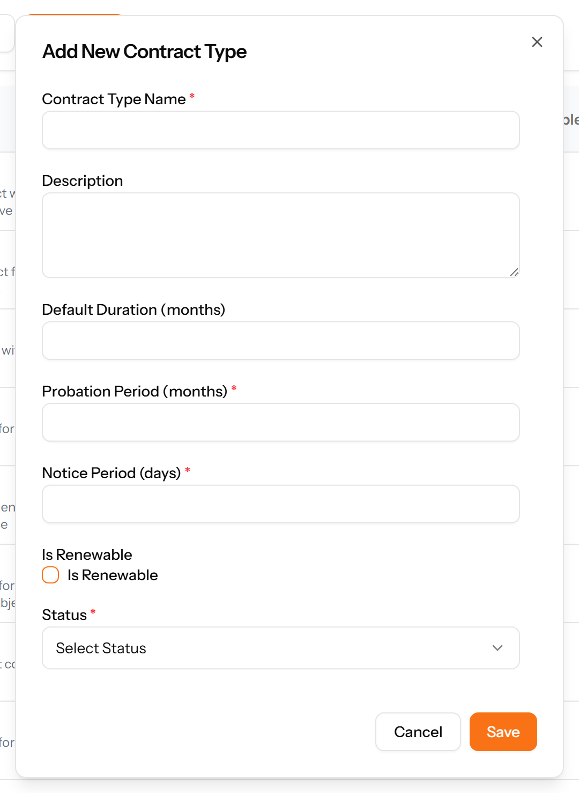
Figure 119: The Add Contract Type form

17.2 Employee Contracts
The actual agreements: which employee, for what period, on what compensation, and whether it has been approved.
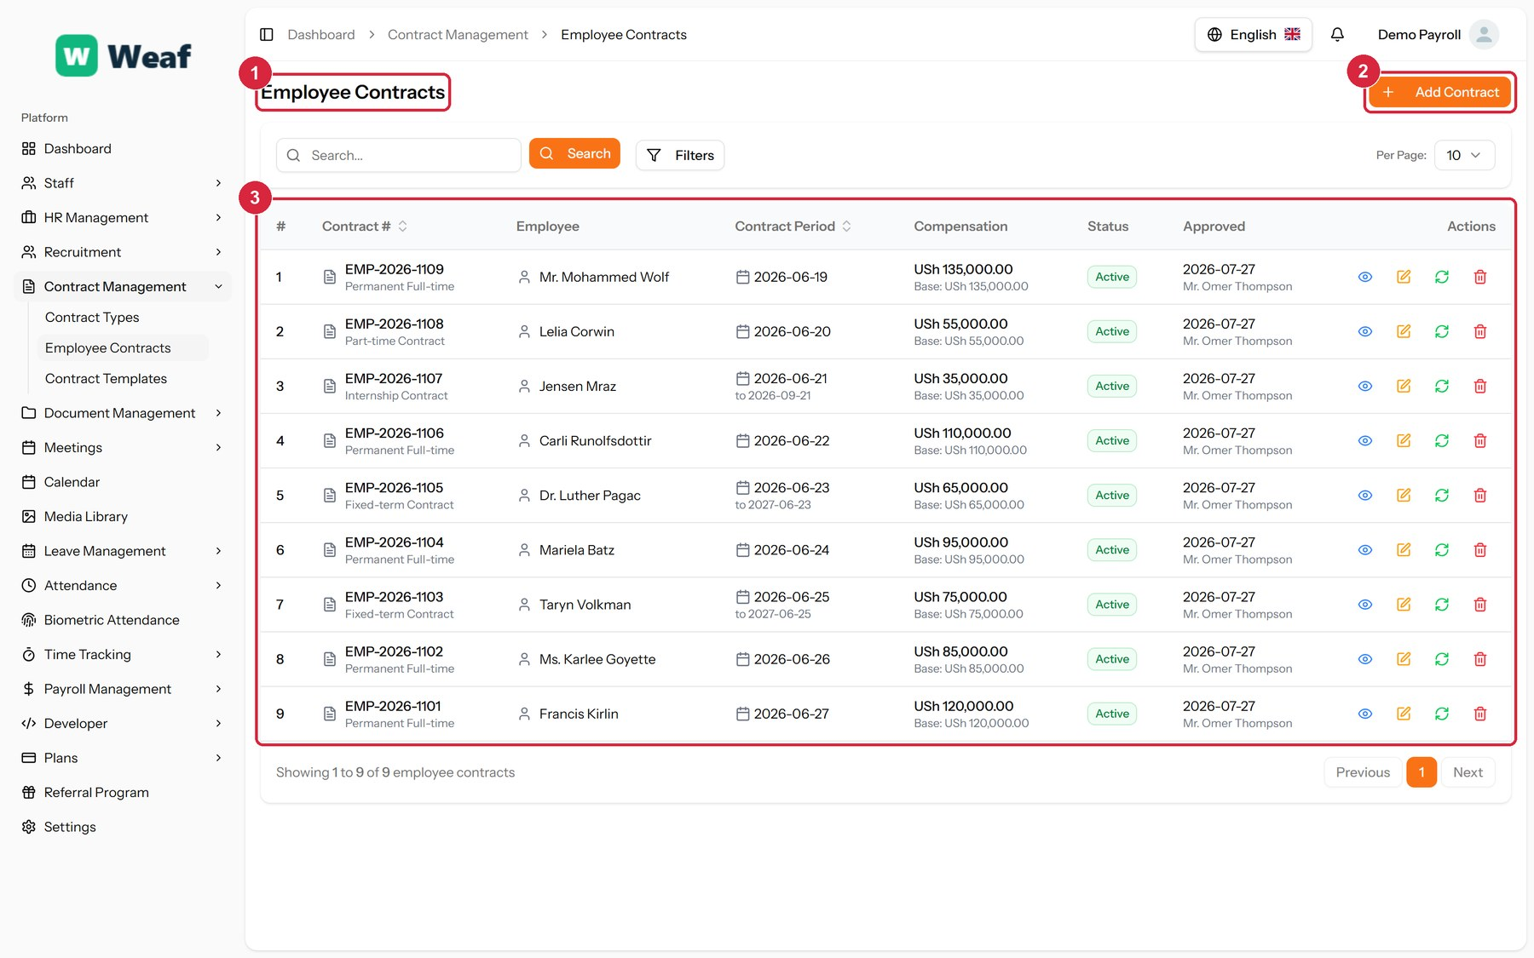
Figure 120: The Employee Contracts page
1 page title · 2 primary action · 3 records table
Columns: #, Contract #, Employee, Contract Period, Compensation, Status, Approved, Actions
Actions on this page: Add Contract
1. Choose Add Contract at the top right. The form opens in a panel.
2. Complete the required fields: Start Date, Basic Salary.
3. Fill in anything else that applies: End Date, Terms & Conditions.
4. Make the selections the form asks for: Employee, Contract Type.
5. Choose Save. The new record appears in the list.
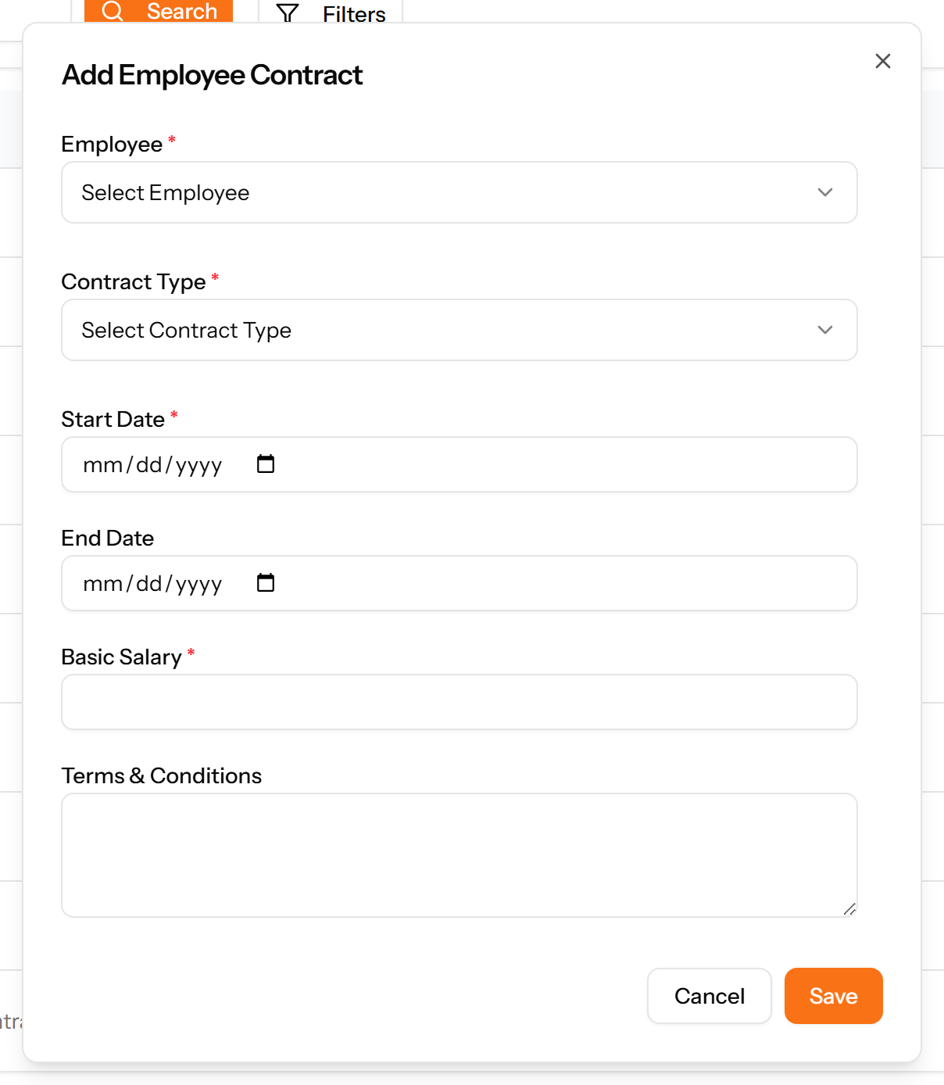
Figure 121: The Add Contract form

17.3 Contract Templates
Standard contract wording with variables and clauses, so issuing a contract does not mean drafting one.
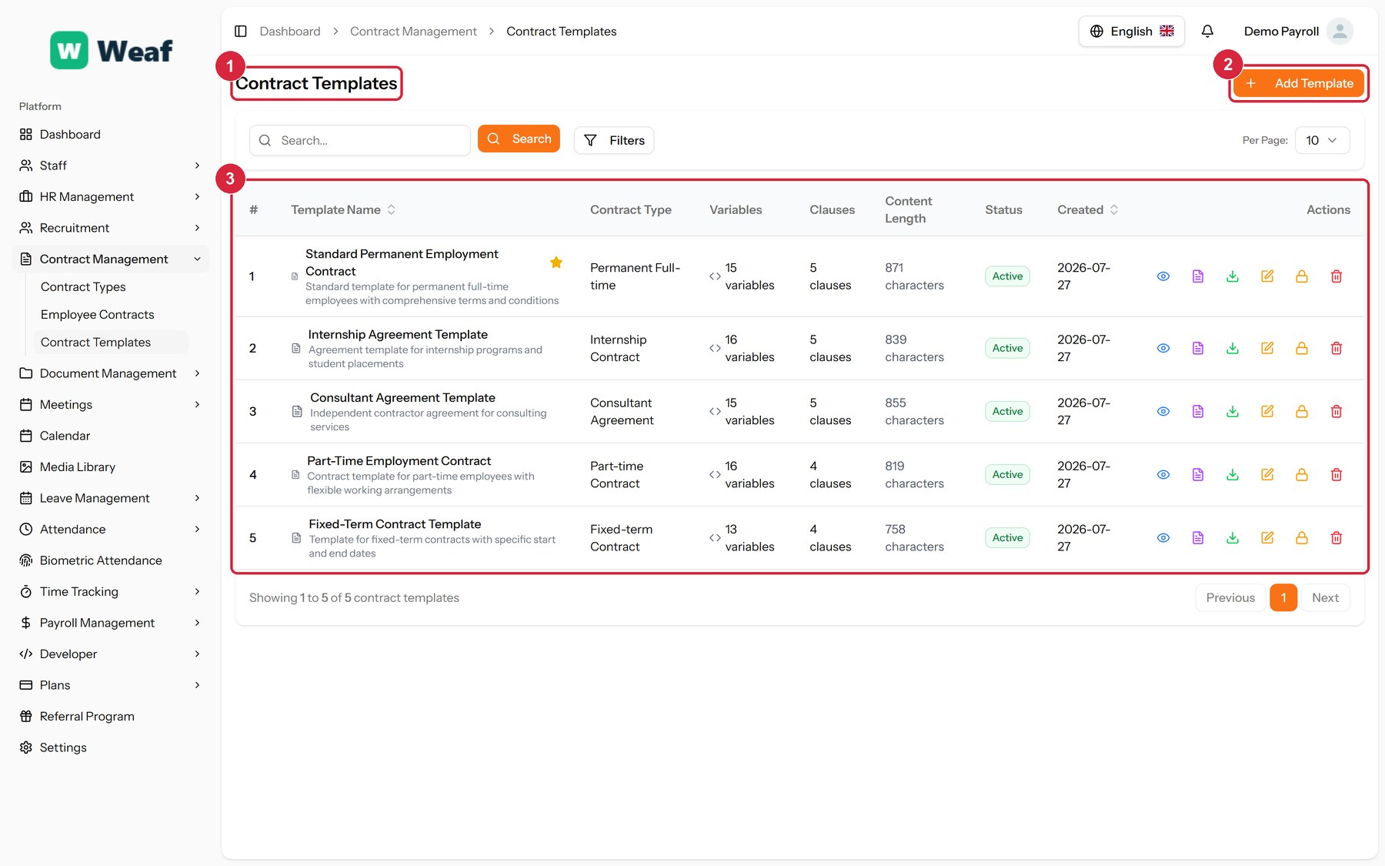
Figure 122: The Contract Templates page
1 page title · 2 primary action · 3 records table
Columns: #, Template Name, Contract Type, Variables, Clauses, Content Length, Status, Created, Actions
Actions on this page: Add Template
1. Choose Add Template at the top right. The form opens in a panel.
2. Complete the required fields: Template Name, Template Content.
3. Fill in anything else that applies: Description, Variables, Clauses, Set as Default for Type.
4. Make the selections the form asks for: Contract Type, Status.
5. Choose Save. The new record appears in the list.
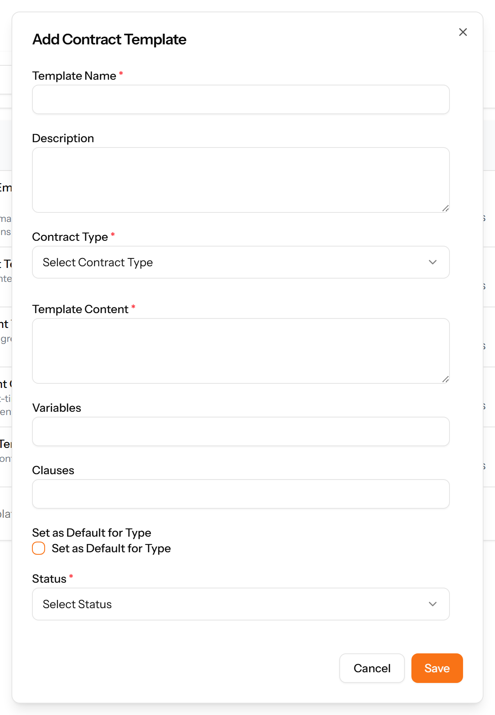
Figure 123: The Add Template form

18. Documents
This module holds company documents and, importantly, proof that people have read them.
Pages in this chapter: Document Categories, HR Documents, Acknowledgments, Document Templates

18.1 Document Categories
A reference list. Entries created here become the options offered when you create an HR document. Setting these up once, before the records that use them, saves correcting the same choice repeatedly later.
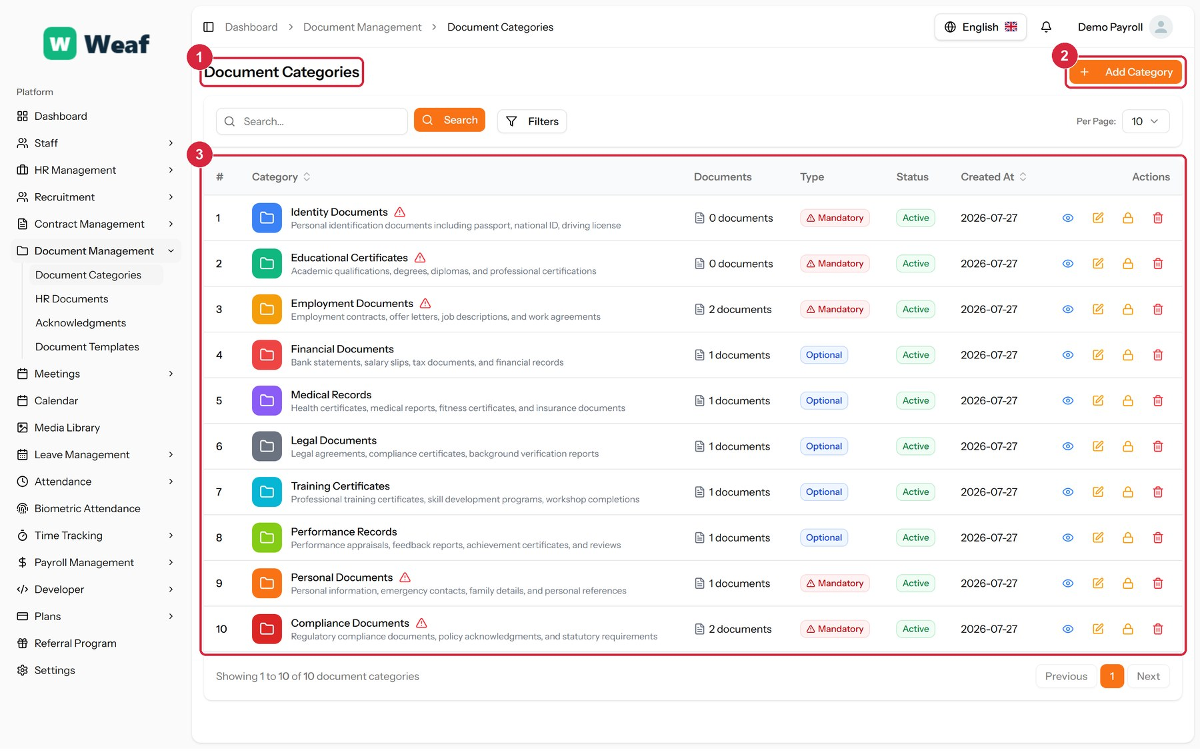
Figure 124: The Document Categories page
1 page title · 2 primary action · 3 records table
Columns: #, Category, Documents, Type, Status, Created At, Actions
Actions on this page: Add Category
1. Choose Add Category at the top right. The form opens in a panel.
2. Complete the required fields: Category Name, Color.
3. Fill in anything else that applies: Description, Mandatory Category.
4. Make the selections the form asks for: Icon, Status.
5. Choose Save. The new record appears in the list.
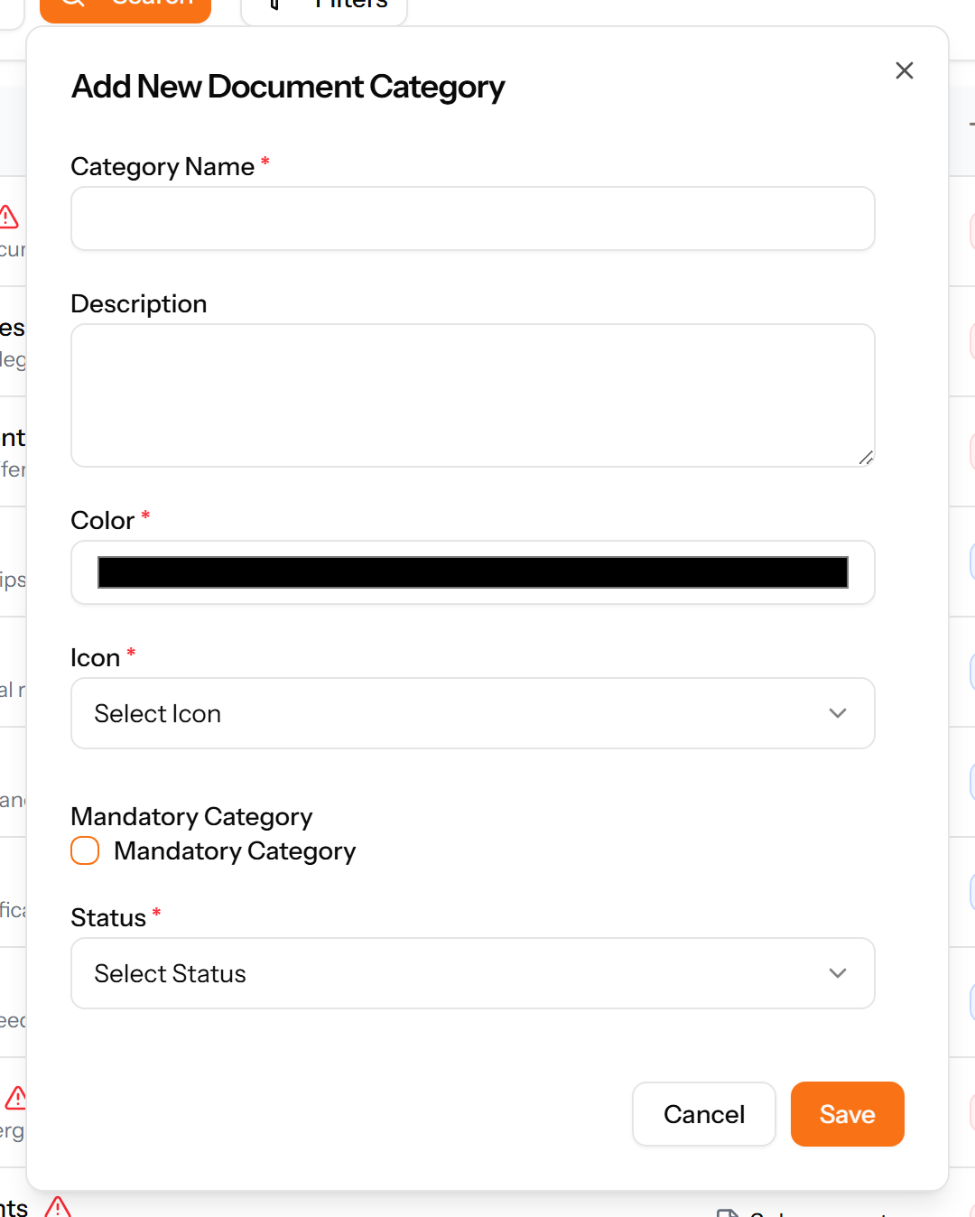
Figure 125: The Add Category form

18.2 HR Documents
The company's own documents — policies, handbooks, forms — with their size, status, download count and expiry.
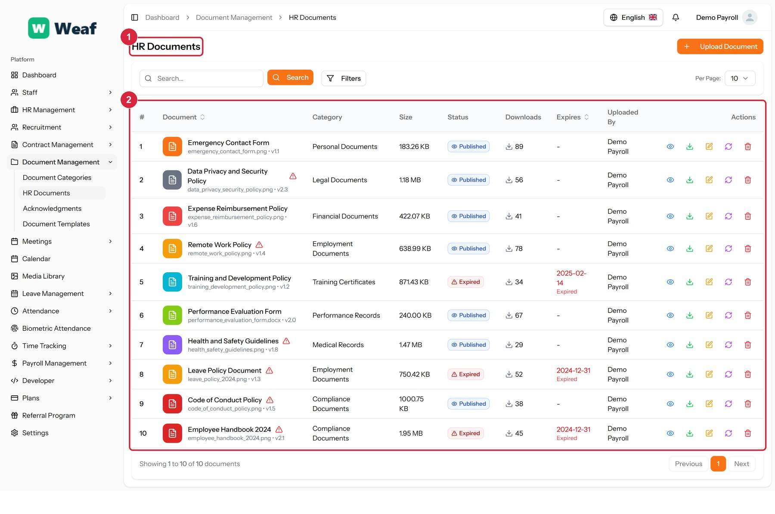
Figure 126: The HR Documents page
1 page title · 2 records table
Columns: #, Document, Category, Size, Status, Downloads, Expires, Uploaded By, Actions
Actions on this page: Upload Document

18.3 Acknowledgments
Who has confirmed they have read which document, and by when they were required to. This is the page that turns a published policy into evidence that it was received.
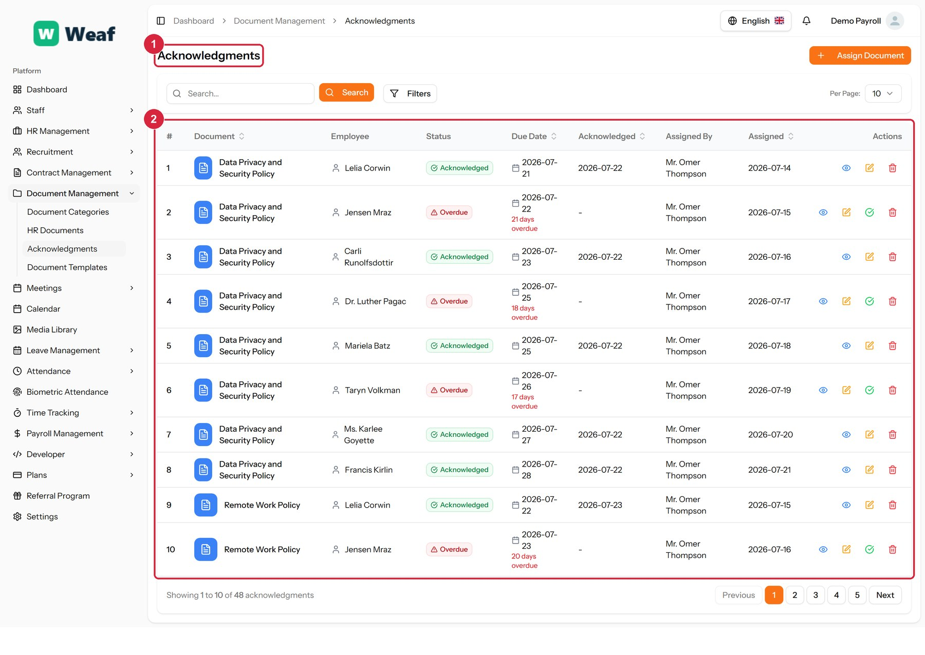
Figure 127: The Acknowledgments page
1 page title · 2 records table
Columns: #, Document, Employee, Status, Due Date, Acknowledged, Assigned By, Assigned, Actions
Actions on this page: Assign Document

18.4 Document Templates
Reusable document wording with placeholders, used to generate letters and forms.
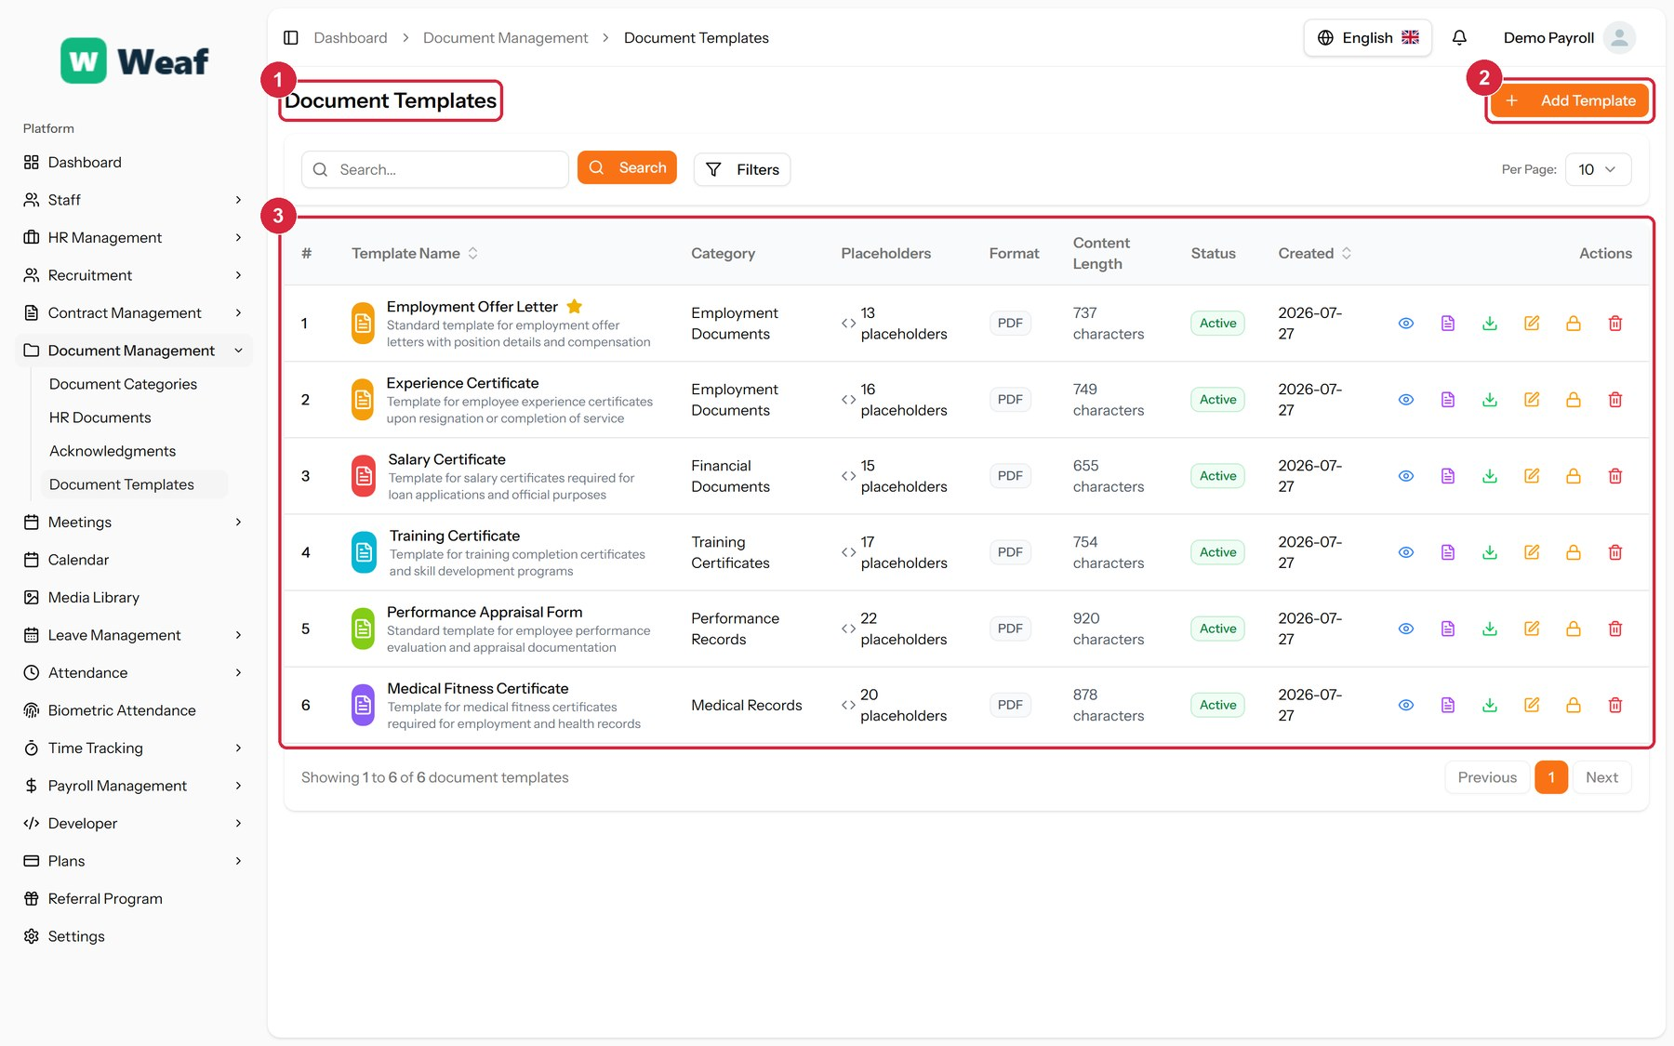
Figure 128: The Document Templates page
1 page title · 2 primary action · 3 records table
Columns: #, Template Name, Category, Placeholders, Format, Content Length, Status, Created, Actions
Actions on this page: Add Template
1. Choose Add Template at the top right. The form opens in a panel.
2. Complete the required fields: Template Name, Template Content.
3. Fill in anything else that applies: Description, Placeholders, Default Values, Set as Default for Category.
4. Make the selections the form asks for: Category, File Format, Status.
5. Choose Save. The new record appears in the list.
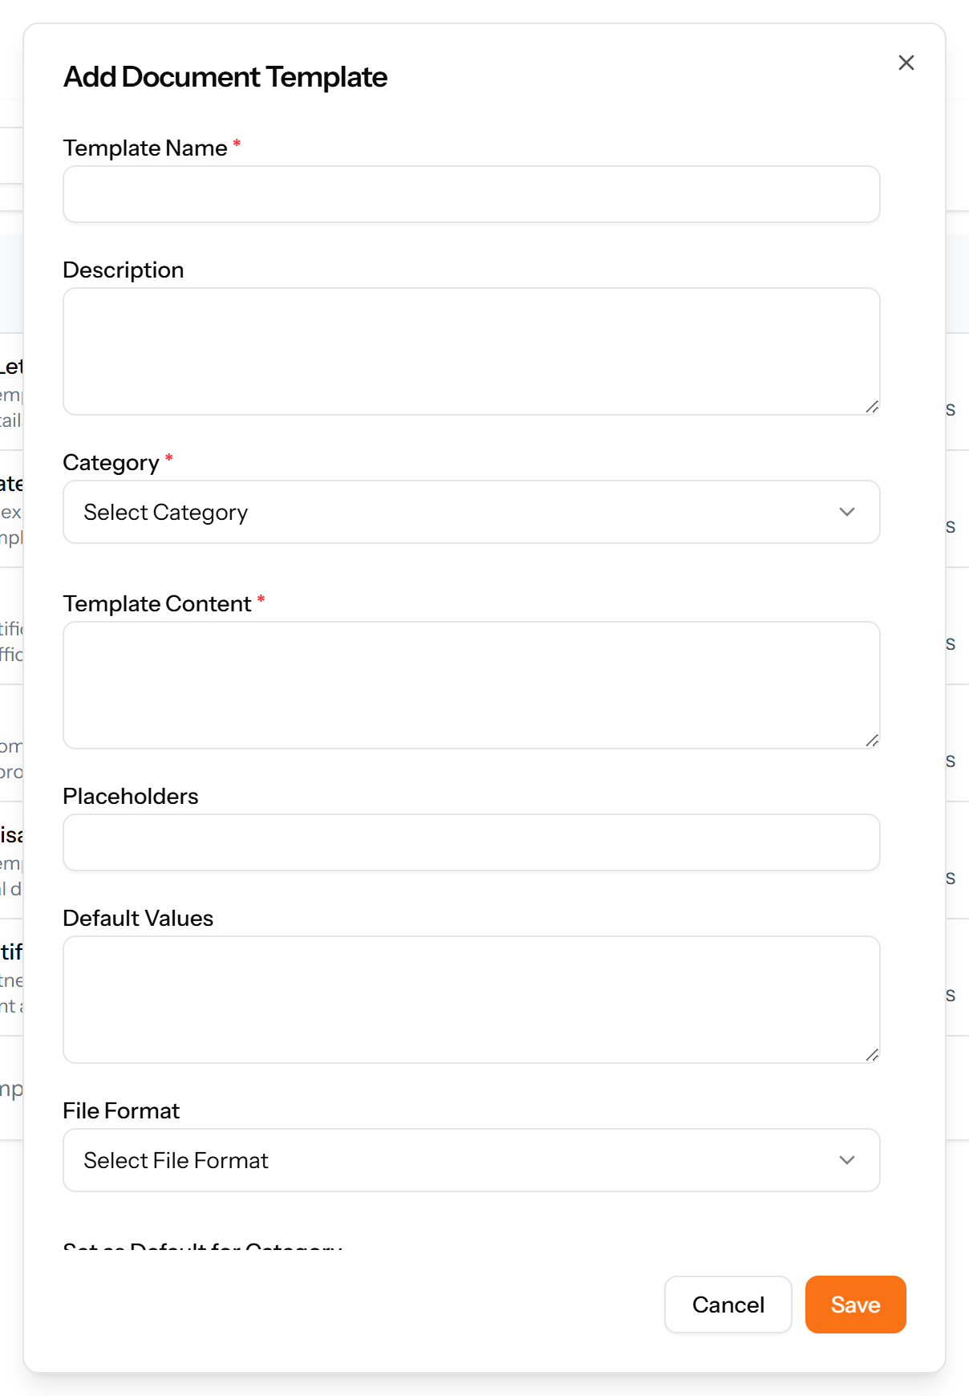
Figure 129: The Add Template form

19. Meetings and Calendar
Meetings are scheduled, attended, minuted and — the part that matters afterwards — turned into action items with owners and due dates.
Pages in this chapter: Meeting Types, Meeting Rooms, Meetings, Meeting Attendees, Meeting Minutes, Action Items, Calendar, Media Library

19.1 Meeting Types
A reference list. Entries created here become the options offered when you create a meeting. Setting these up once, before the records that use them, saves correcting the same choice repeatedly later.
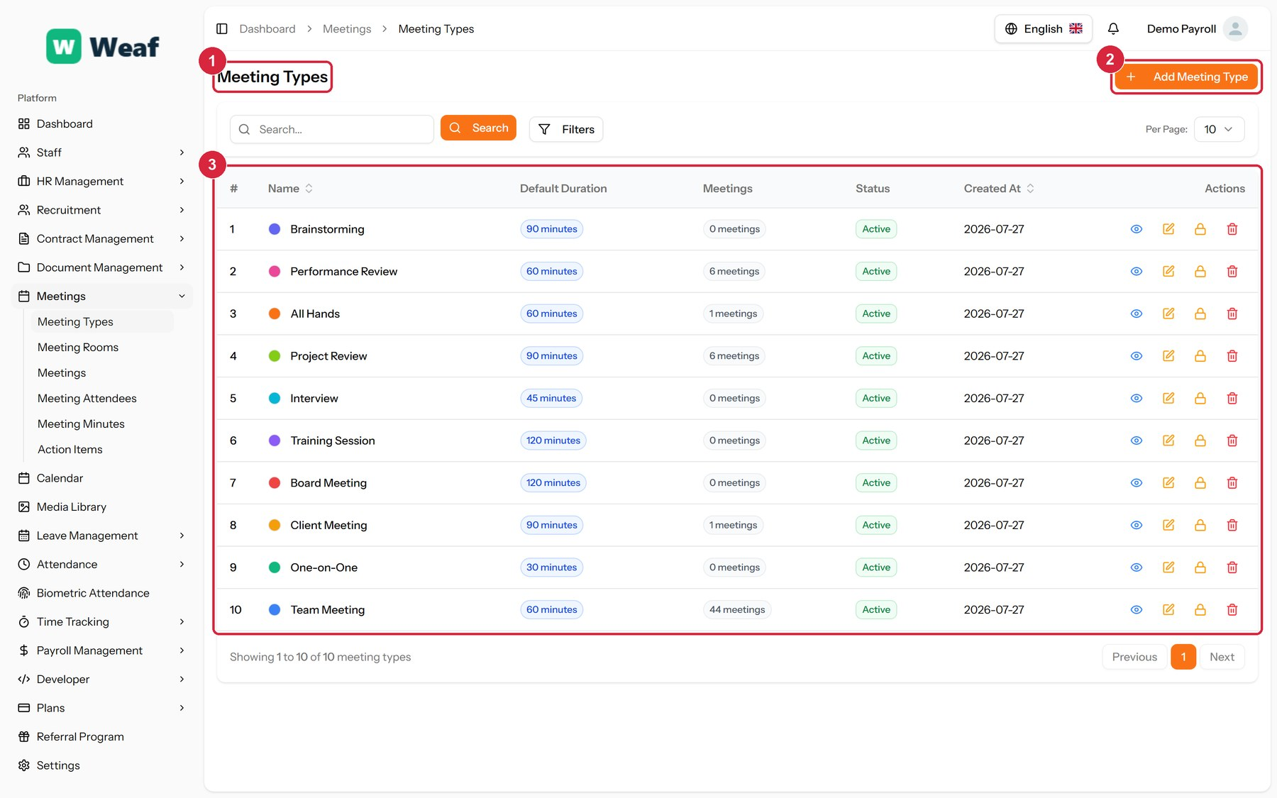
Figure 130: The Meeting Types page
1 page title · 2 primary action · 3 records table
Columns: #, Name, Default Duration, Meetings, Status, Created At, Actions
Actions on this page: Add Meeting Type
1. Choose Add Meeting Type at the top right. The form opens in a panel.
2. Complete the required fields: Name, Color, Default Duration (minutes).
3. Fill in anything else that applies: Description.
4. Make the selections the form asks for: Status.
5. Choose Save. The new record appears in the list.
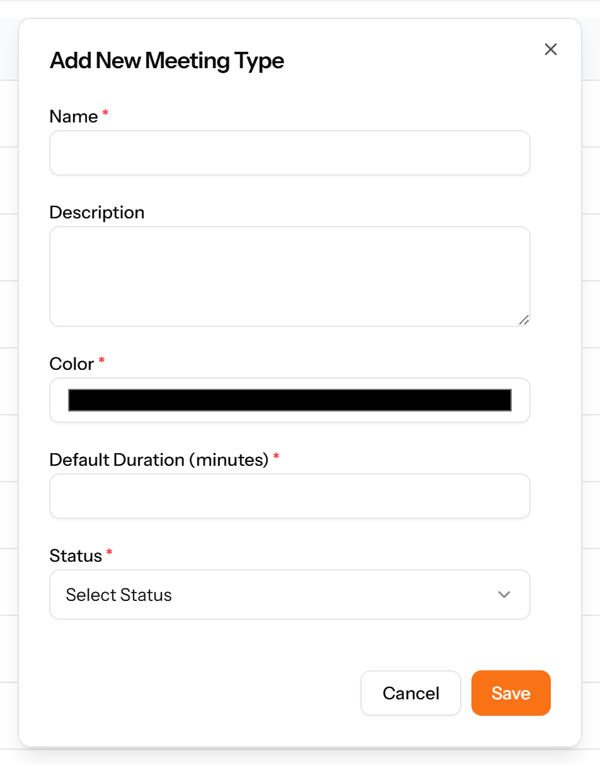
Figure 131: The Add Meeting Type form

19.2 Meeting Rooms
Bookable spaces, with their location, capacity and equipment.
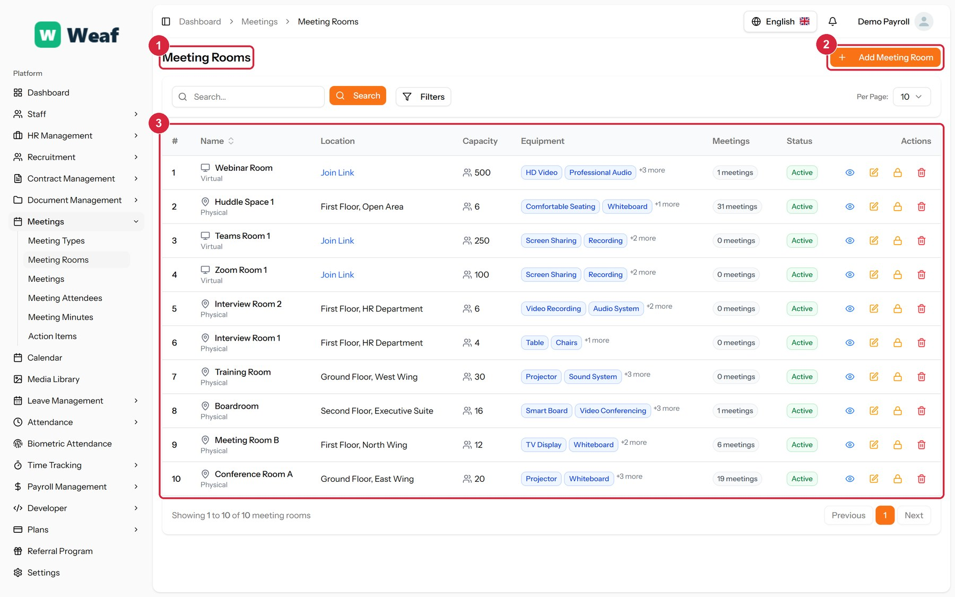
Figure 132: The Meeting Rooms page
1 page title · 2 primary action · 3 records table
Columns: #, Name, Location, Capacity, Equipment, Meetings, Status, Actions
Actions on this page: Add Meeting Room
1. Choose Add Meeting Room at the top right. The form opens in a panel.
2. Complete the required fields: Room Name, Capacity.
3. Fill in anything else that applies: Description, Location, Equipment, Booking URL.
4. Make the selections the form asks for: Type, Status.
5. Choose Save. The new record appears in the list.
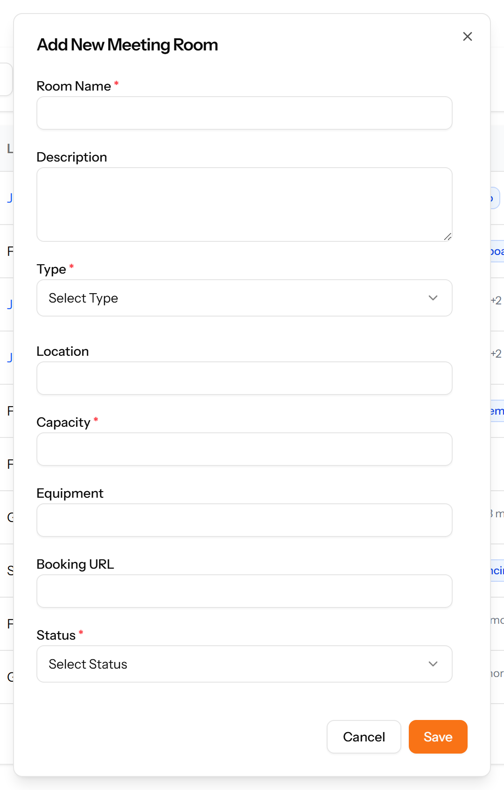
Figure 133: The Add Meeting Room form

19.3 Meetings
The meetings themselves: when, who organised them, which room, and whether they repeat.
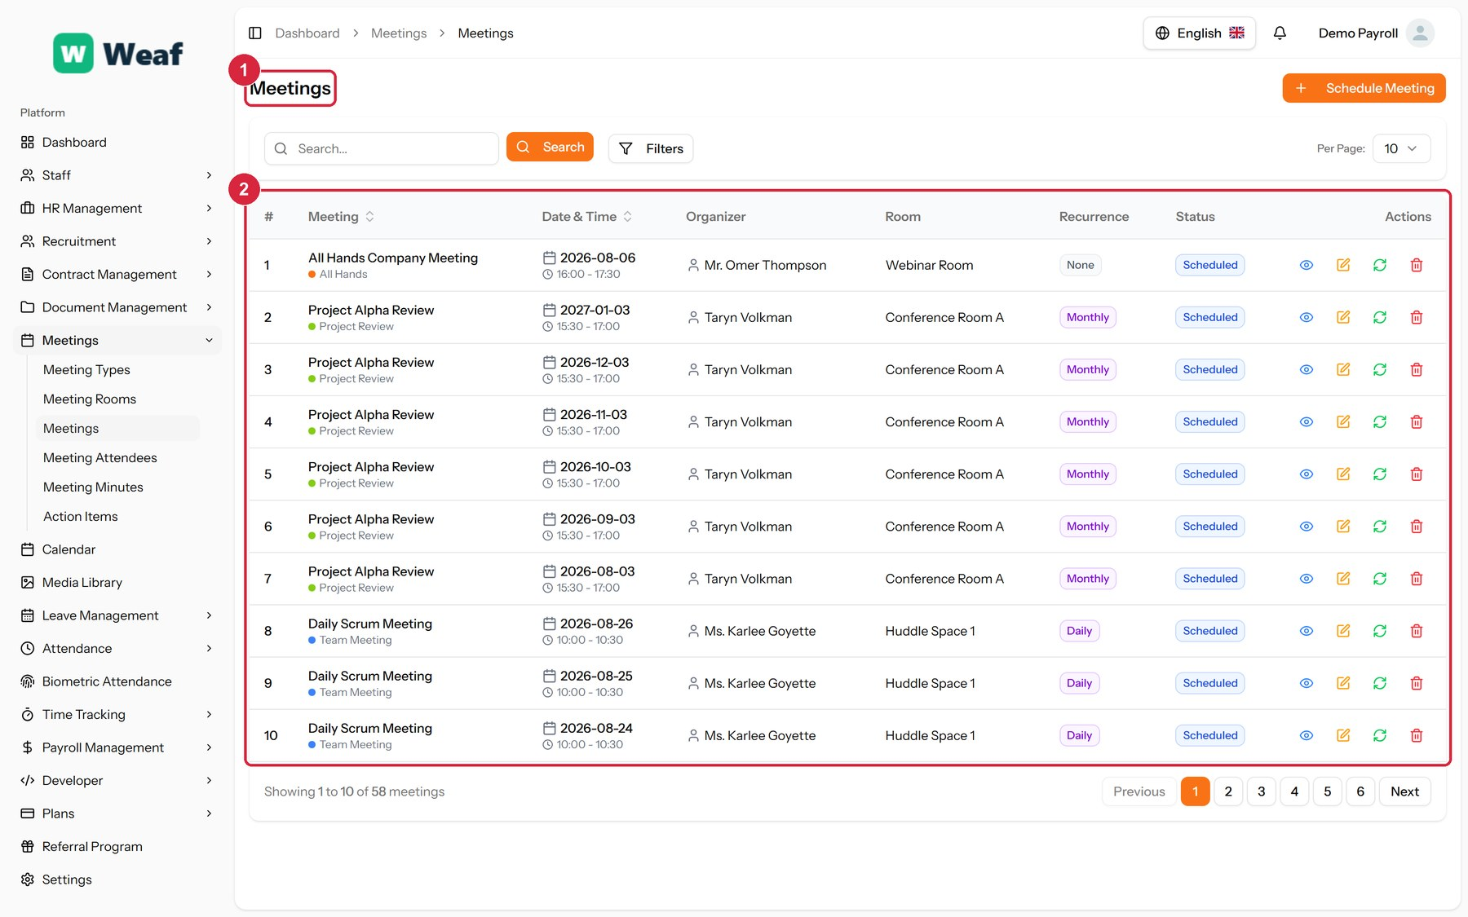
Figure 134: The Meetings page
1 page title · 2 records table
Columns: #, Meeting, Date & Time, Organizer, Room, Recurrence, Status, Actions
Actions on this page: Schedule Meeting

19.4 Meeting Attendees
Who was invited to each meeting, what they replied and whether they actually attended.
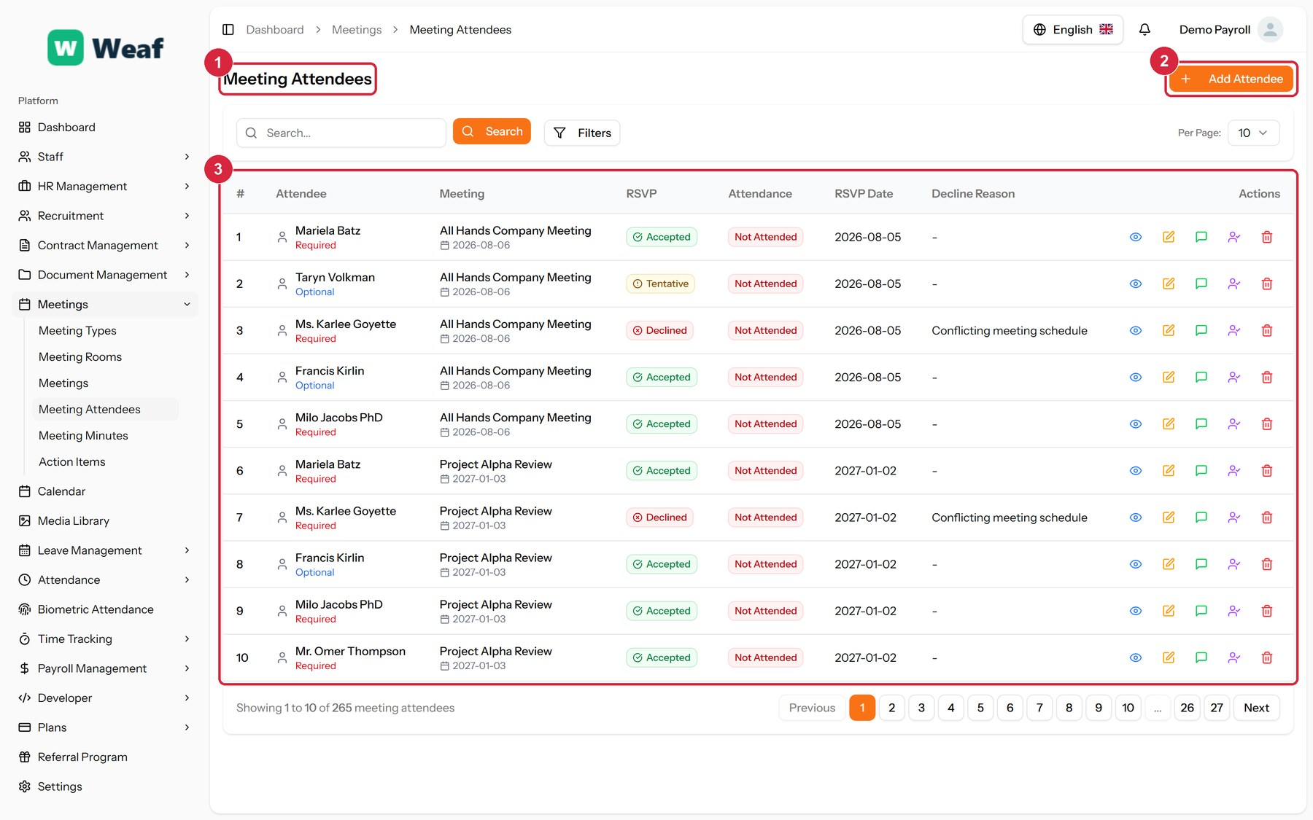
Figure 135: The Meeting Attendees page
1 page title · 2 primary action · 3 records table
Columns: #, Attendee, Meeting, RSVP, Attendance, RSVP Date, Decline Reason, Actions
Actions on this page: Add Attendee, ...
1. Choose Add Attendee at the top right. The form opens in a panel.
2. Fill in anything else that applies: Decline Reason.
3. Make the selections the form asks for: Meeting, Employee, Attendance Type, RSVP Status, Attendance Status.
4. Choose Save. The new record appears in the list.
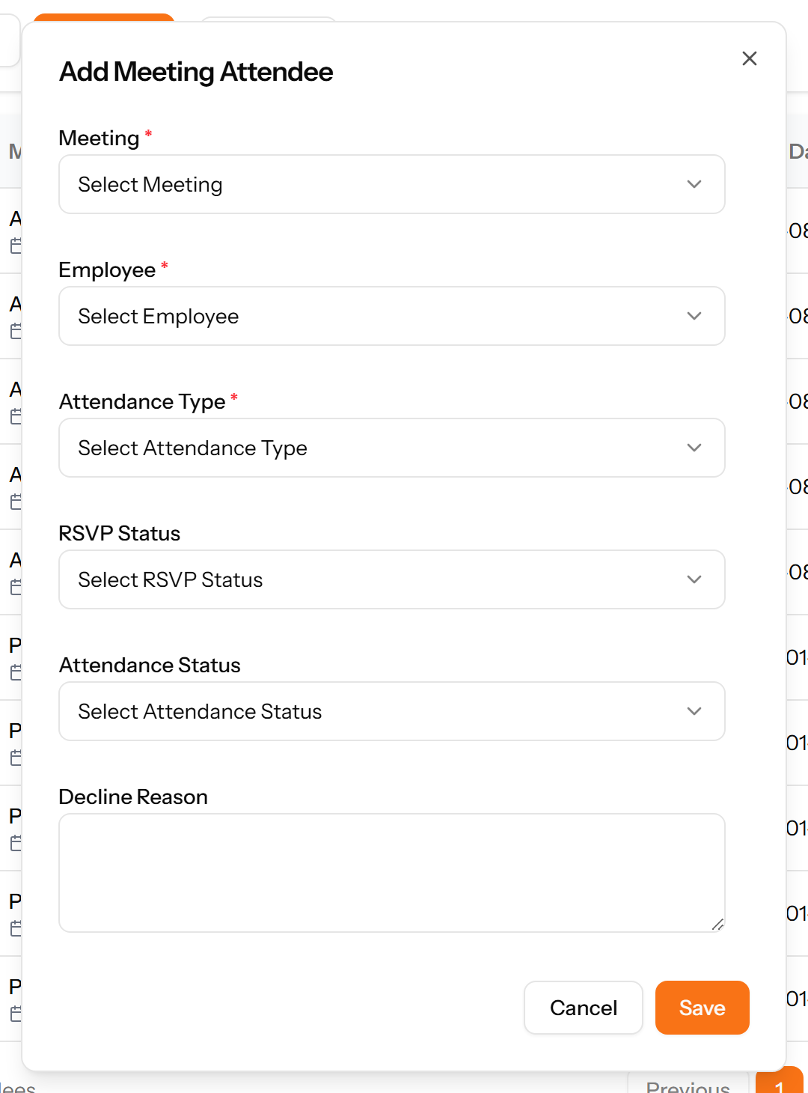
Figure 136: The Add Attendee form

19.5 Meeting Minutes
What was recorded against a meeting, by whom and when.
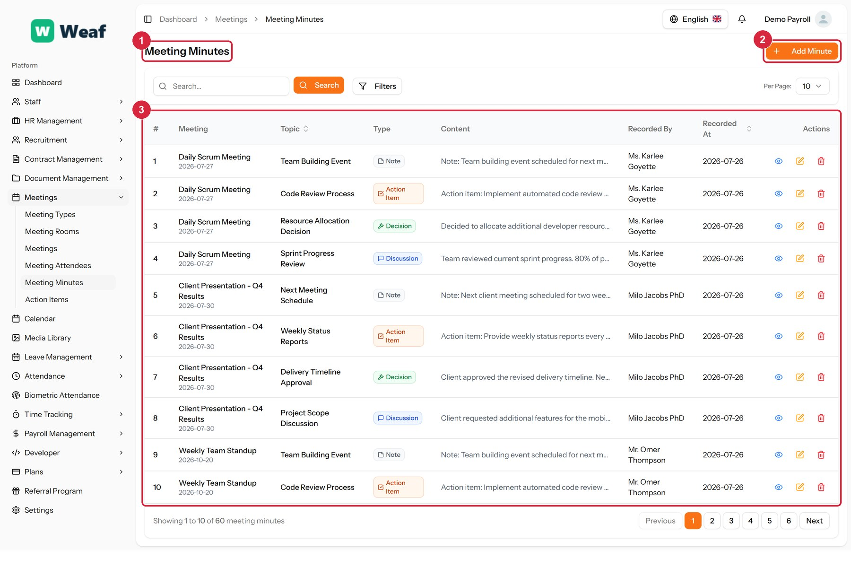
Figure 137: The Meeting Minutes page
1 page title · 2 primary action · 3 records table
Columns: #, Meeting, Topic, Type, Content, Recorded By, Recorded At, Actions
Actions on this page: Add Minute
1. Choose Add Minute at the top right. The form opens in a panel.
2. Complete the required fields: Topic, Content.
3. Fill in anything else that applies: Recorded Date, Recorded Time.
4. Make the selections the form asks for: Meeting, Type, Recorded By.
5. Choose Save. The new record appears in the list.
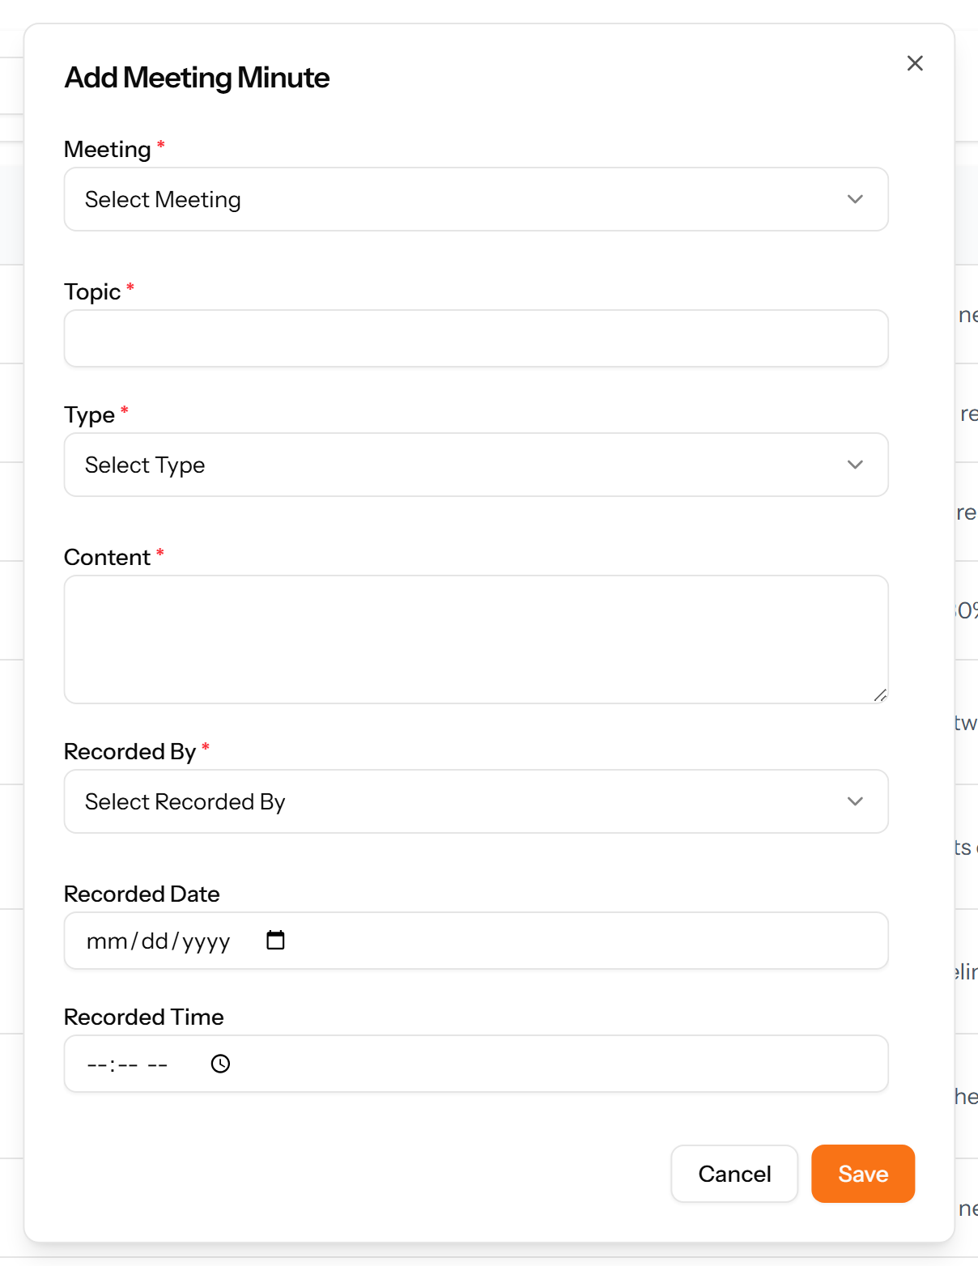
Figure 138: The Add Minute form

19.6 Action Items
Tasks arising from meetings, each with an owner, a due date, a priority and a progress figure — the part of a meeting that outlives it.
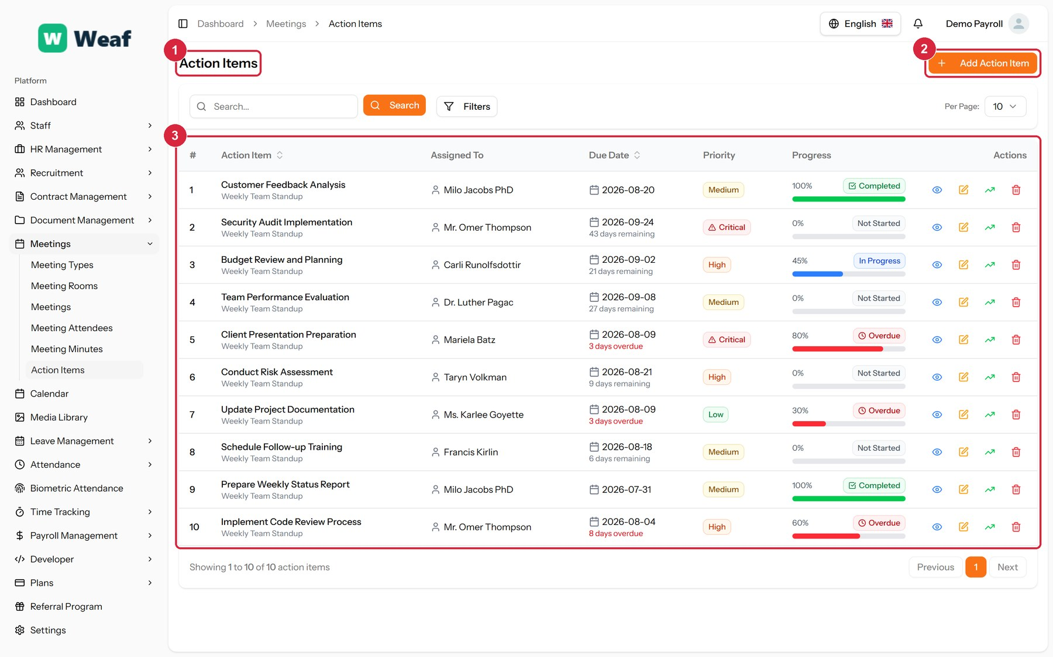
Figure 139: The Action Items page
1 page title · 2 primary action · 3 records table
Columns: #, Action Item, Assigned To, Due Date, Priority, Progress, Actions
Actions on this page: Add Action Item
1. Choose Add Action Item at the top right. The form opens in a panel.
2. Complete the required fields: Action Item Title, Due Date.
3. Fill in anything else that applies: Description, Progress (%), Notes.
4. Make the selections the form asks for: Meeting, Assign To, Priority.
5. Choose Save. The new record appears in the list.
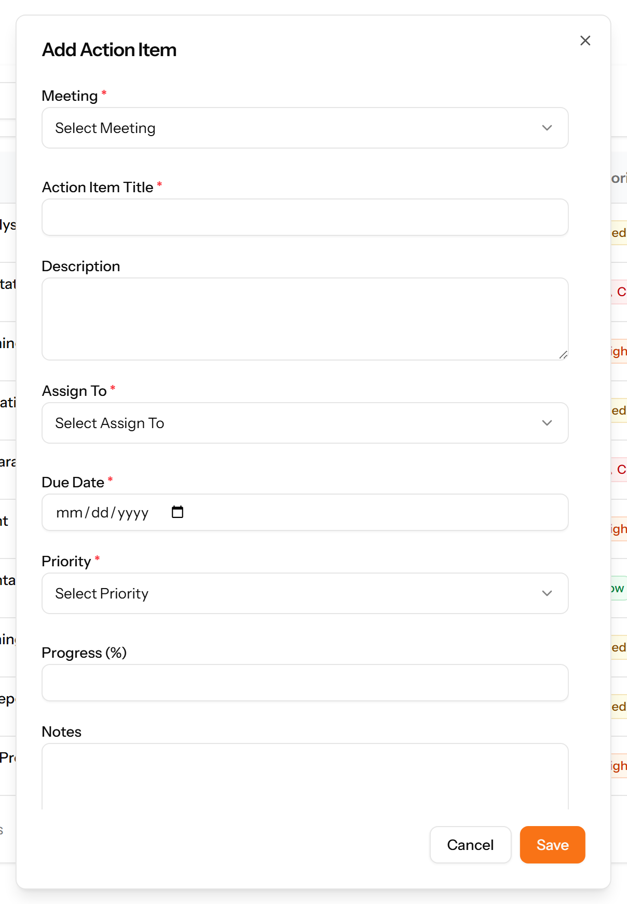
Figure 140: The Add Action Item form

19.7 Calendar
One month view of everything dated in the system: holidays, leave, meetings, interviews and training sessions. Use it to see what is happening before scheduling anything new.
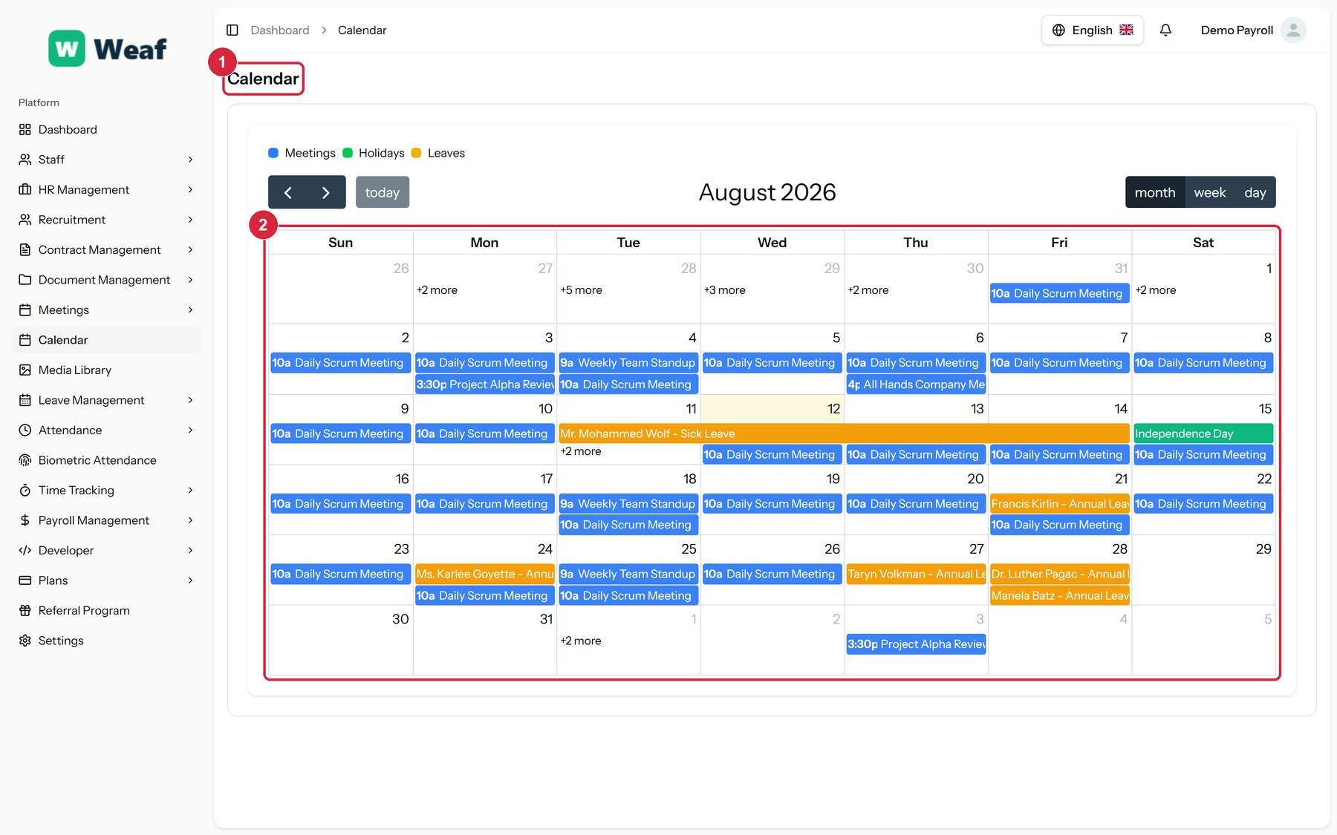
Figure 141: The Calendar page
1 page title · 2 records table
Columns: Sun Mon Tue Wed Thu Fri Sat, Sun, Mon, Tue, Wed, Thu, Fri, Sat
Actions on this page: today, month, week, day

19.8 Media Library
Every file uploaded anywhere in the system, in one place. Useful for finding a document when you remember the file but not the record it was attached to.
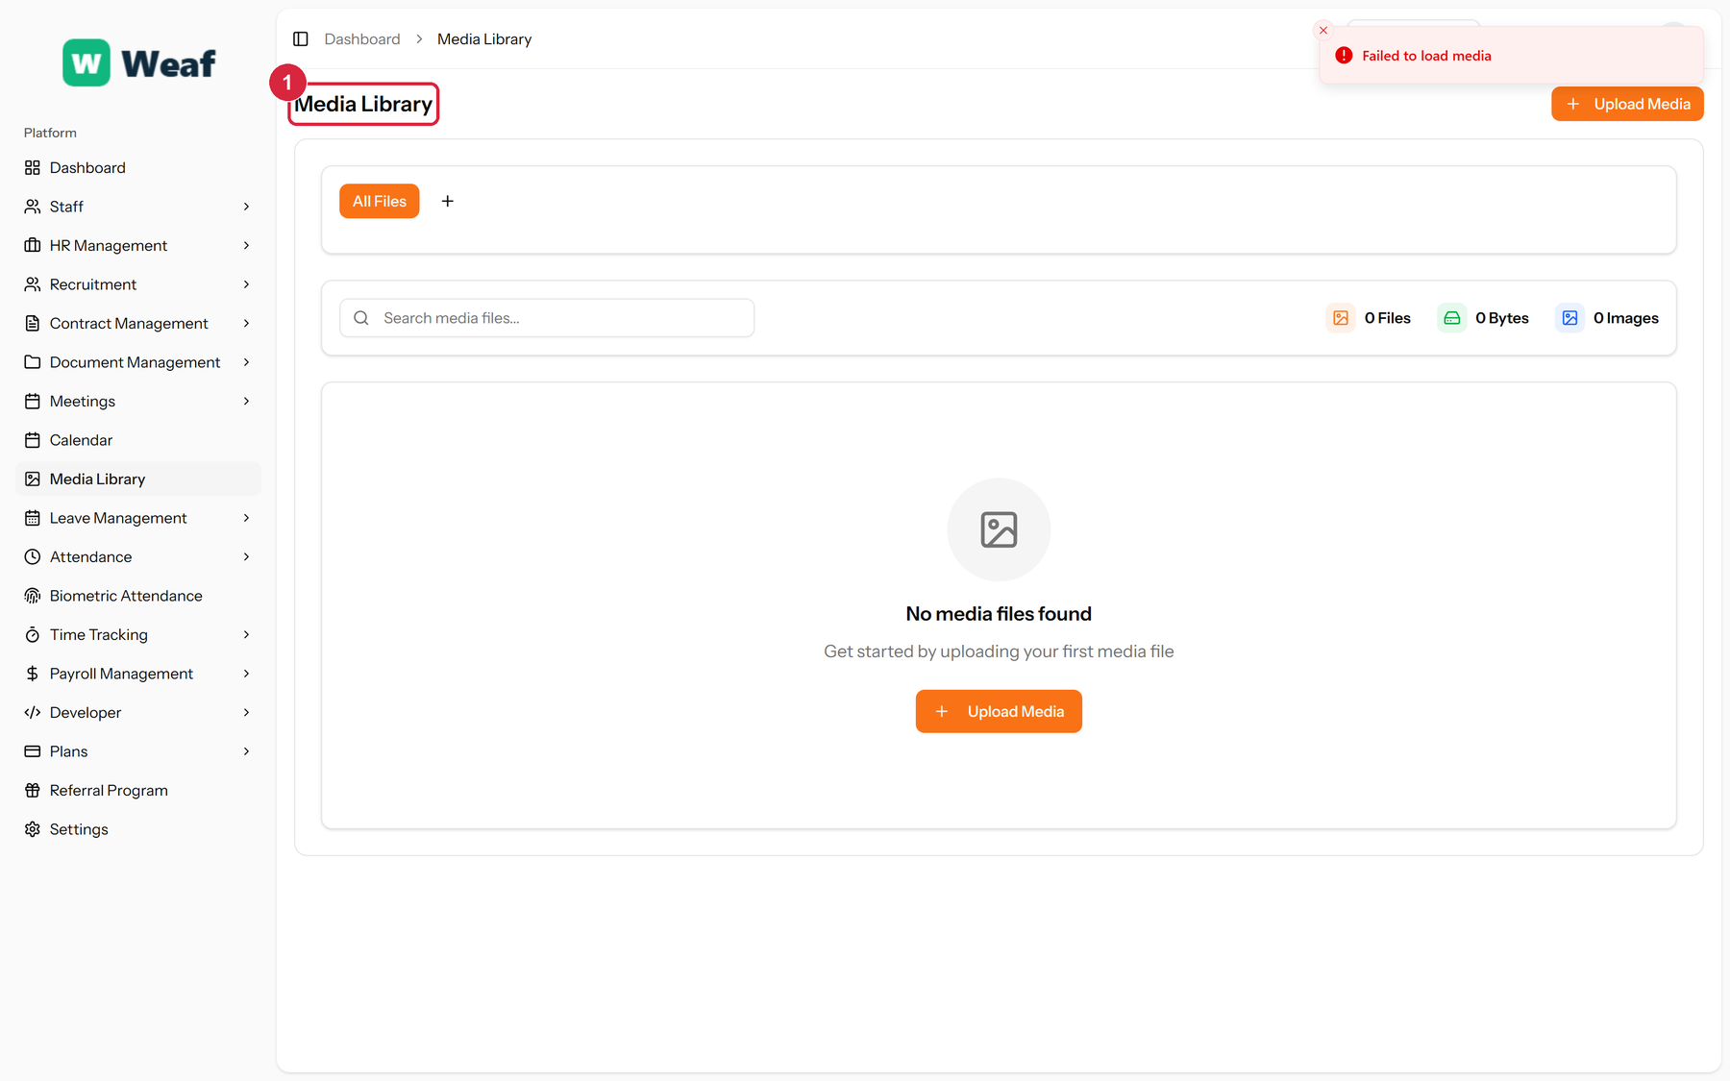
Figure 142: The Media Library page
1 page title
Actions on this page: Upload Media, All Files

20. The Employee Record Over Time
An employment is not static. This chapter covers everything that happens to a record between joining and leaving: recognition, advancement, movement, discipline and departure.
Each of these is a dated record rather than an edit to the employee, so the history survives. That is what makes it possible to answer, a year later, why someone's designation changed.
Pages in this chapter: Award Types, Awards, Promotions, Transfers, Trips, Warnings, Complaints, Resignations, Terminations, Holidays, Announcements

20.1 Award Types
A reference list. Entries created here become the options offered when you create an award. Setting these up once, before the records that use them, saves correcting the same choice repeatedly later.
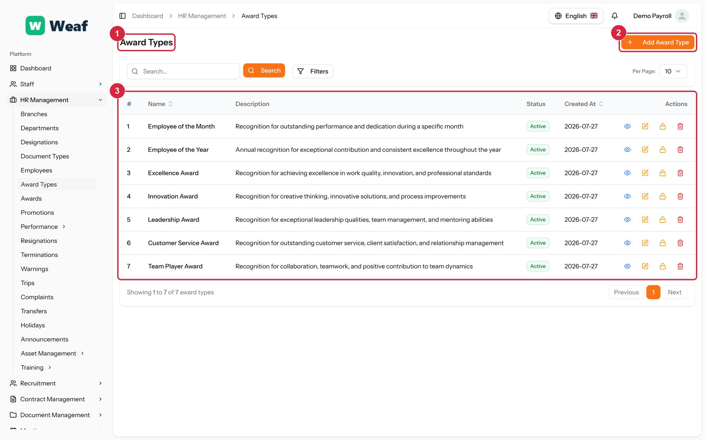
Figure 143: The Award Types page
1 page title · 2 primary action · 3 records table
Columns: #, Name, Description, Status, Created At, Actions
Actions on this page: Add Award Type
1. Choose Add Award Type at the top right. The form opens in a panel.
2. Complete the required fields: Award Type Name.
3. Fill in anything else that applies: Description.
4. Choose Save. The new record appears in the list.
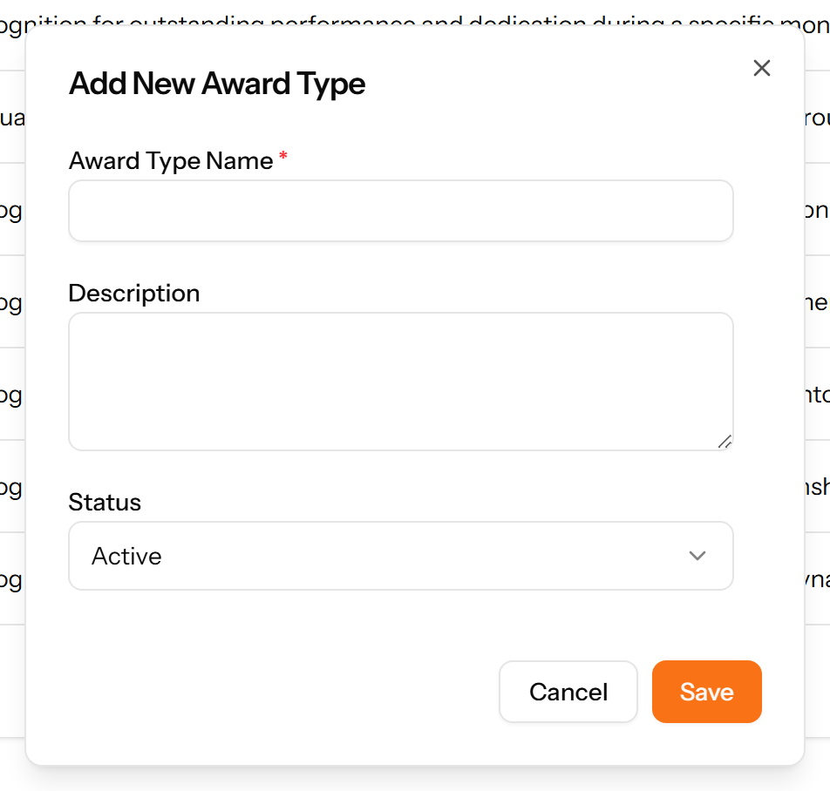
Figure 144: The Add Award Type form

20.2 Awards
Recognition given to an employee — the award, the date, any gift and its value. Supporting files can be attached.
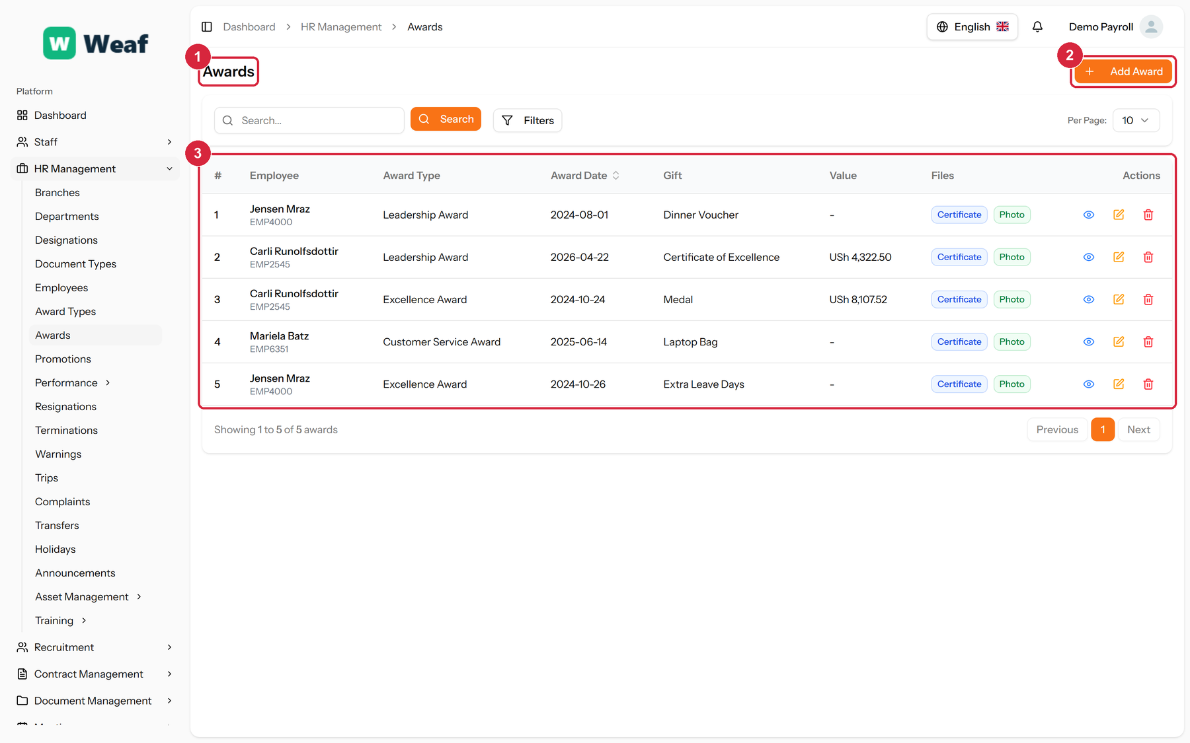
Figure 145: The Awards page
1 page title · 2 primary action · 3 records table
Columns: #, Employee, Award Type, Award Date, Gift, Value, Files, Actions
Actions on this page: Add Award
1. Choose Add Award at the top right. The form opens in a panel.
2. Complete the required fields: Award Date.
3. Fill in anything else that applies: Gift, Monetary Value, Description, Select certificate file..., Select photo file....
4. Make the selections the form asks for: Employee, Award Type.
5. Choose Save. The new record appears in the list.
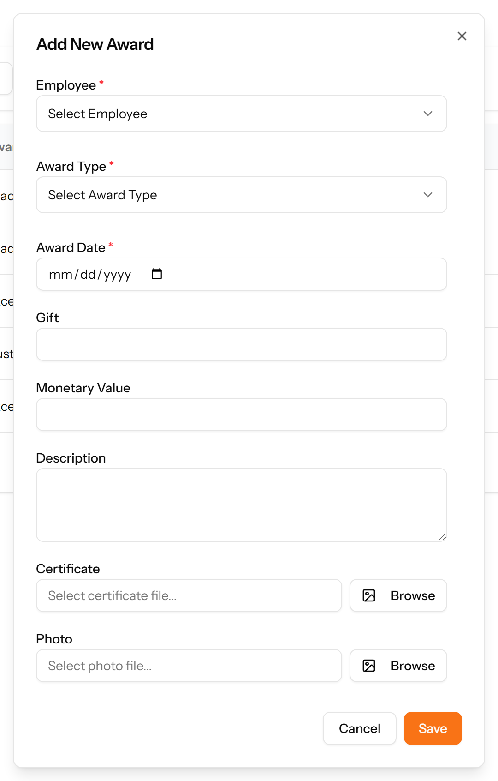
Figure 146: The Add Award form

20.3 Promotions
A record of an employee moving from one designation to another, with the date it was decided and the date it takes effect.
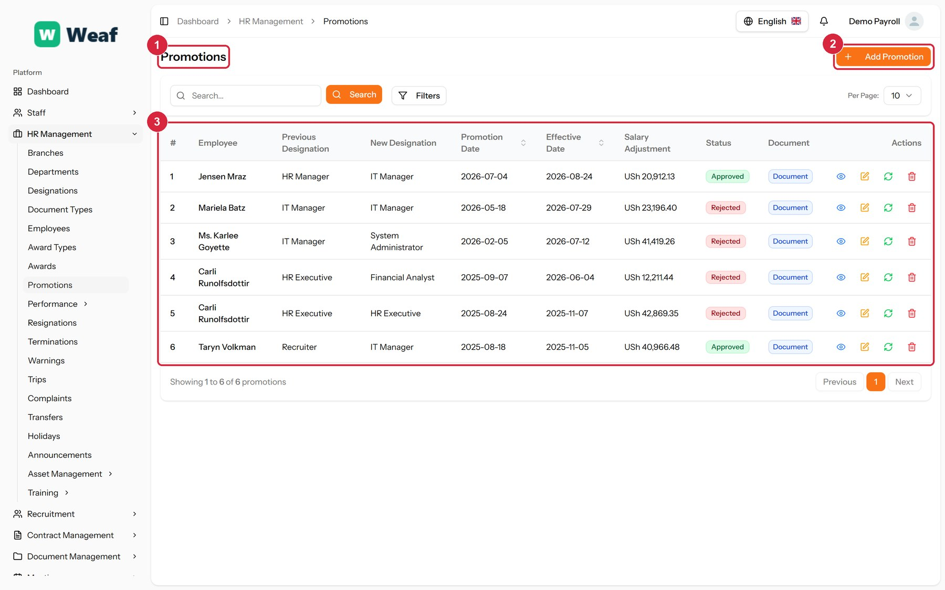
Figure 147: The Promotions page
1 page title · 2 primary action · 3 records table
Columns: #, Employee, Previous Designation, New Designation, Promotion Date, Effective Date, Salary Adjustment, Status, Document, Actions
Actions on this page: Add Promotion
1. Choose Add Promotion at the top right. The form opens in a panel.
2. Complete the required fields: Previous Designation, Promotion Date, Effective Date.
3. Fill in anything else that applies: Salary Adjustment, Reason for Promotion, Select document file....
4. Make the selections the form asks for: Employee, New Designation.
5. Choose Save. The new record appears in the list.
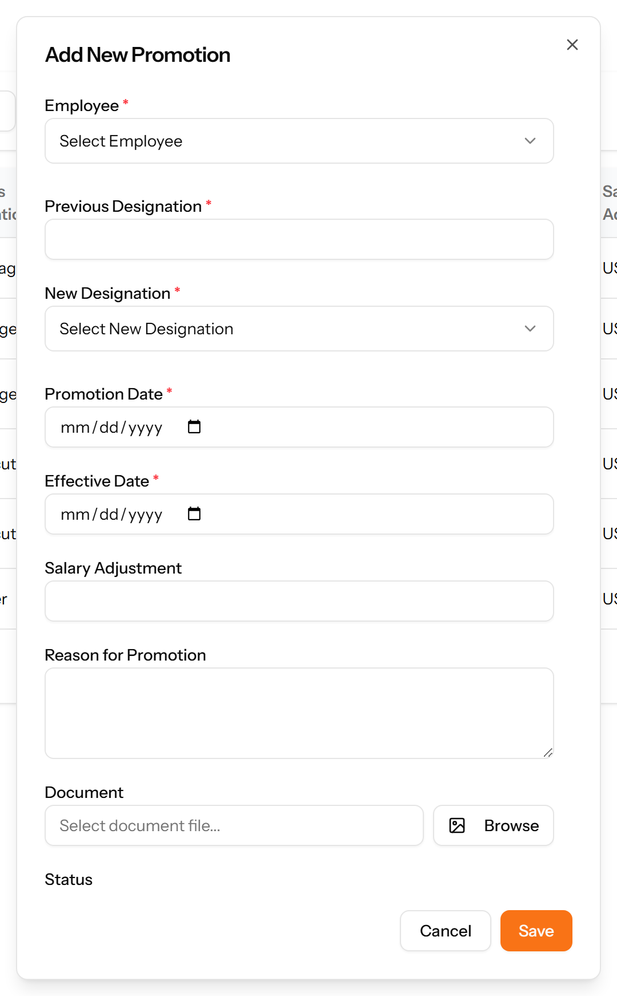
Figure 148: The Add Promotion form

20.4 Transfers
Movements between branches or departments, showing where the employee came from, where they went, and when it takes effect.
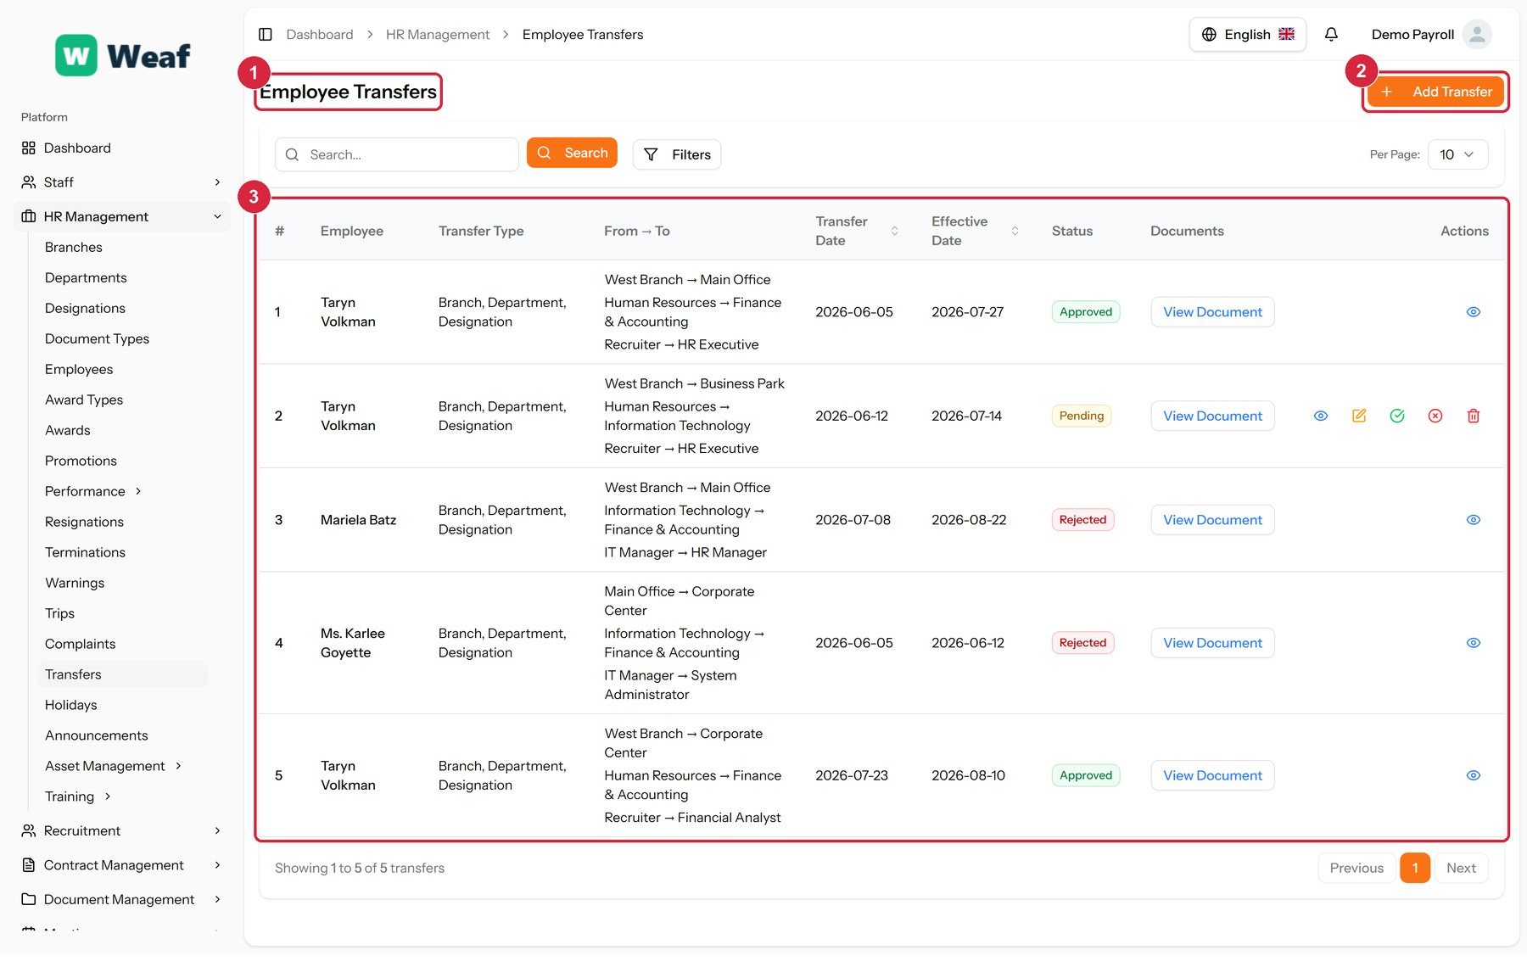
Figure 149: The Transfers page
1 page title · 2 primary action · 3 records table
Columns: #, Employee, Transfer Type, From → To, Transfer Date, Effective Date, Status, Documents, Actions
Actions on this page: Add Transfer, View Document
1. Choose Add Transfer at the top right. The form opens in a panel.
2. Complete the required fields: Transfer Date, Effective Date.
3. Fill in anything else that applies: To Branch, To Department, To Designation, Reason, Select document file....
4. Make the selections the form asks for: Employee.
5. Choose Save. The new record appears in the list.
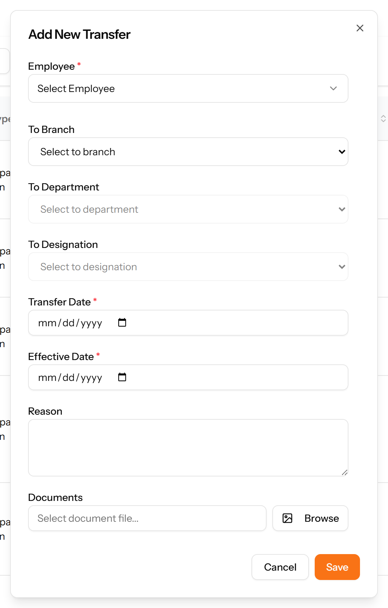
Figure 150: The Add Transfer form

20.5 Trips
Business travel: who travelled, why, where, and between which dates.
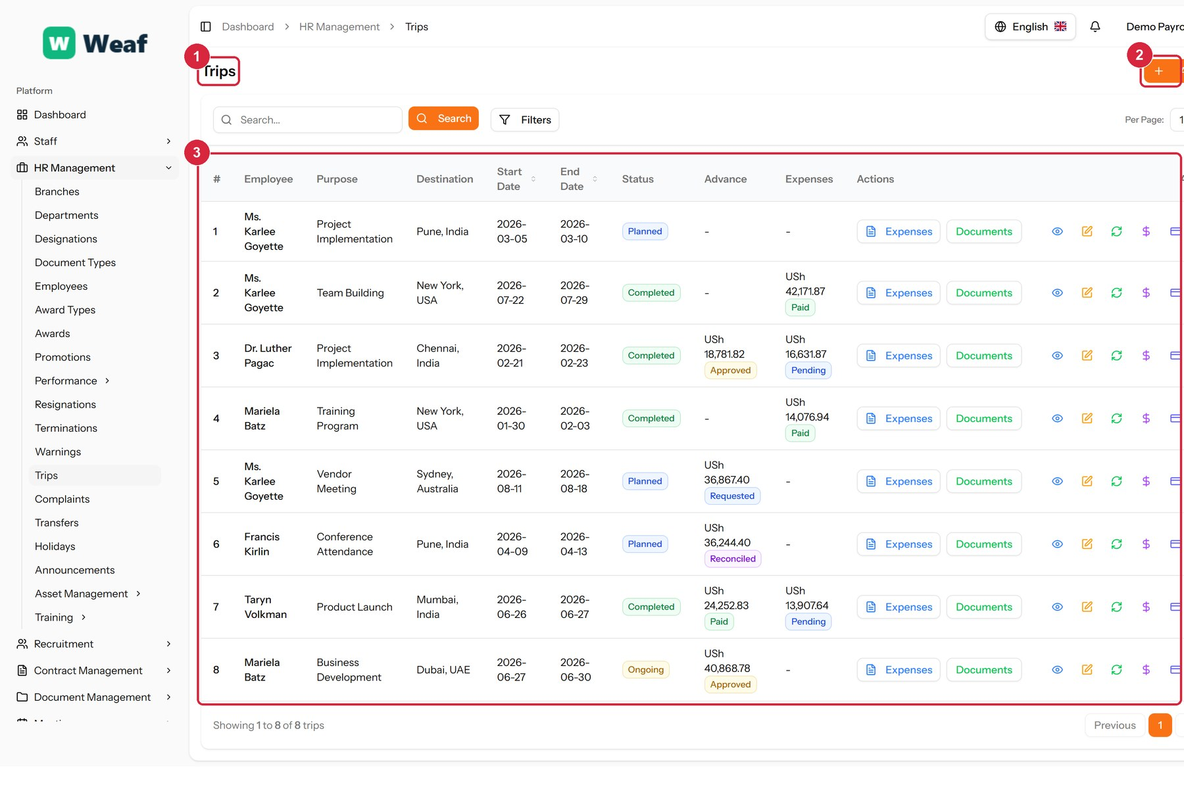
Figure 151: The Trips page
1 page title · 2 primary action · 3 records table
Columns: #, Employee, Purpose, Destination, Start Date, End Date, Status, Advance, Expenses, Actions
Actions on this page: Add Trip, Expenses, Documents
1. Choose Add Trip at the top right. The form opens in a panel.
2. Complete the required fields: Purpose, Destination, Start Date, End Date.
3. Fill in anything else that applies: Description, Expected Outcomes, Select document file..., Advance Amount.
4. Make the selections the form asks for: Employee.
5. Choose Save. The new record appears in the list.
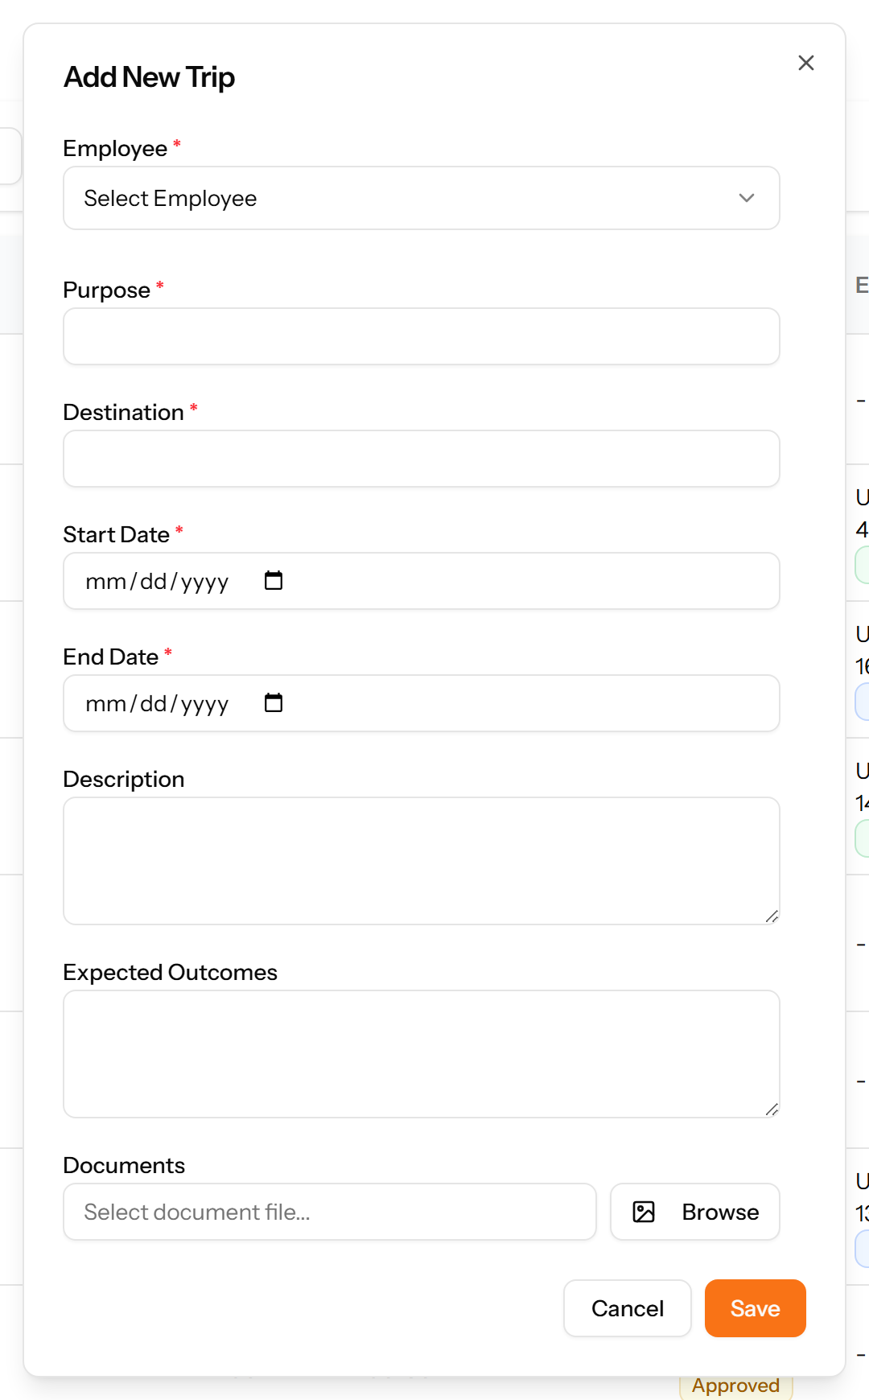
Figure 152: The Add Trip form

20.6 Warnings
Formal disciplinary warnings, with a type, a severity and a status, so a documented history exists before any termination decision.
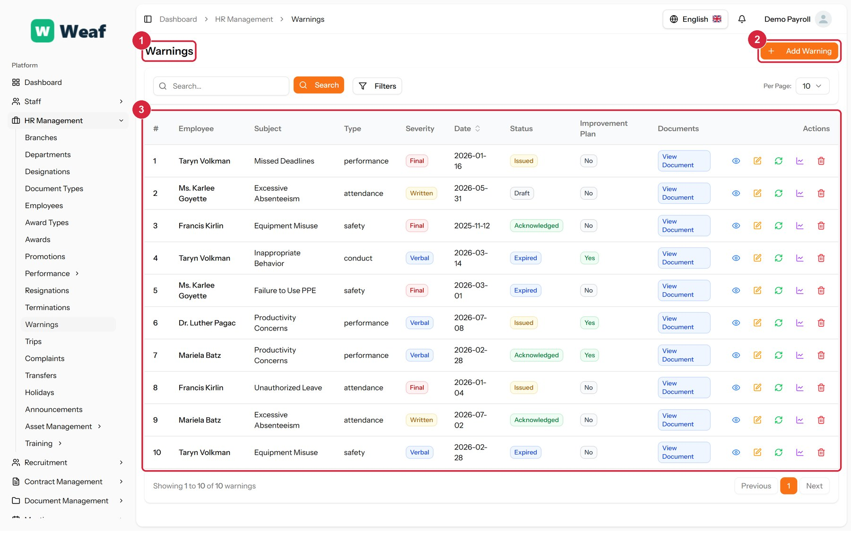
Figure 153: The Warnings page
1 page title · 2 primary action · 3 records table
Columns: #, Employee, Subject, Type, Severity, Date, Status, Improvement Plan, Documents, Actions
Actions on this page: Add Warning
1. Choose Add Warning at the top right. The form opens in a panel.
2. Complete the required fields: Subject, Warning Date.
3. Fill in anything else that applies: Description, Select document file..., Expiry Date, Has Improvement Plan, Improvement Plan Goals, Improvement Plan Start Date, Improvement Plan End Date.
4. Make the selections the form asks for: Employee, Warning By, Warning Type, Severity.
5. Choose Save. The new record appears in the list.
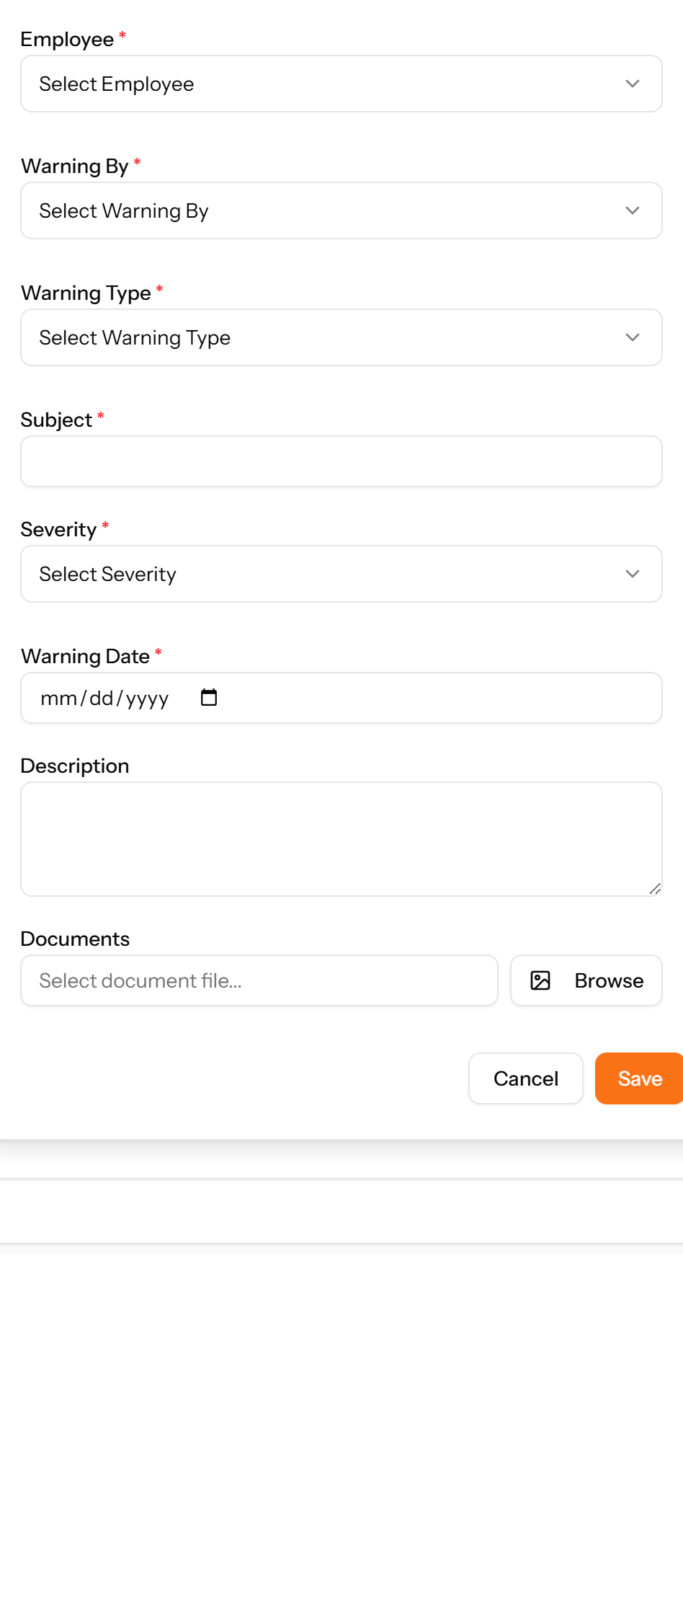
Figure 154: The Add Warning form

20.7 Complaints
Grievances raised by one person about another, with the type, subject and current status. The complainant and the person complained about are both recorded.
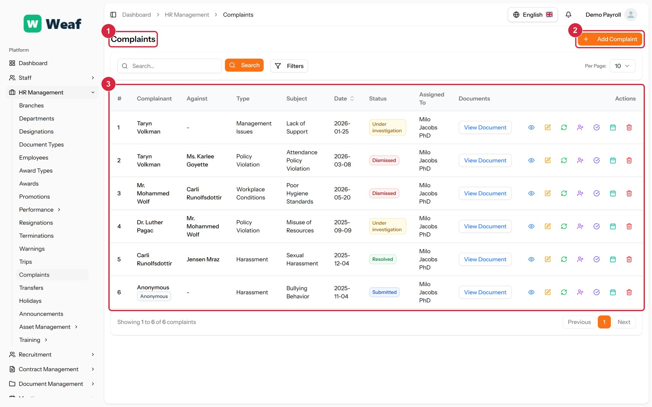
Figure 155: The Complaints page
1 page title · 2 primary action · 3 records table
Columns: #, Complainant, Against, Type, Subject, Date, Status, Assigned To, Documents, Actions
Actions on this page: Add Complaint, View Document
1. Choose Add Complaint at the top right. The form opens in a panel.
2. Complete the required fields: Subject, Complaint Date.
3. Fill in anything else that applies: Against, Description, Select document file..., Submit Anonymously.
4. Make the selections the form asks for: Complainant, Complaint Type.
5. Choose Save. The new record appears in the list.
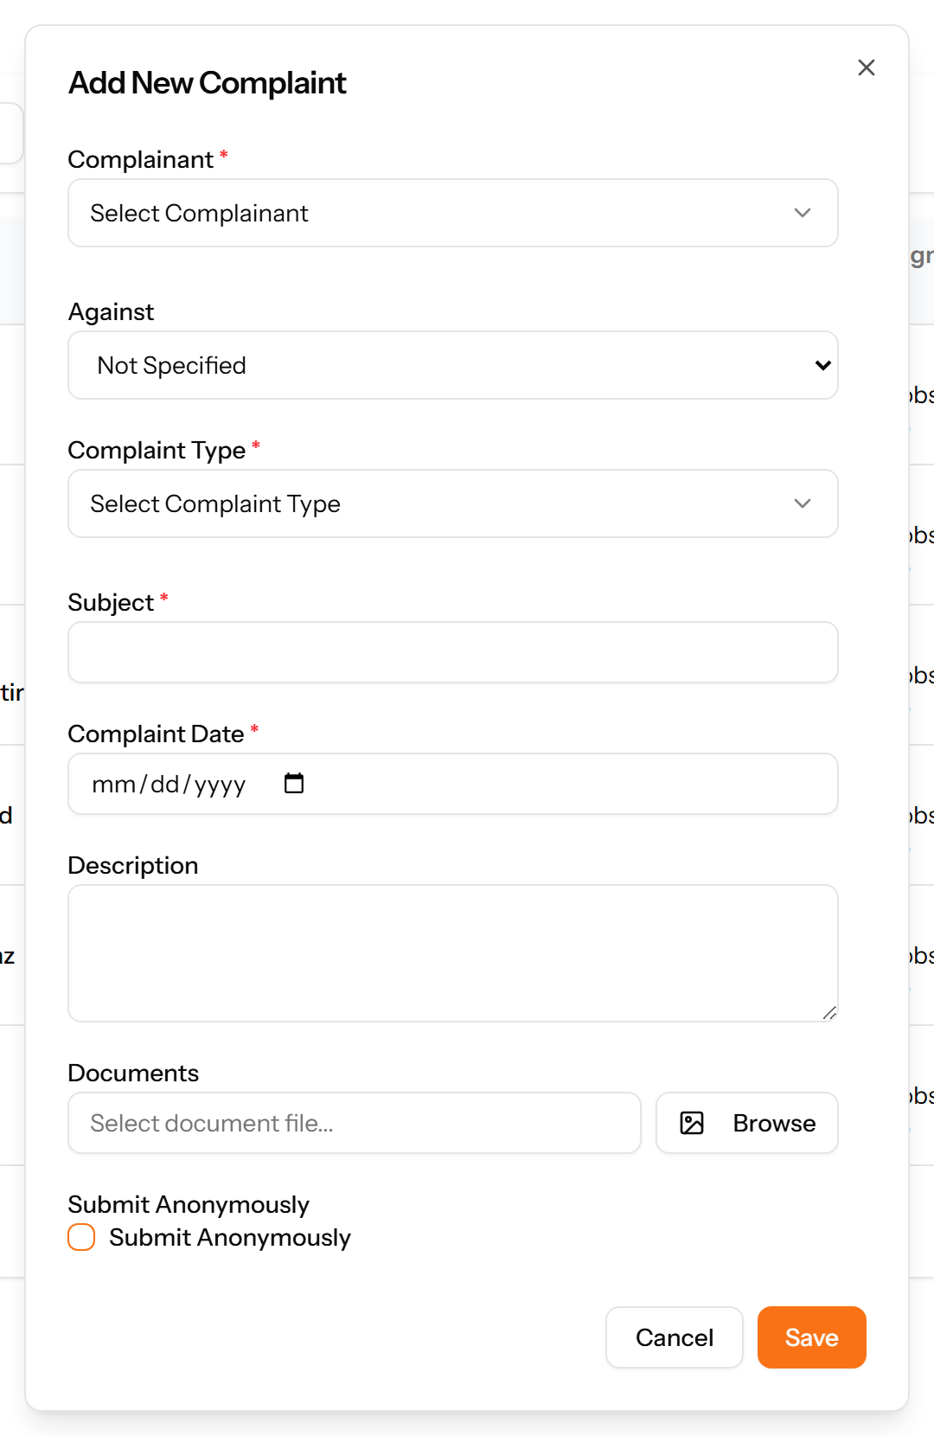
Figure 156: The Add Complaint form

20.8 Resignations
Employee-initiated departures: when notice was given, the last working day, the notice period served and the stated reason.
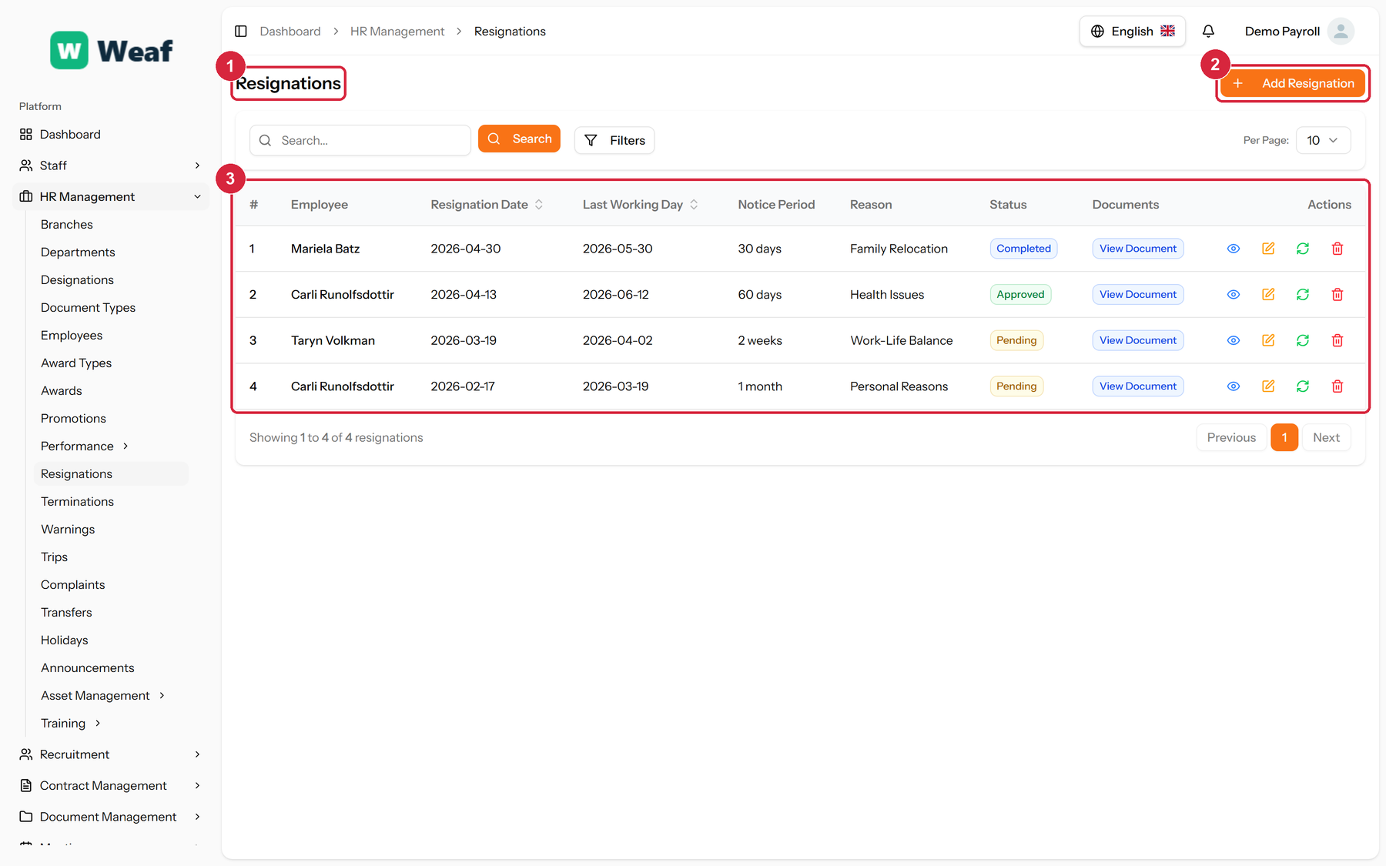
Figure 157: The Resignations page
1 page title · 2 primary action · 3 records table
Columns: #, Employee, Resignation Date, Last Working Day, Notice Period, Reason, Status, Documents, Actions
Actions on this page: Add Resignation
1. Choose Add Resignation at the top right. The form opens in a panel.
2. Complete the required fields: Resignation Date, Last Working Day.
3. Fill in anything else that applies: Notice Period, Reason, Description, Select document file....
4. Make the selections the form asks for: Employee.
5. Choose Save. The new record appears in the list.
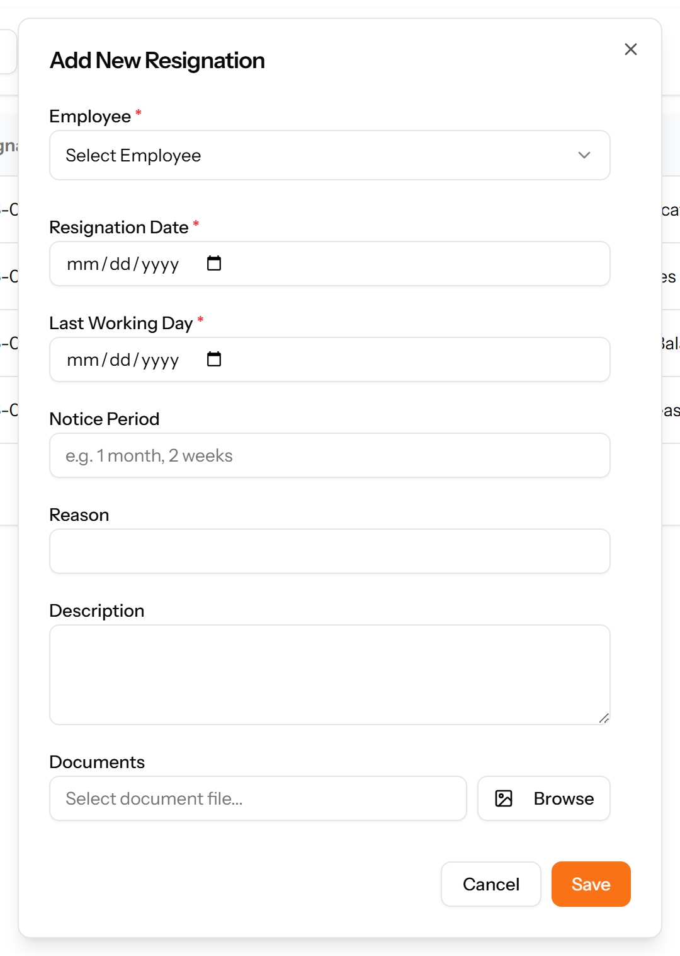
Figure 158: The Add Resignation form

20.9 Terminations
Company-initiated departures, recorded with their type, dates and reason. Kept separate from resignations because the two need different handling and reporting.
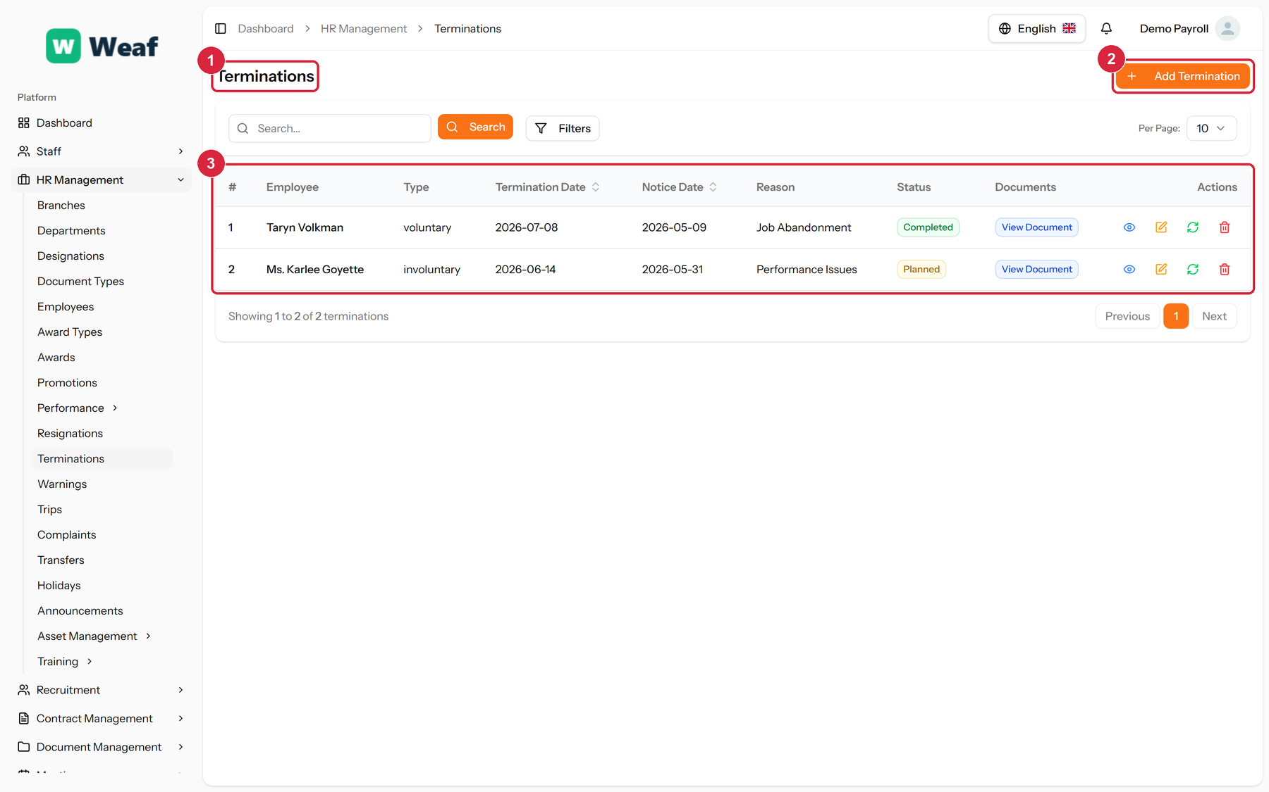
Figure 159: The Terminations page
1 page title · 2 primary action · 3 records table
Columns: #, Employee, Type, Termination Date, Notice Date, Reason, Status, Documents, Actions
Actions on this page: Add Termination
1. Choose Add Termination at the top right. The form opens in a panel.
2. Complete the required fields: Notice Date, Termination Date.
3. Fill in anything else that applies: Notice Period, Reason, Description, Select document file....
4. Make the selections the form asks for: Employee, Termination Type.
5. Choose Save. The new record appears in the list.
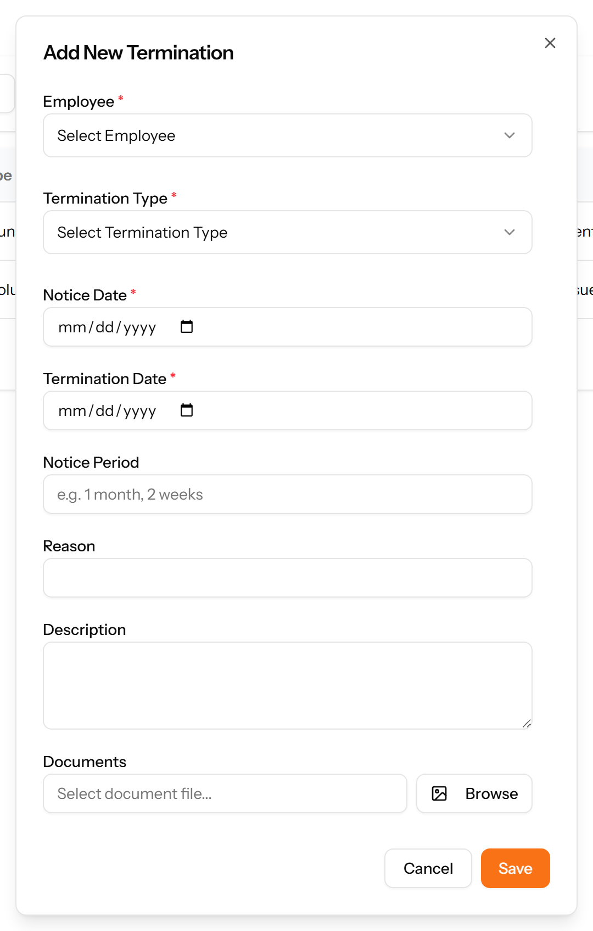
Figure 160: The Add Termination form

20.10 Holidays
Company holidays. Because a holiday can be declared for particular branches, the same calendar serves a company operating in more than one place.
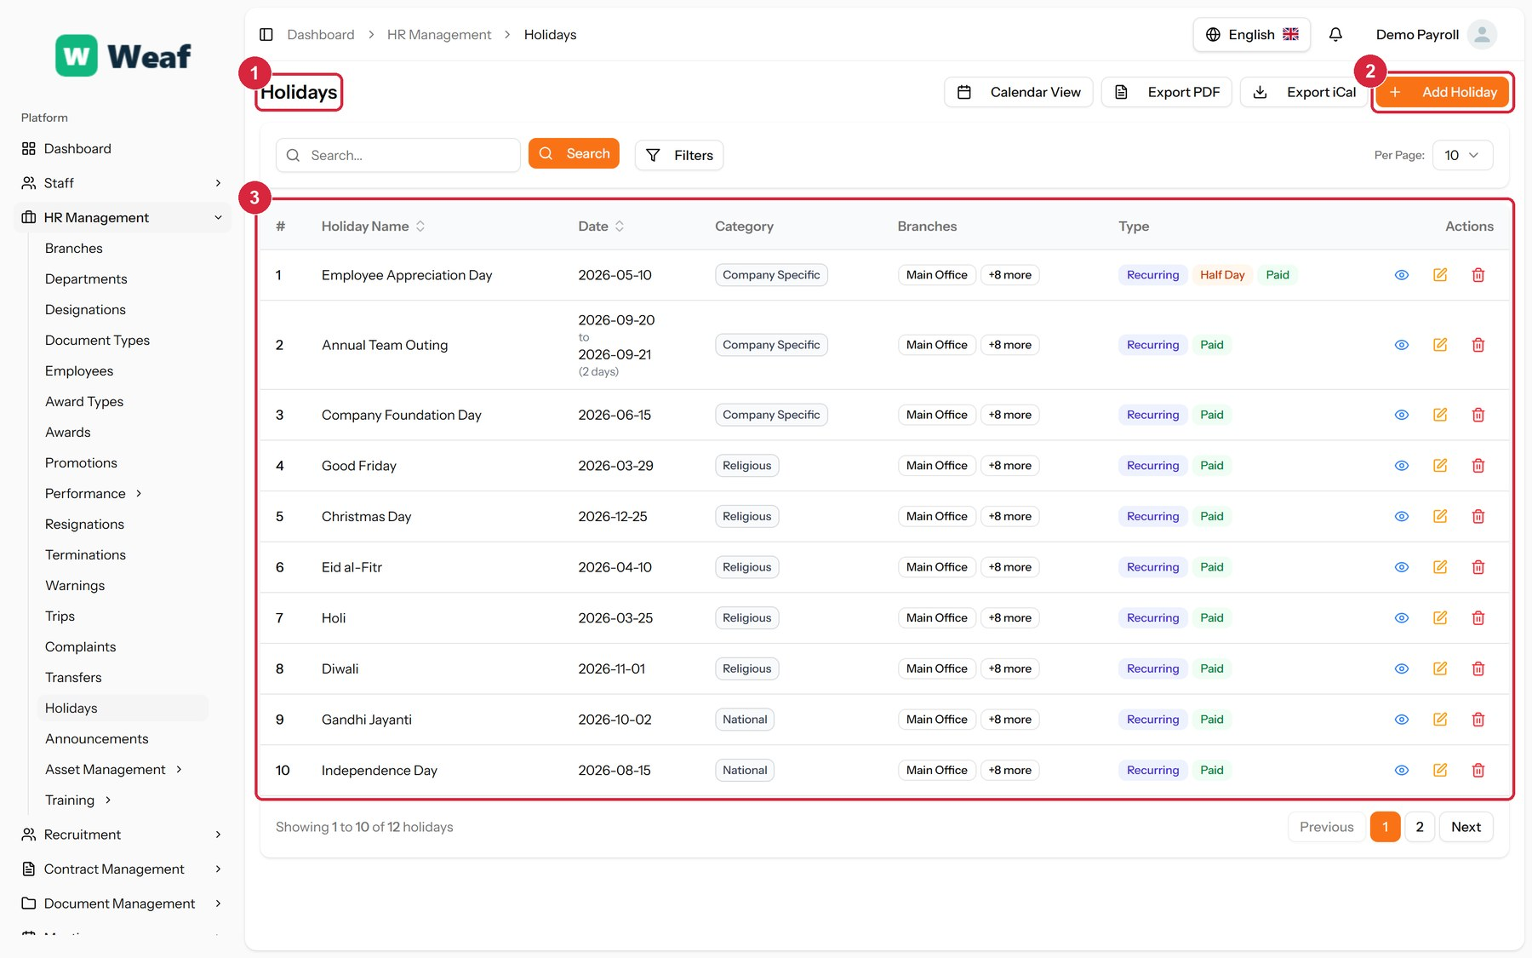
Figure 161: The Holidays page
1 page title · 2 primary action · 3 records table
Columns: #, Holiday Name, Date, Category, Branches, Type, Actions
Actions on this page: Calendar View, Export PDF, Export iCal, Add Holiday
1. Choose Add Holiday at the top right. The form opens in a panel.
2. Complete the required fields: Holiday Name, Start Date.
3. Fill in anything else that applies: End Date, Description, Paid Holiday, Half Day, Select Applicable Branches.
4. Make the selections the form asks for: Category.
5. Choose Save. The new record appears in the list.
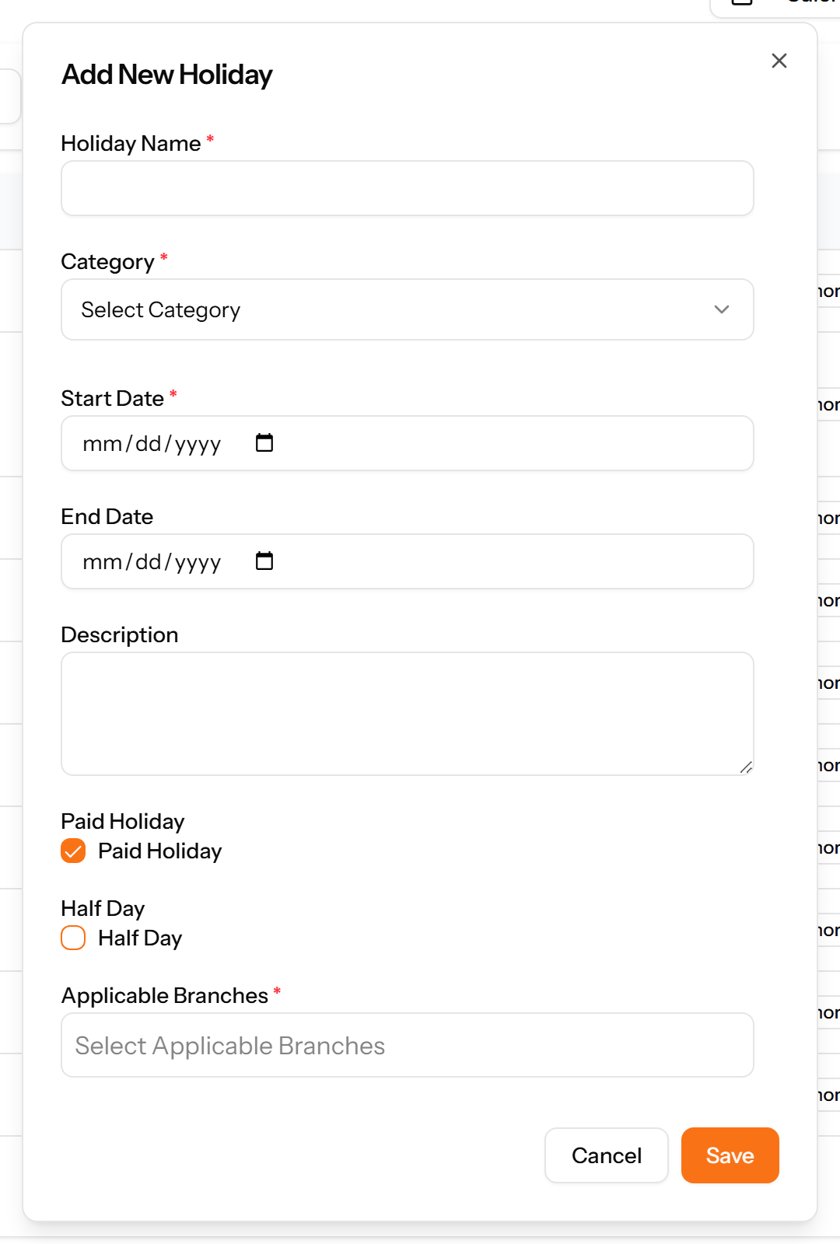
Figure 162: The Add Holiday form

20.11 Announcements
Notices published to a chosen audience for a date range, with optional attachments.
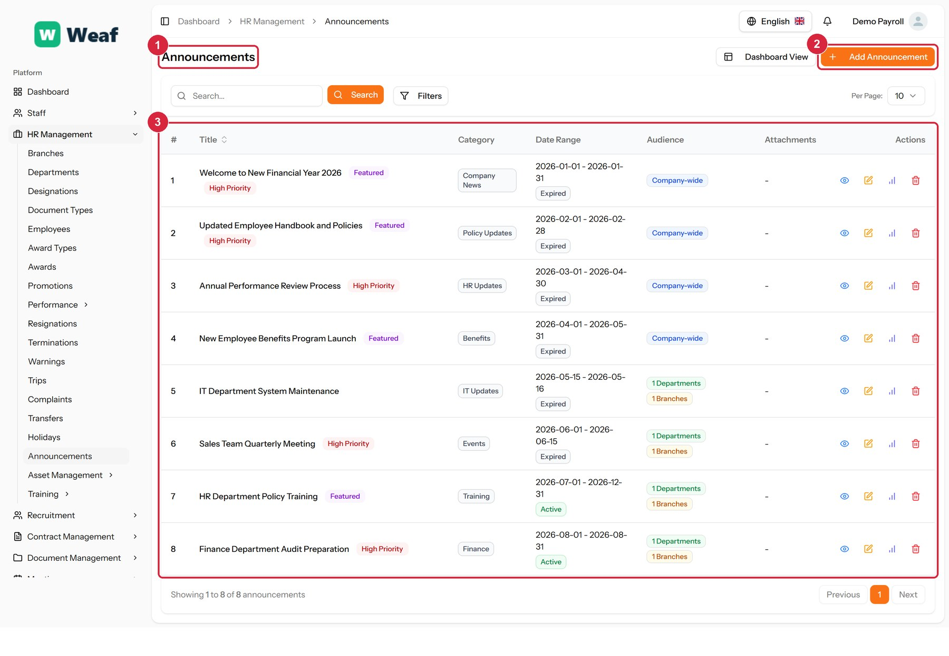
Figure 163: The Announcements page
1 page title · 2 primary action · 3 records table
Columns: #, Title, Category, Date Range, Audience, Attachments, Actions
Actions on this page: Dashboard View, Add Announcement
1. Choose Add Announcement at the top right. The form opens in a panel.
2. Complete the required fields: Title, Start Date.
3. Fill in anything else that applies: Short Description, End Date, Select attachment file..., Featured Announcement, High Priority, Company-wide Announcement, Target Branches, Target Departments.
4. Make the selections the form asks for: Category.
5. Choose Save. The new record appears in the list.
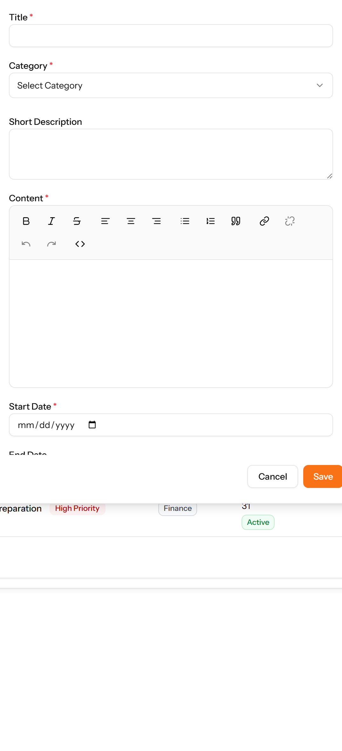
Figure 164: The Add Announcement form

Part V — Administration

21. Administration
The remaining pages configure the system itself rather than the people in it.
A few administrative screens — currencies, and the custom pages behind the public site — are reserved for the platform’s super administrator and are not reachable from a company account. They are named here for completeness but are not documented, because a company administrator will never see them.
Pages in this chapter: Settings, Plans, Plan Requests, Plan Orders, Referral Program, Landing Page

21.1 Settings
Company-wide configuration: company details, branding, localisation, email, and the security options that apply to everyone who signs in.
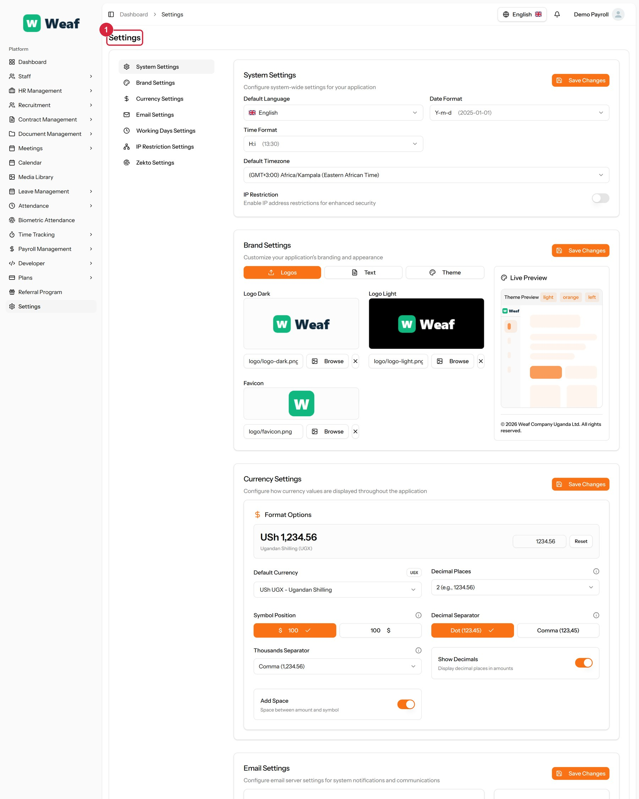
Figure 165: The Settings page
1 page title
Columns: #, IP Address, Actions
Actions on this page: System Settings, Brand Settings, Currency Settings, Email Settings, Working Days Settings, IP Restriction Settings, Zekto Settings, Save Changes, Y-m-d (2025-01-01), H:i (13:30), Logos, Text, Theme, Browse, Reset, USh UGX - Ugandan Shilling, 2 (e.g., 1234.56), $ 100, 100 $, Dot (123.45), Comma (123,45), Comma (1,234.56), SMTP, TLS, Send Test Email, Add IP Address, Generate Token
1. Choose Add IP Address at the top right. The form opens in a panel.
2. Complete the required fields: IP Address.
3. Choose Save. The new record appears in the list.
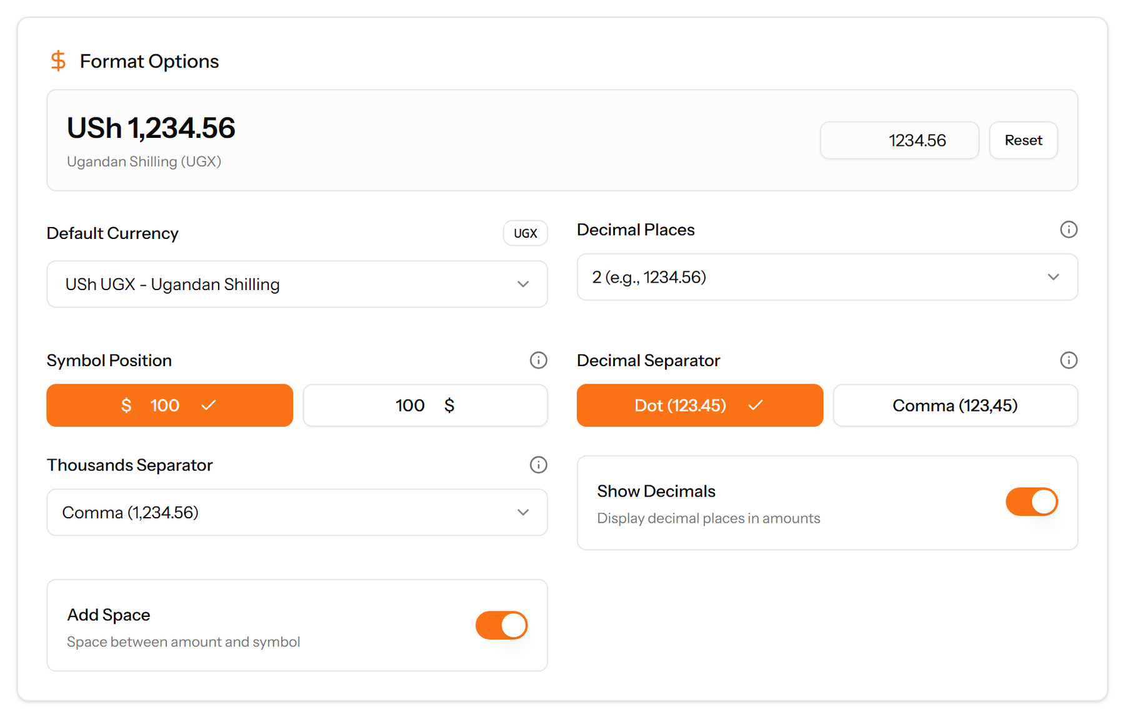
Figure 166: The Add IP Address form

21.2 Plans
The subscription tiers available to your company, and which one you are on.
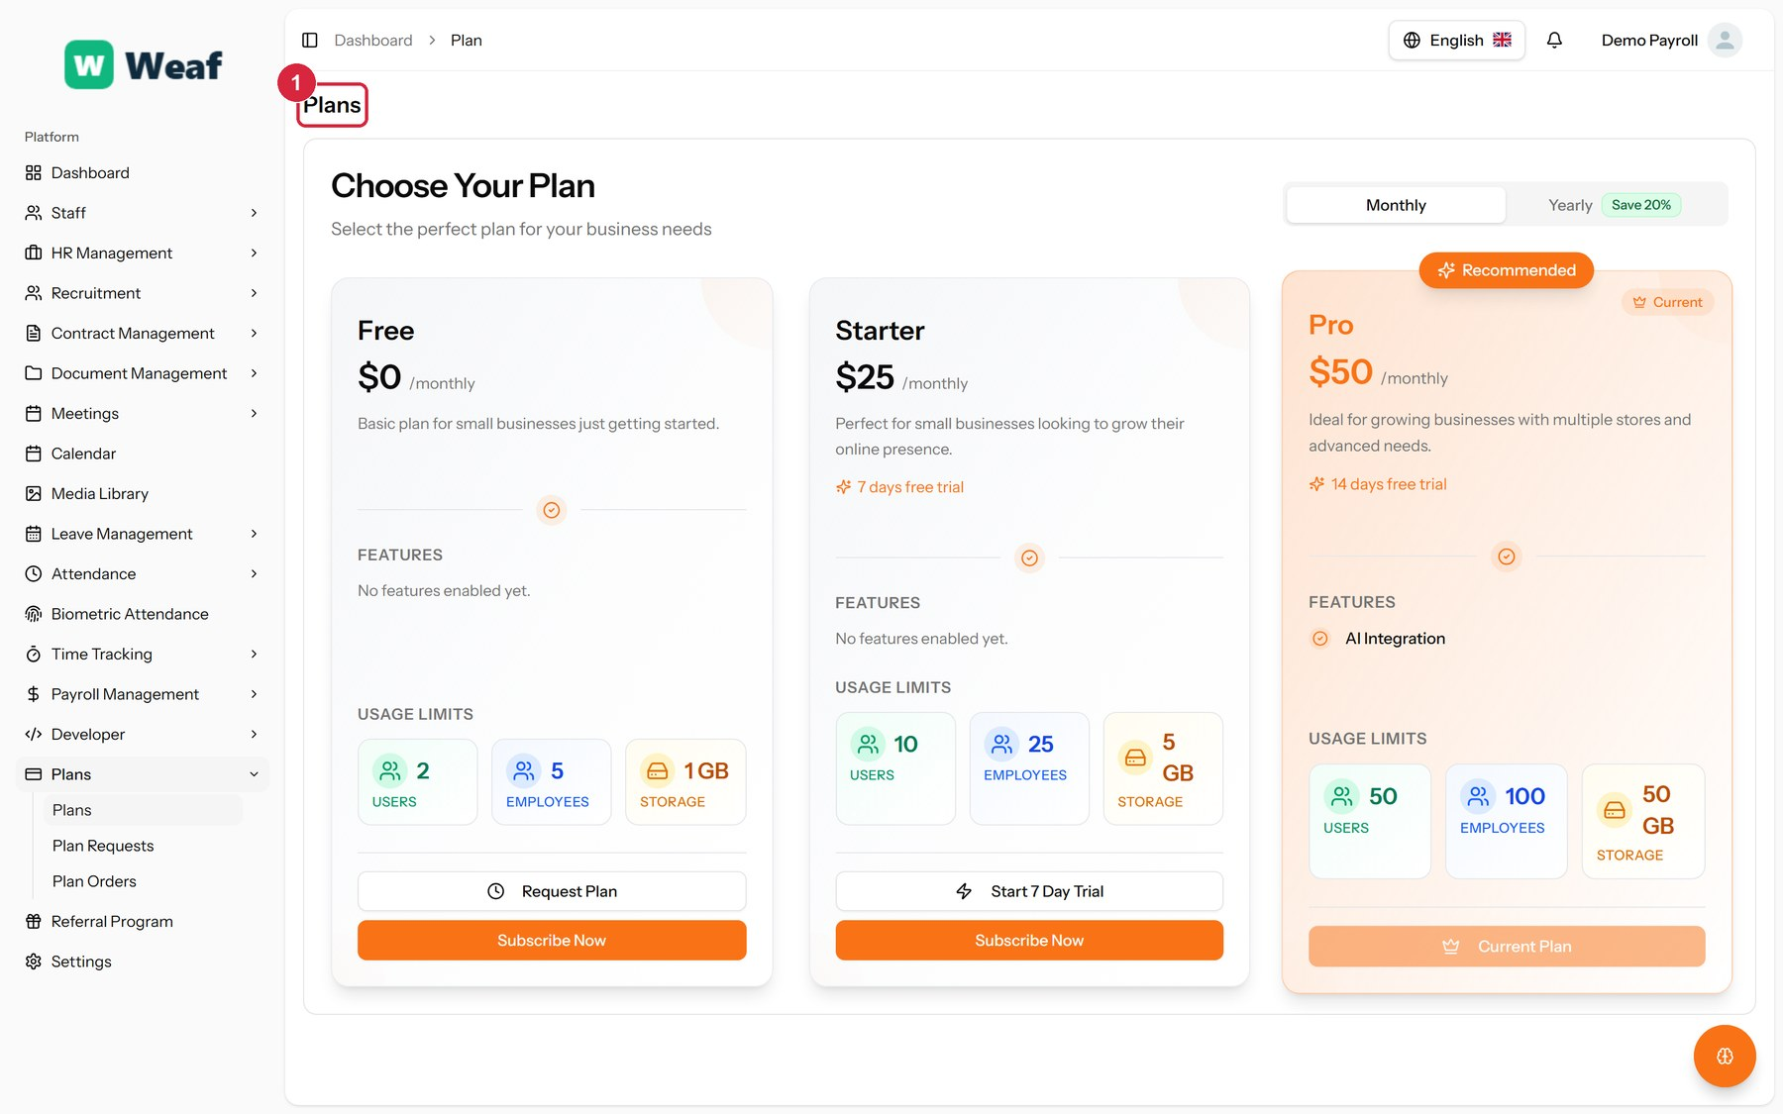
Figure 167: The Plans page
1 page title
Actions on this page: Monthly, Yearly Save 20%, Request Plan, Subscribe Now, Start 7 Day Trial, Current Plan

21.3 Plan Requests
Requests to change plan, and where each has got to.
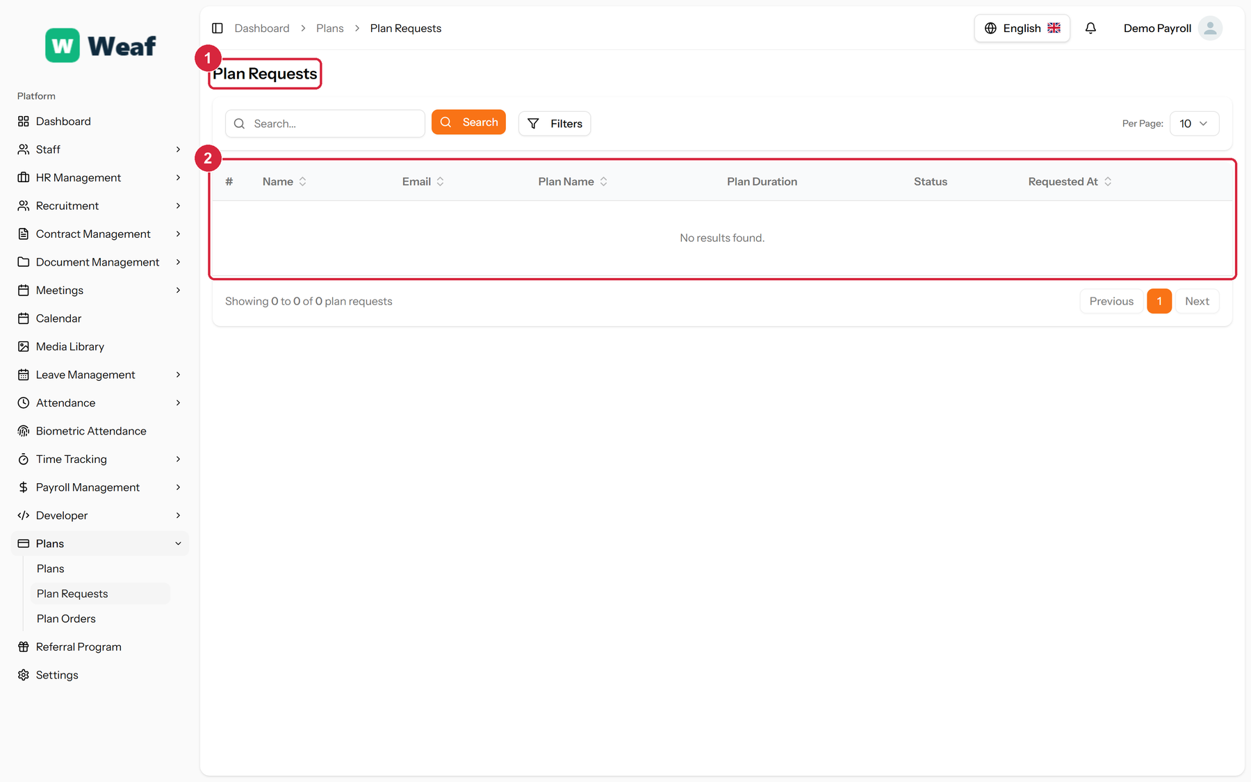
Figure 168: The Plan Requests page
1 page title · 2 records table
Columns: #, Name, Email, Plan Name, Plan Duration, Status, Requested At

21.4 Plan Orders
Completed plan purchases, with the order number, the price, any coupon and the date.
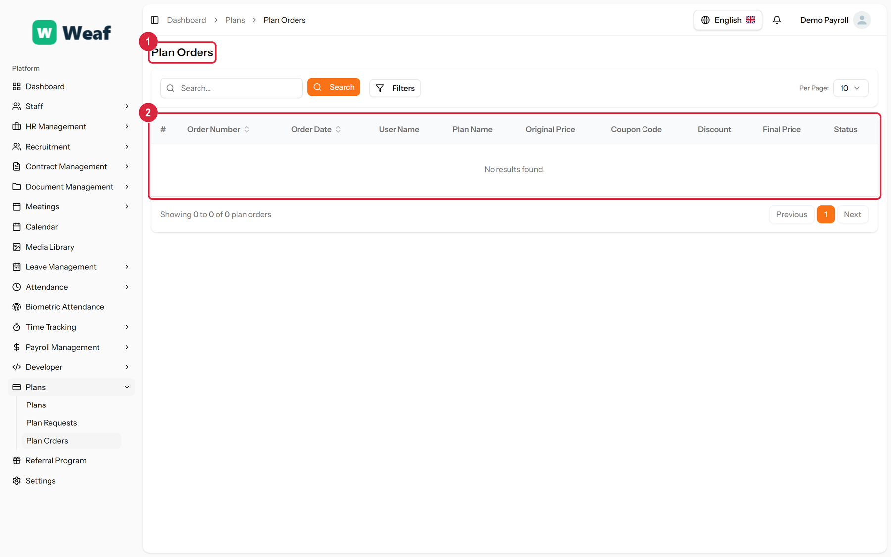
Figure 169: The Plan Orders page
1 page title · 2 records table
Columns: #, Order Number, Order Date, User Name, Plan Name, Original Price, Coupon Code, Discount, Final Price, Status

21.5 Referral Program
Your referral link and what it has earned, with each referral's amount, status and date.
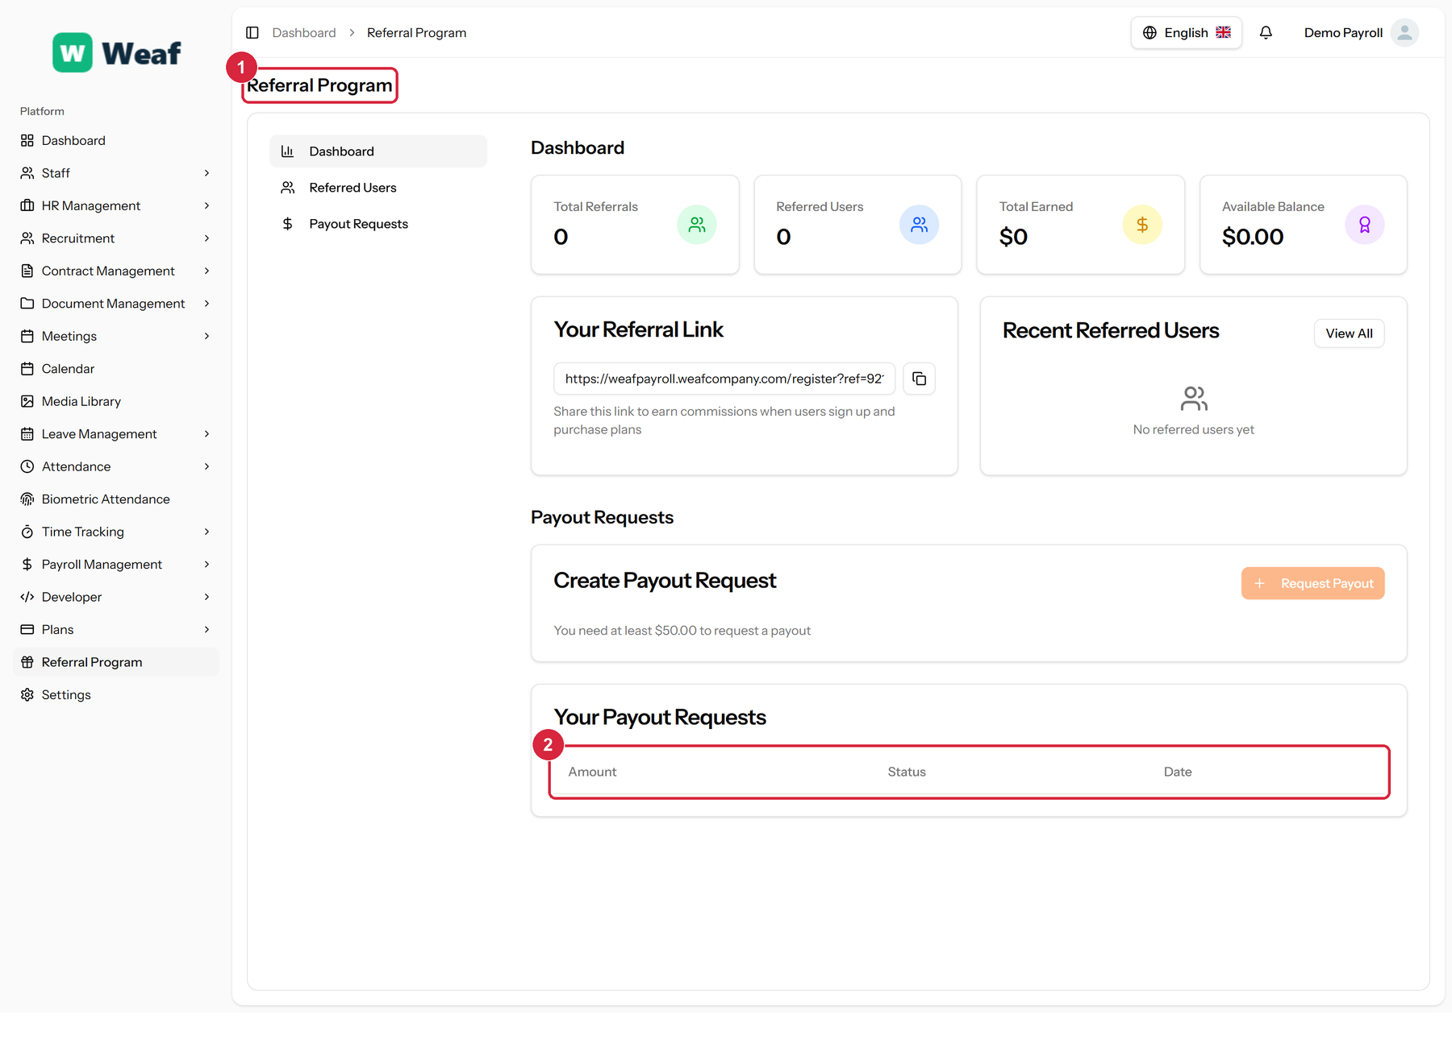
Figure 170: The Referral Program page
1 page title · 2 records table
Columns: Amount, Status, Date
Actions on this page: Dashboard, Payout Requests, Request Payout

21.6 Landing Page
Where the public website is edited: the text, images, ordering and visibility of every section covered in chapter 3.
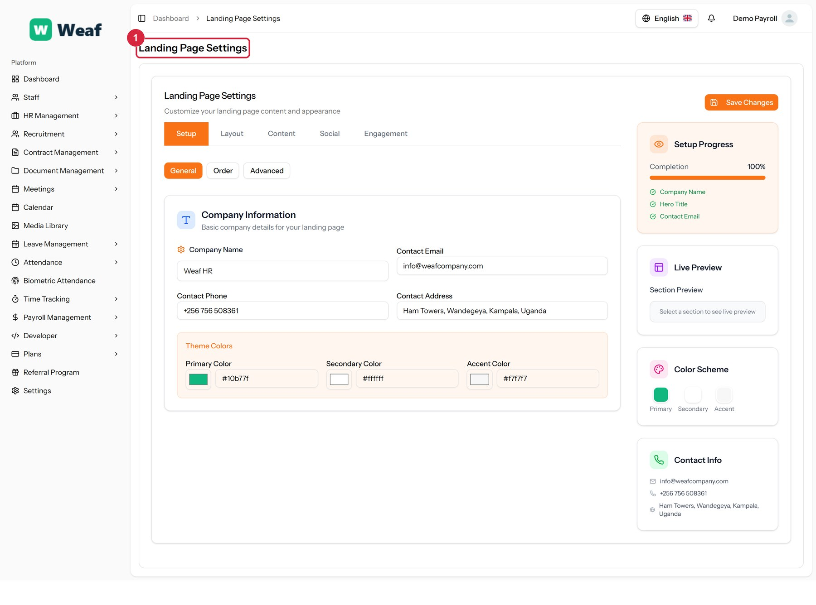
Figure 171: The Landing Page page
1 page title
Actions on this page: Save Changes, Setup, Layout, Content, Social, Engagement, General, Order, Advanced

22. Developer Tools
Weaf HR can be driven by other software. A token authenticates the other system, webhooks let it hear about changes as they happen, and the reference documents every endpoint.
One rule governs all of it: a token can only ever see what the person who created it can see. Access is not widened by automating it.
Pages in this chapter: API Tokens, Webhooks, API Reference

22.1 API Tokens
Tokens that let other software sign in as your company without a password. A token can only ever see what the person who created it can see, and the token itself is shown once, at creation.
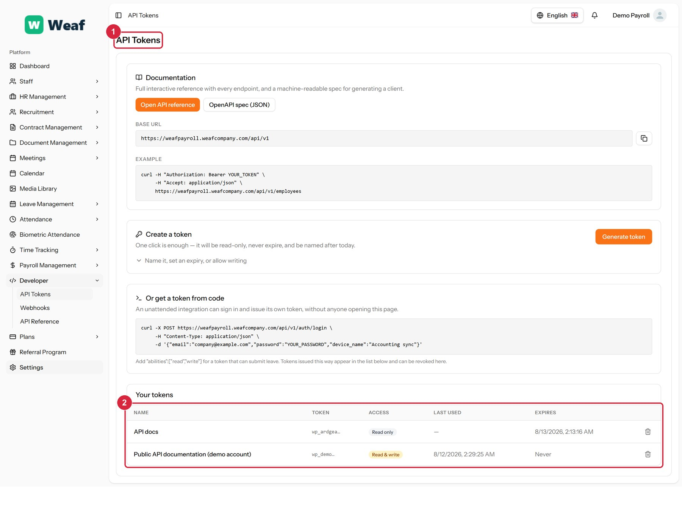
Figure 172: The API Tokens page
1 page title · 2 records table
Columns: NAME, TOKEN, ACCESS, LAST USED, EXPIRES
Actions on this page: Open API reference, OpenAPI spec (JSON), Generate token
Note: The token is shown once, when it is created. If it is lost it cannot be recovered — issue a new one and delete the old.

22.2 Webhooks
Addresses the system calls when something happens, so another system can react without polling for changes.
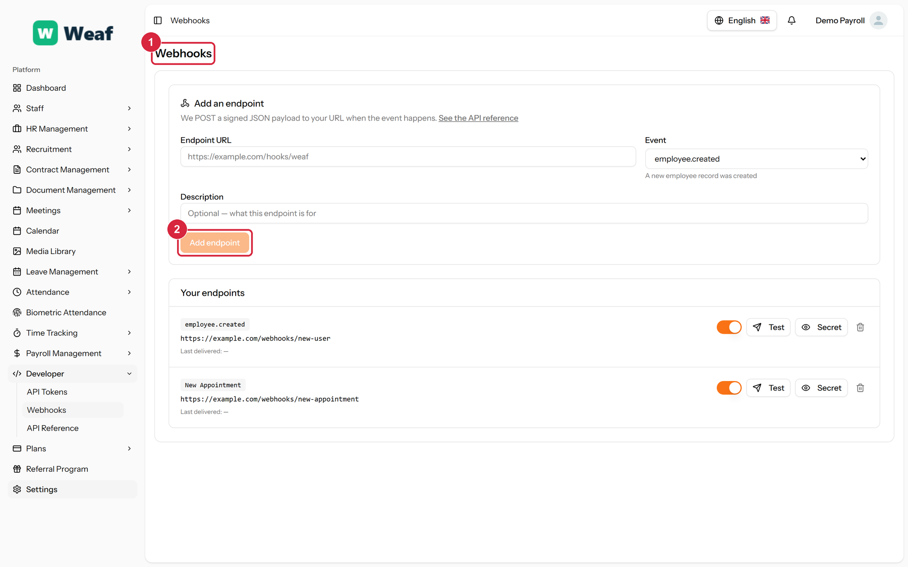
Figure 173: The Webhooks page
1 page title · 2 primary action
Actions on this page: Add endpoint, Test, Secret

22.3 API Reference
The API documentation, with every endpoint listed and a console for trying them. It is public — a developer evaluating the platform can read it without an account.
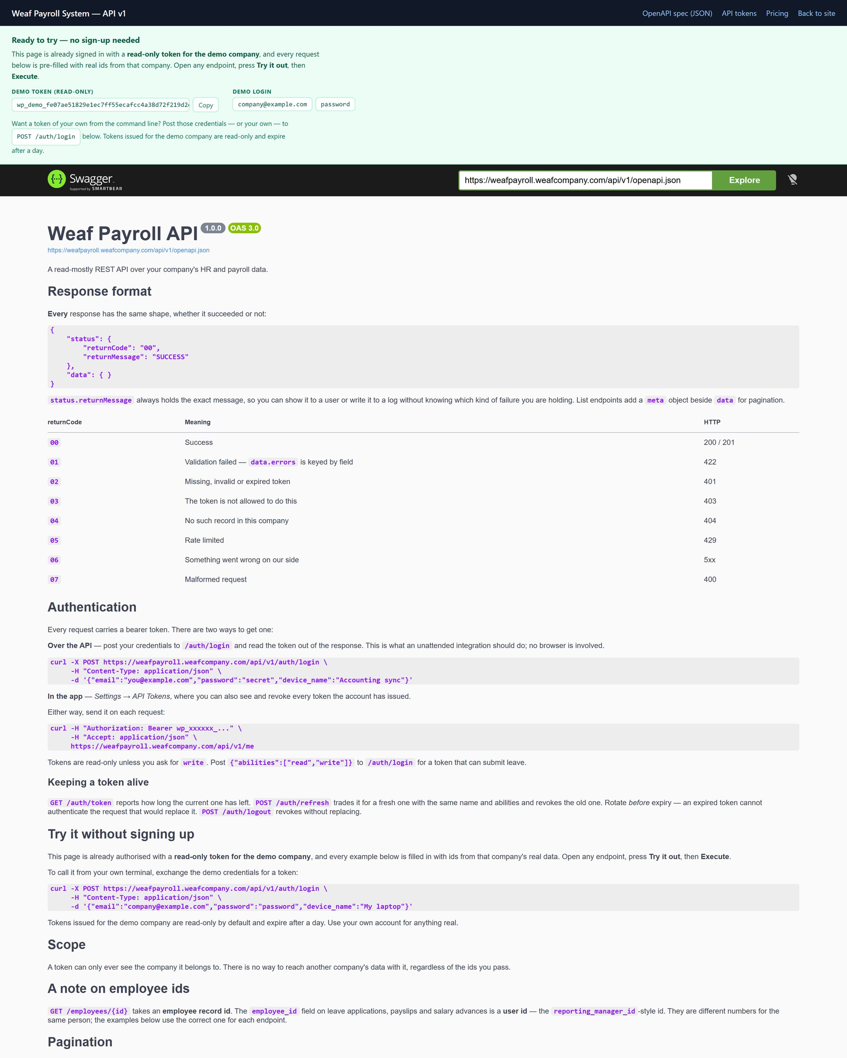
Figure 174: The API Reference page
Actions on this page: GET /auth/token Check the current token, GET /employees List employees, GET /employees/{id} Fetch one employee, GET /departments List departments, GET /designations List designations, GET /branches List branches, GET /leave-types List leave types, GET /payroll-runs List payroll runs, GET /payslips List payslips, Schemas

Appendix

A. Complete Page Index
Every page reached from the sidebar, with the module it belongs to and the number of records present on the demonstration company at the time of capture. A count of zero means the page was empty, not that it does not work.
Table 5: Complete index of application pages
Module | Page | Records | Columns
Attendance | Attendance Policies | 3 | 7
Attendance | Attendance Records | 10 | 10
Attendance | Attendance Regularizations | 10 | 9
Attendance | Shifts | 3 | 10
Contract Management | Contract Templates | 5 | 9
Contract Management | Contract Types | 8 | 10
Contract Management | Employee Contracts | 9 | 8
Developer | API Reference | 0 | 0
Developer | API Tokens | 2 | 5
Developer | Webhooks | 0 | 0
Document Management | Acknowledgments | 10 | 9
Document Management | Document Categories | 10 | 7
Document Management | Document Templates | 6 | 9
Document Management | HR Documents | 10 | 9
HR Management | Announcements | 8 | 7
HR Management | Award Types | 7 | 6
HR Management | Awards | 5 | 8
HR Management | Branches | 9 | 7
HR Management | Complaints | 6 | 10
HR Management | Departments | 10 | 7
HR Management | Designations | 10 | 7
HR Management | Document Types | 4 | 6
HR Management | Employees | 10 | 8
HR Management | Holidays | 10 | 7
HR Management | Promotions | 6 | 10
HR Management | Resignations | 4 | 9
HR Management | Terminations | 2 | 9
HR Management | Transfers | 5 | 9
HR Management | Trips | 8 | 10
HR Management | Warnings | 10 | 10
HR Management > Asset Management | Asset Types | 10 | 5
HR Management > Asset Management | Assets | 10 | 9
HR Management > Asset Management | Dashboard | 0 | 0
HR Management > Asset Management | Depreciation | 10 | 7
HR Management > Performance | Employee Goals | 10 | 9
HR Management > Performance | Employee Reviews | 8 | 8
HR Management > Performance | Goal Types | 10 | 5
HR Management > Performance | Indicator Categories | 10 | 6
HR Management > Performance | Indicators | 10 | 8
HR Management > Performance | Review Cycles | 8 | 7
HR Management > Training | Employee Trainings | 10 | 11
HR Management > Training | Training Programs | 10 | 10
HR Management > Training | Training Sessions | 10 | 8
HR Management > Training | Training Types | 10 | 6
Landing Page | Landing Page | 0 | 0
Leave Management | Leave Applications | 10 | 9
Leave Management | Leave Balances | 10 | 10
Leave Management | Leave Policies | 10 | 9
Leave Management | Leave Types | 10 | 8
Meetings | Action Items | 10 | 7
Meetings | Meeting Attendees | 10 | 8
Meetings | Meeting Minutes | 10 | 8
Meetings | Meeting Rooms | 10 | 8
Meetings | Meeting Types | 10 | 7
Meetings | Meetings | 10 | 8
Payroll Management | Employee Salaries | 9 | 7
Payroll Management | Payroll Runs | 5 | 10
Payroll Management | Payslips | 1 | 9
Payroll Management | Salary Advances | 2 | 8
Payroll Management | Salary Components | 10 | 7
Plans | Plan Orders | 1 | 10
Plans | Plan Requests | 1 | 7
Plans | Plans | 0 | 0
Recruitment | Candidate Assessments | 10 | 8
Recruitment | Candidate Onboarding | 9 | 8
Recruitment | Candidate Sources | 10 | 6
Recruitment | Candidates | 10 | 10
Recruitment | Checklist Items | 10 | 6
Recruitment | Custom Questions | 1 | 5
Recruitment | Interview Feedback | 10 | 8
Recruitment | Interview Rounds | 10 | 8
Recruitment | Interview Types | 10 | 6
Recruitment | Interviews | 10 | 9
Recruitment | Job Categories | 10 | 6
Recruitment | Job Locations | 8 | 7
Recruitment | Job Postings | 10 | 11
Recruitment | Job Types | 8 | 6
Recruitment | Offer Templates | 6 | 7
Recruitment | Offers | 10 | 8
Recruitment | Onboarding Checklists | 8 | 6
Staff | Roles | 3 | 6
Staff | Users | 3 | 5
Time Tracking | Time Entries | 10 | 9
— | Biometric Attendance | 0 | 0
— | Calendar | 7 | 8
— | Dashboard | 0 | 0
— | Media Library | 0 | 0
— | Referral Program | 0 | 3
— | Settings | 1 | 3

